LAPORAN

**Nevisco**   
(Freelancer Company Website with Portofolio Members)

Disusun untuk memenuhi salah satu tugas mata kuliah COMP6462- Human Computer Interaction

Oleh:

Fajar Muhammad Hamka / 2440113616

Rahmat Jaelani Syifana / 2440113585

Reyhan Willy Tanuwijaya / 2440082522  
Julian Alifirman Wardana / 2440065264



**PROGRAM STUDI INFORMATIKA**

**FAKULTAS COMPUTER SCIENCE**

**2021**

# PENDAHULUAN

*Jelaskan maksud penulisan laporan ini dan jelaskan gambaran umum dari studi kasus dan apa saja yang dikerjakan.*

Freelancer Company Website with Portofolio Members adalah website tentang promosi *company profile*, yang dimana didalamnya terdapat informasi dan portofolio dari anggota website untuk menunjang dan memperkuat kepercayaan Client. Website ini kami ditujukan untuk berbisnis dalam bentuk jasa. Jasa yang kami tawarkan adalah jasa dalam bentuk lingkungan IT. Contoh sederhana dari lingkungan IT itu adalah seperti Website, Discord Bot, Line Bot, Mobile Application dan sebagainya.   
  
Selanjutnya, kami juga bukan hanya membantu dalam bentuk jasa yang biasa. Artinya, disini kami membantu agar dapat membantu para client untuk membangun start-up atau perusahaan yang akan mereka buat hingga menjadi sebuah perusahaan yang dapat berdiri sendiri.  
  
Kesimpulannya adalah apabila seseorang ingin membuat start up dari awal, mereka akan membuka website kami dan melihat profile - profile dari portofolio kami. Tujuan dari portofolio ini adalah untuk memperkuat kepercayaan client, karena mereka dapat melihat skills dan kemampuan kita. Hal ini bertujuan agar dapat memenuhi ekspestasi mereka dan tidak membuat kecewa apabila ingin membutuhkan sebuah jasa.

# ATURAN BISNIS

*Tuliskan aturan bisnis yang berlaku di studi kasusnya. Silakan salin penjelasan aturan bisnis yang diberikan. (Gambarkan dalam bentuk Flowchart ataupun dalam bentuk narasi)*

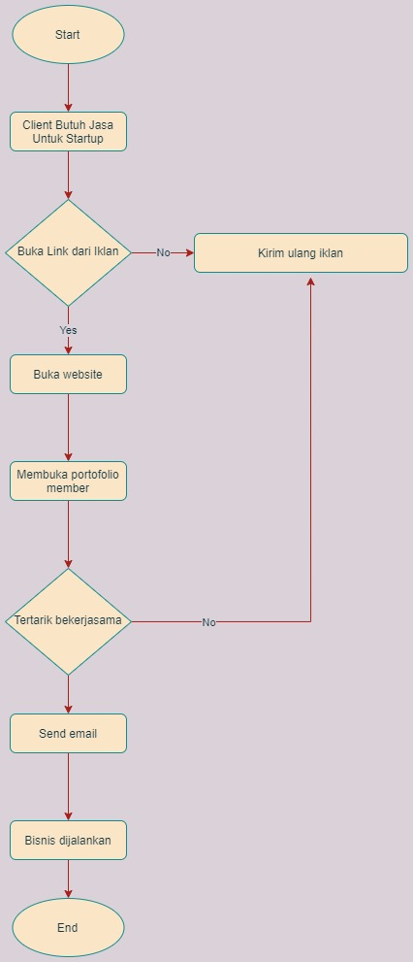 Jadi disini awal mula dari bisnis kami adalah saat client membutuhkan jasa untuk membuat startup. Jasa tersebut bisa berupa apa saja asalkan ruang lingkupnya masih dalam dunia IT. Disini kami menyediakan apapun jasa untuk IT. Setelah Client membutuhkan jasa start up, client pastinya akan mencari sebuah penjasa terbaik.   
  
 Suatu saat dia akan menemukan iklan kami, hal ini karena kami akan melakukan iklan menggunakan social media advertising dan ads networks. Setelah mereka melihat dari suatu website atau apapun, mereka kan ada jejaknya tuh diwebsite, disitu kita ambil data emailnya, lalu kita marketingin menggunakan Newsletter & drip. Jadi kita akan kirim ulang mengenai iklan kita. Lalu sekarang kita lanjut ke case apabila mereka buka website. Setelah mereka buka website, otomatis mereka akan cek portofolio para member.   
  
 Setelah itu, apabila mereka tidak tertarik, sama seperti sebelumnya, kita akan mengirim ulang iklan. Dan ternyata apabila mereka tertarik, mereka akan send email yang ada pada website kita, lalu akan masuk ke email company kita, disitu kita akan bahas lebih lanjut dan pastinya bisnis akan dijalankan.

# IMPLEMENTASI DESIGN

## Halaman Aplikasi

*Definisikan dan jelaskan halaman-halaman apa saja yang terdapat pada desain web yang dibuat. Kemudian jelaskan fungsi dari halaman tersebut dan sertakan juga screenshot dari halaman tersebut serta cara menggunakannya. (Jelaskan dengan singkat bagaimana masuk ke halaman itu).*

**Nama Halaman: Bagian Home Main**

**Deskripsi (fungsi halaman):** Terdapat navbar dan juga salam perkenalan mengenai perusahaan kami kepada user. Sekilas pada navbar terdapat logo Nevisco dan beberapa nav yang terdiri dari home, teams, dan contract.

**Cara menggunakan dan masuk ke halaman tersebut:** Jika masing masing navbar diklik maka akan hover ke bagiannya masing - masing.

**Screenshot :**

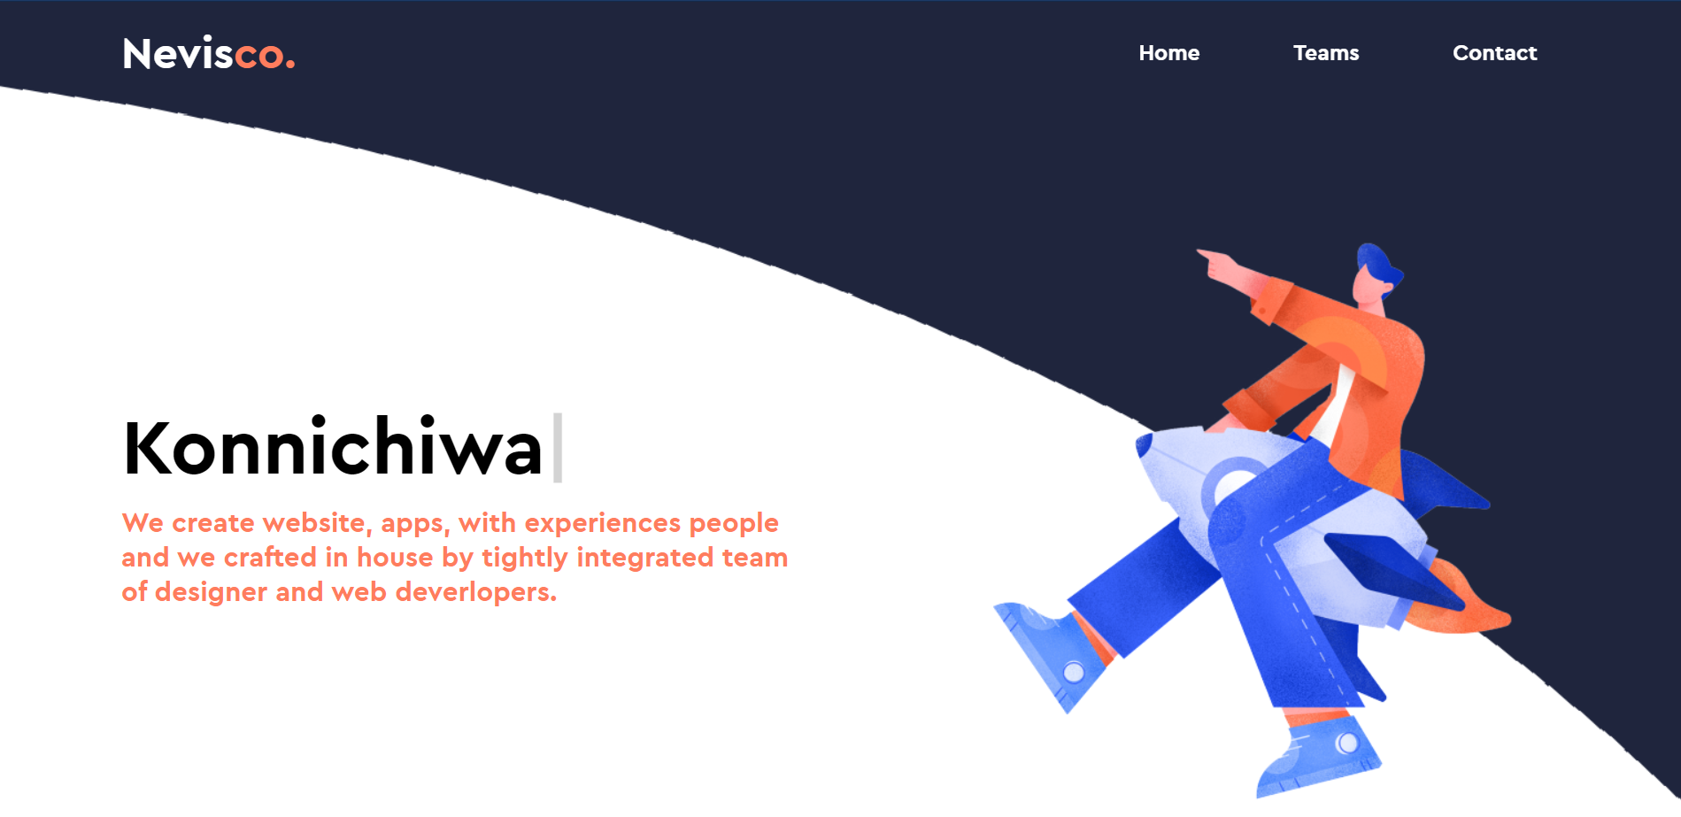

**Nama Halaman : Bagian Teams Main  
Deskripsi (fungsi halaman):** Pada bagian ini akan terdapat profil team yang mengembangkan website ini dengan info nama, nim, dan quotes pada masing – masing profil. **Cara menggunakan dan masuk ke halaman tersebut:** Setiap profil juga diberi action, jika diklik maka akan terhover ke new page yang berisi permainan untuk memasuki portfolio masing – masing profil.  
**Screenshot :**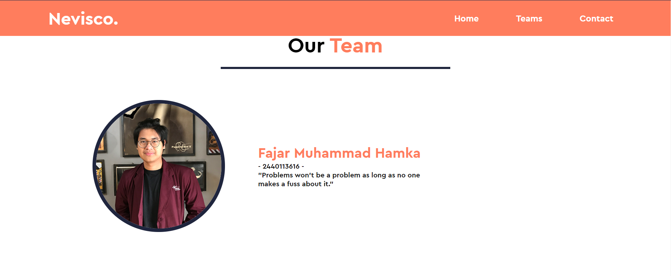

**Nama Halaman : Bagian Contact Main  
Deskripsi (fungsi halaman):** Pada bagian ini, menampilkan contact dari para pengembang diambil dari company name, address, email, dan no. Telp. Selain itu, ada pula bagi yang berminat jasa yang kami tawarkan di website ini, ada fitu untuk mengisi nama, email, subject, dan contents.  
**Cara menggunakan dan masuk ke halaman tersebut:** Setelah diisi, maka klik tombol send untuk kirim ke email perusahaan kami, namun karena send email ini masih belum ada fungsinya, maka kami hover kan untuk ke halaman Home Kembali.  
**Screenshot :**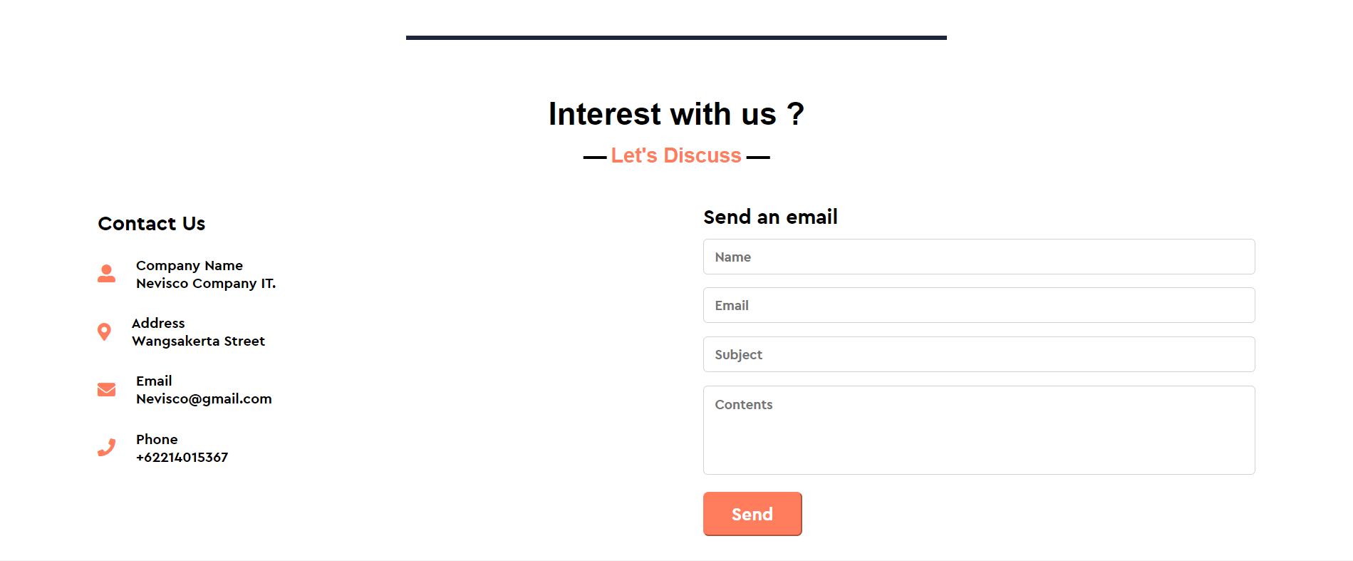

**Nama Halaman : Bagian Footer  
Deskripsi (fungsi halaman):** Pada bagian ini, hanya akan menampilkan logo perusahaan kami dan juga sekilai tentang perusahaan kami serta ikon facebook, twitter, dan Instagram. Dikarenakan kami masih belum memiliki social media untuk setiap ikon-nya, maka kita hanya dapat meng-kilk setiap ikonnya namun tidak akan terjadi apa – apa.  
**Cara menggunakan dan masuk ke halaman tersebut:** Langsung Scroll.

**Screenshot :**



**Nama Halaman:** Halaman Game Fajar (Dinosaur Jar Games).

**Deskripsi (fungsi halaman):** Halaman transisi dari halaman utama ke halaman portfolio fajar (Buat fun).

**Cara menggunakan dan masuk ke halaman tersebut:** Cara menggunakannya, ketik spasi agar dinosaurusnya loncat, apabila dinosaurus terkena batu, maka akan kalah. Apabila score > 80 maka akan lanjut ke halaman portofolio fajar.

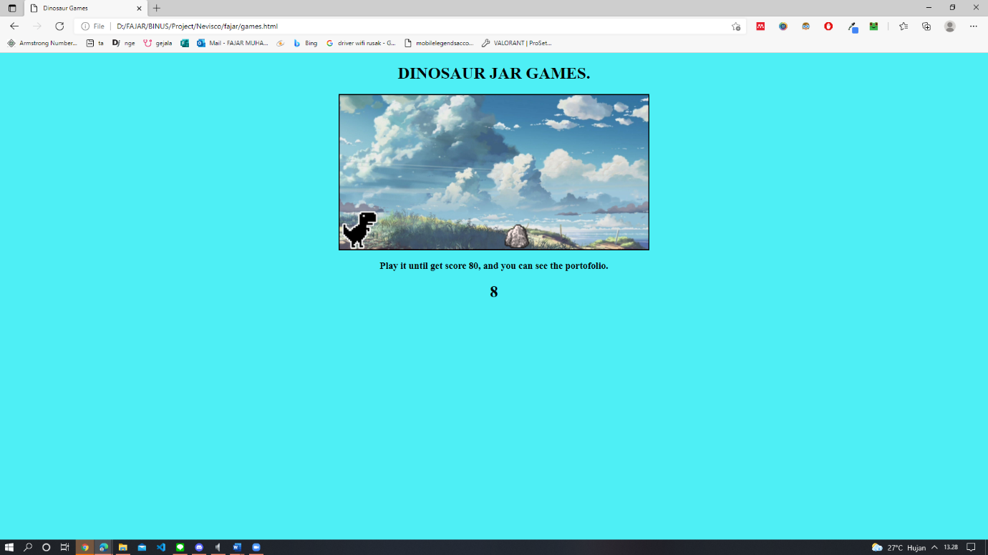**Screenshoot halaman:**

**Nama Halaman:** Halaman Home Portofolio Fajar.

**Deskripsi (fungsi halaman):** Halaman Landpage ( Saat pertama kali muncul ). Halaman Home Ini sudah Responsive untuk segala device ( Large, Medium, Small ).

**Cara menggunakan dan masuk ke halaman tersebut:** Setelah score game > 80, maka akan langsung ke halaman ini.

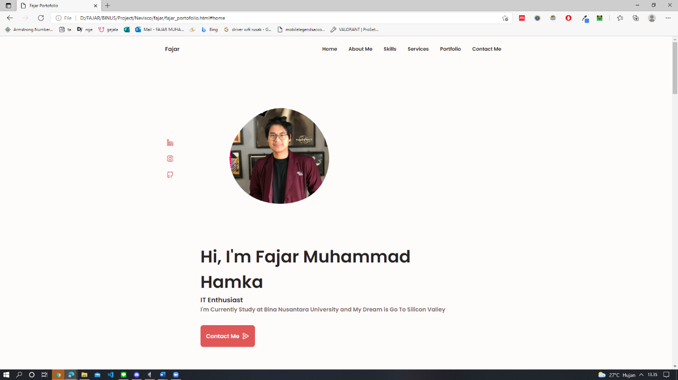**Screenshot Homepage Large Devices :**

**Screenshot Homepage Medium Devices:**

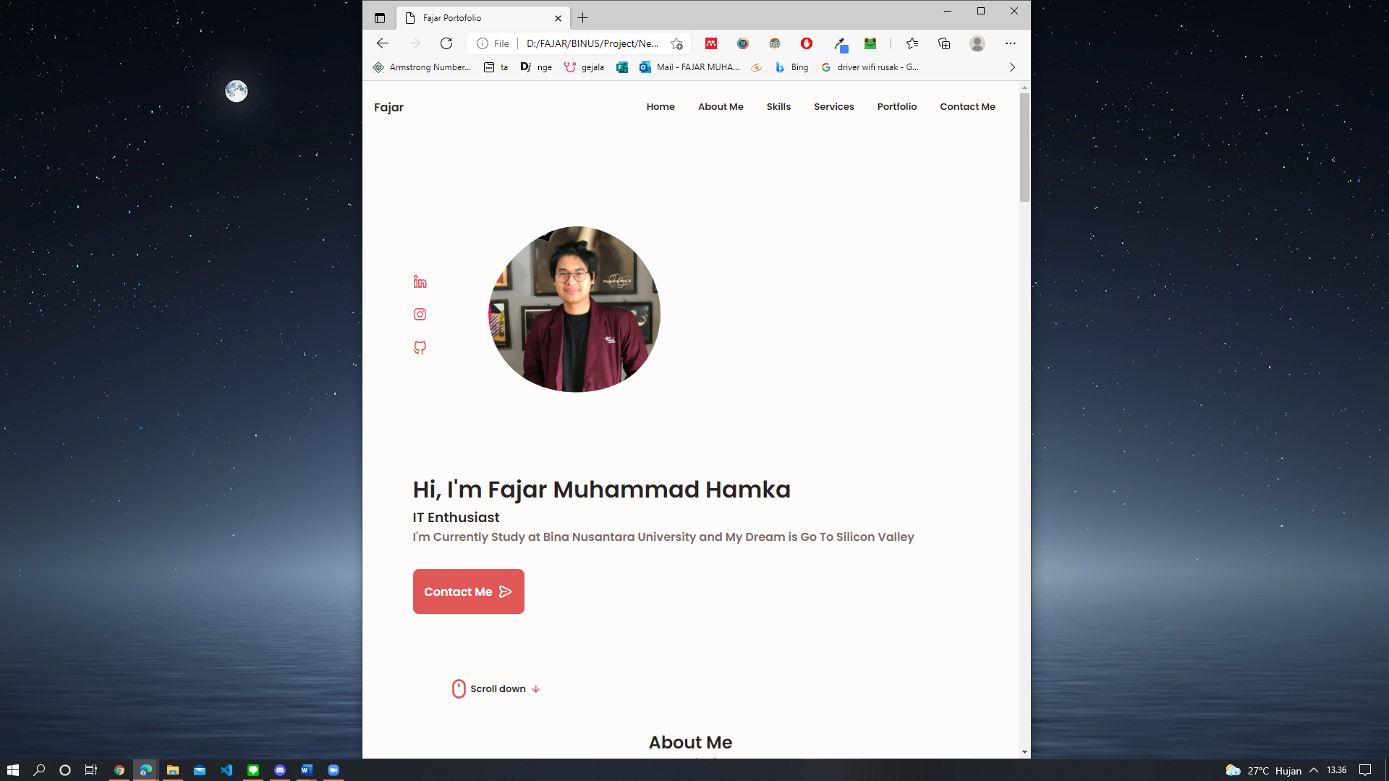

**Screenshot Homepage Small Devices (Navbar Non-Active):**

**Screenshot Homepage Small Devices (Navbar Active (Click Gambar Kotak2)):**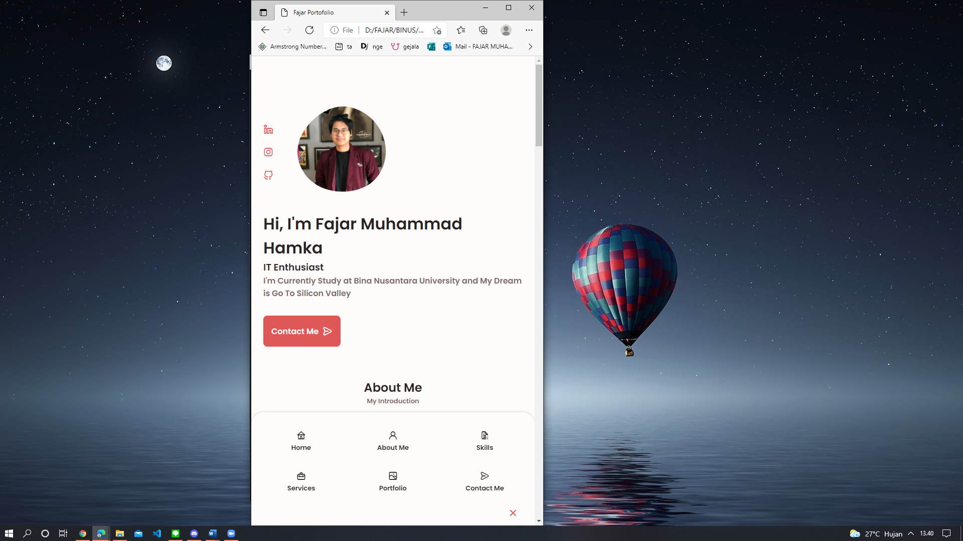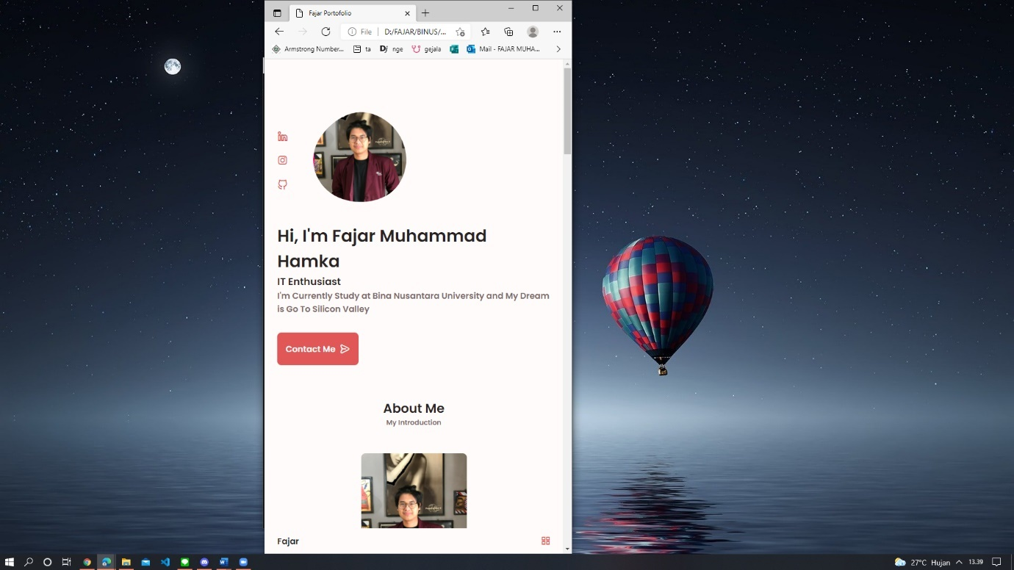

**Nama Halaman:** Halaman About Me Portofolio Fajar.

**Deskripsi (fungsi halaman):**  Halaman ini berfungsi untuk perkenalan Kemampuan Saya.

**Cara menggunakan dan masuk ke halaman tersebut:** Bisa langsung scroll / click About Me di Navbar

**Screenshot About Me Page Large Devices :**

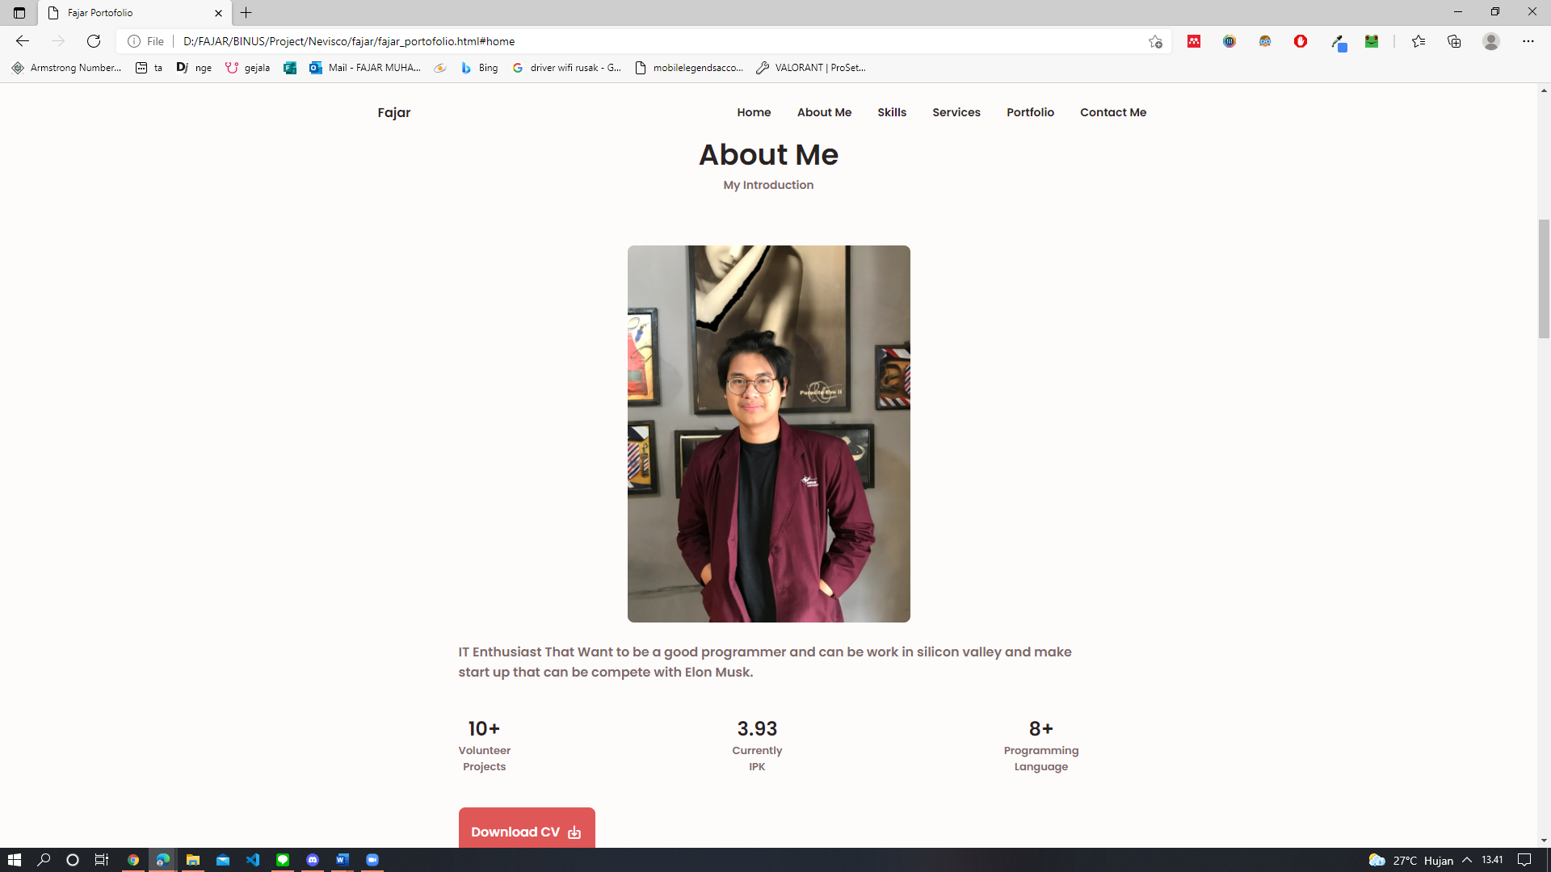

**Screenshot About Me Page Medium Devices :**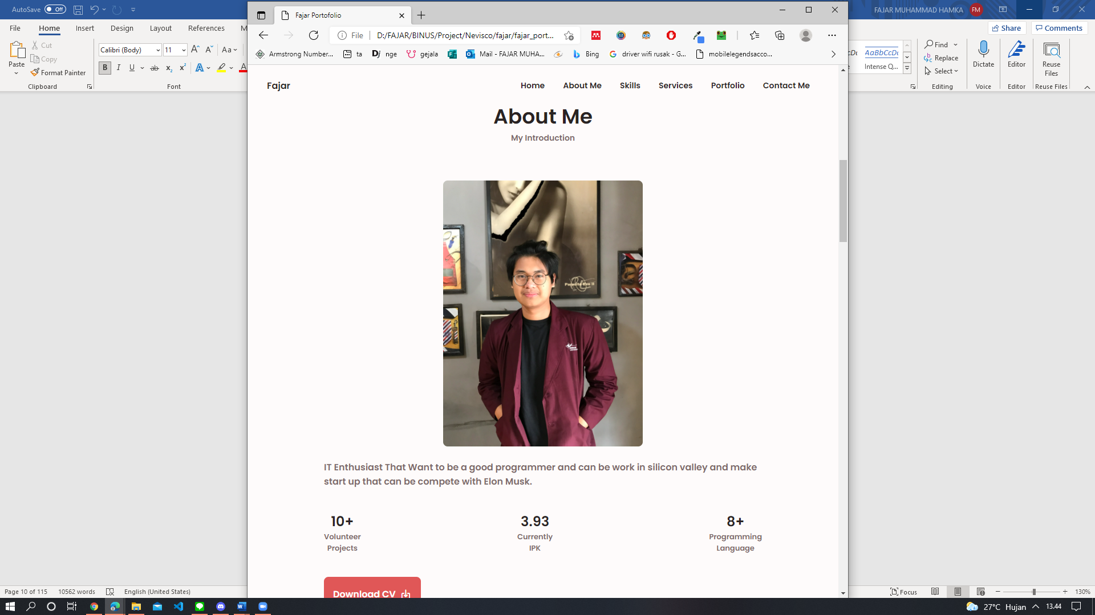

**Screenshot About Me Page Small Devices :**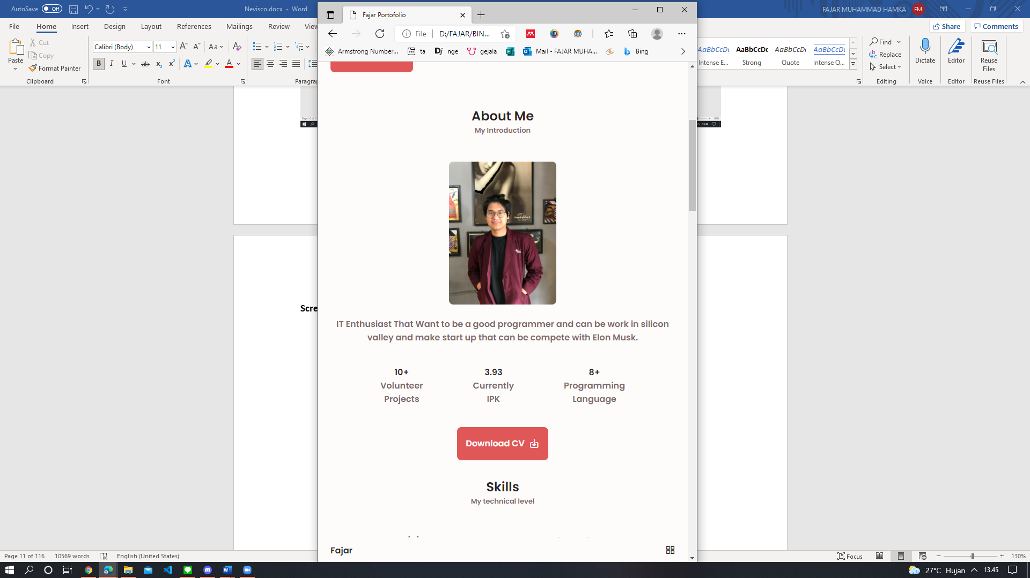

**Nama Halaman:** Halaman Skills Portofolio Fajar.

**Deskripsi (fungsi halaman):**  Halaman ini berfungsi untuk melihat Skills yang saya punya.

**Cara menggunakan dan masuk ke halaman tersebut:** Bisa langsung scroll / click di Navbar. Untuk elihat kemampuan di backend,dsb bisa langsung click saja.

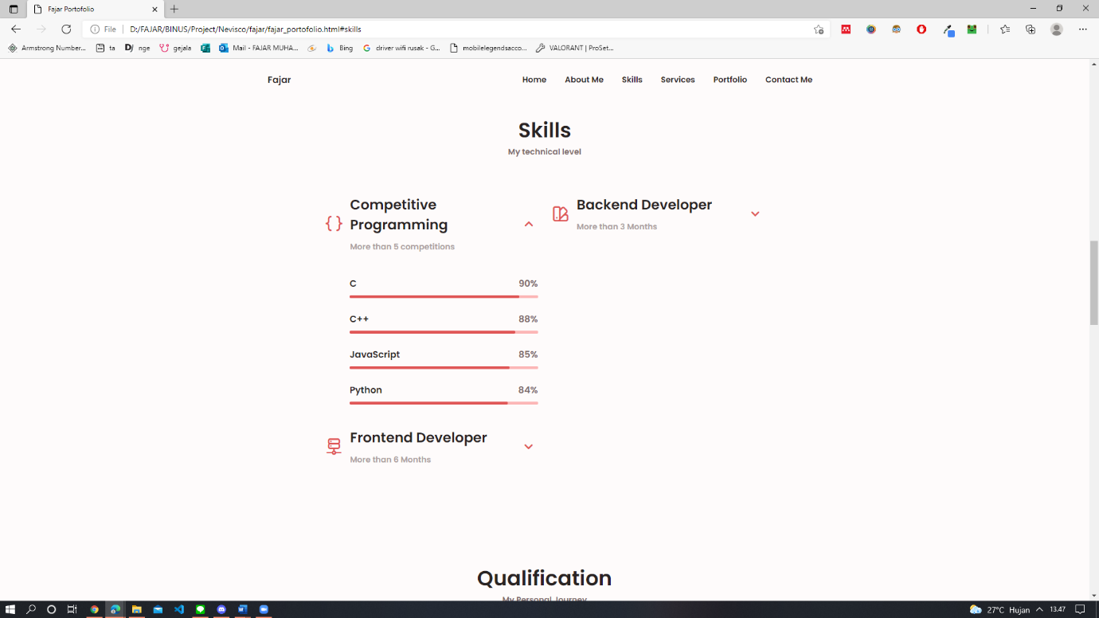**Screenshot Skills Page Large Devices :**

**Screenshot Skills Page Medium Devices :**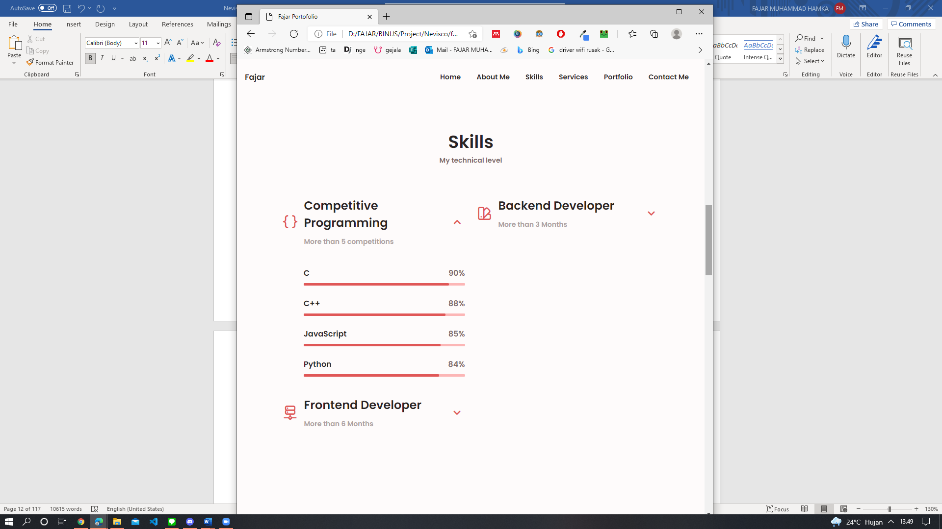

**Screenshot Skills Page Small Devices :**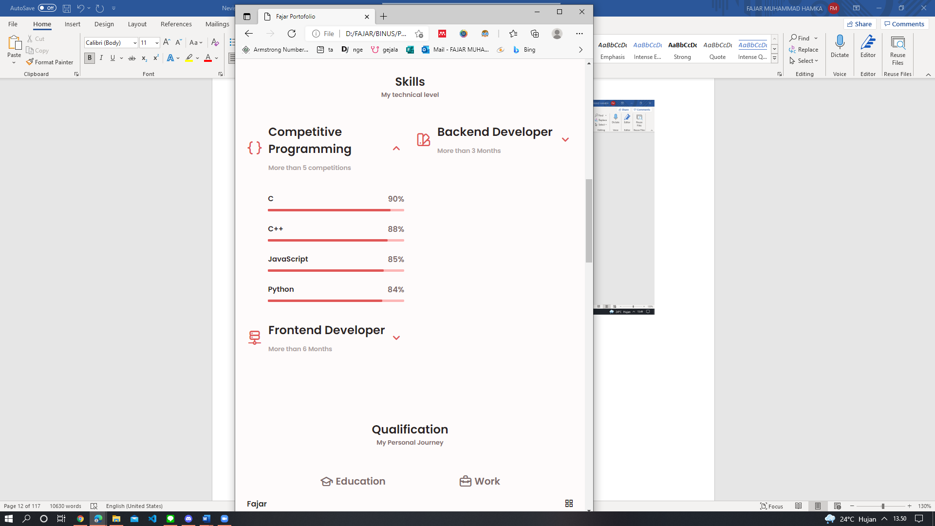

**Nama Halaman:** Halaman Qualification Portofolio Fajar.

**Deskripsi (fungsi halaman):**  Halaman ini berfungsi untuk kualifikasi edukasi dan kerja saya.

**Cara menggunakan dan masuk ke halaman tersebut:** Bisa langsung scroll

**Screenshot Qualification Page Large Devices :**   
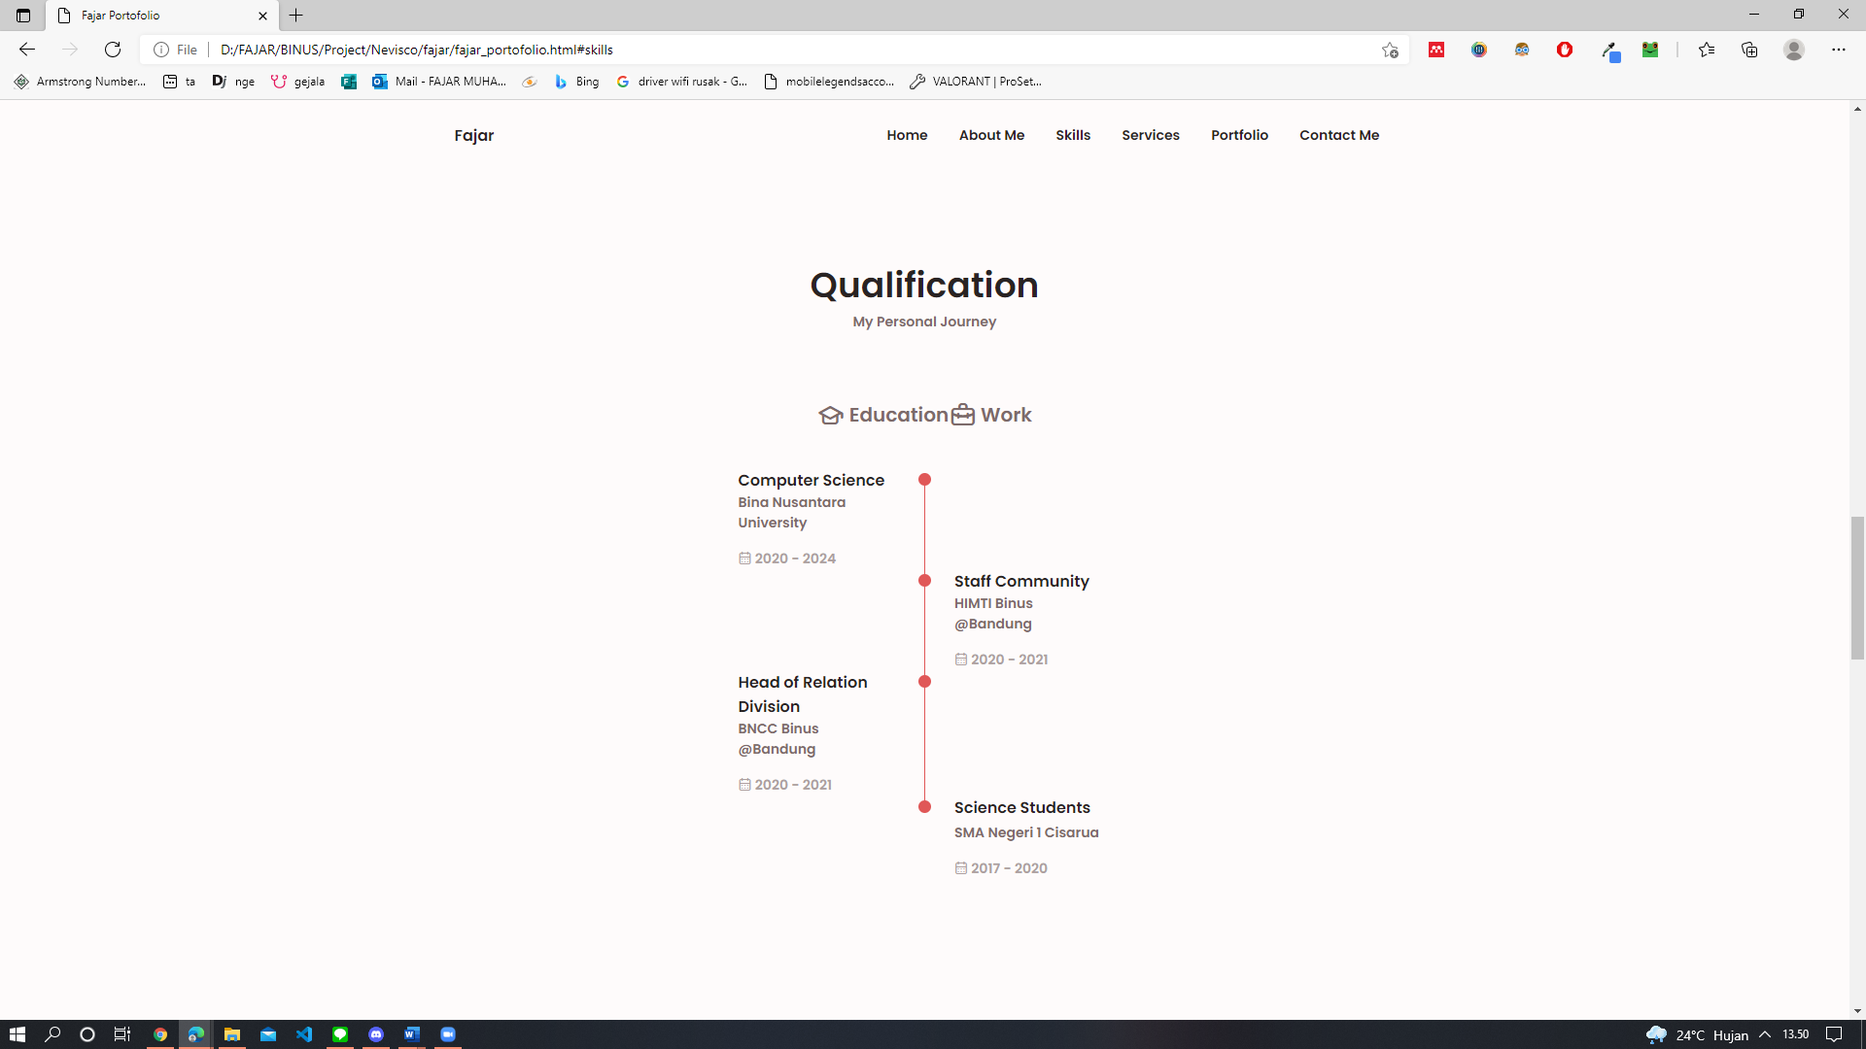

**Screenshot Qualification Page Medium Devices :**

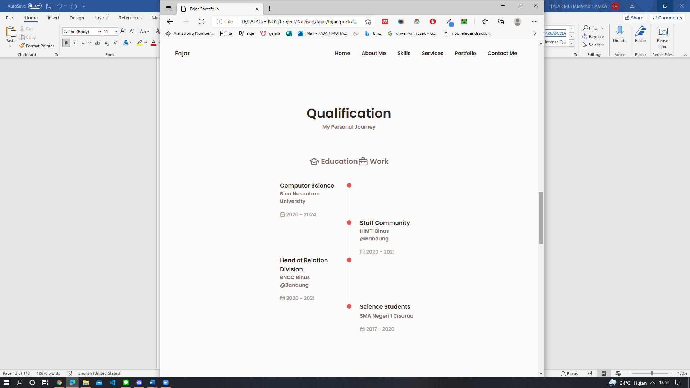

**Screenshot Qualification Page Small Devices :**

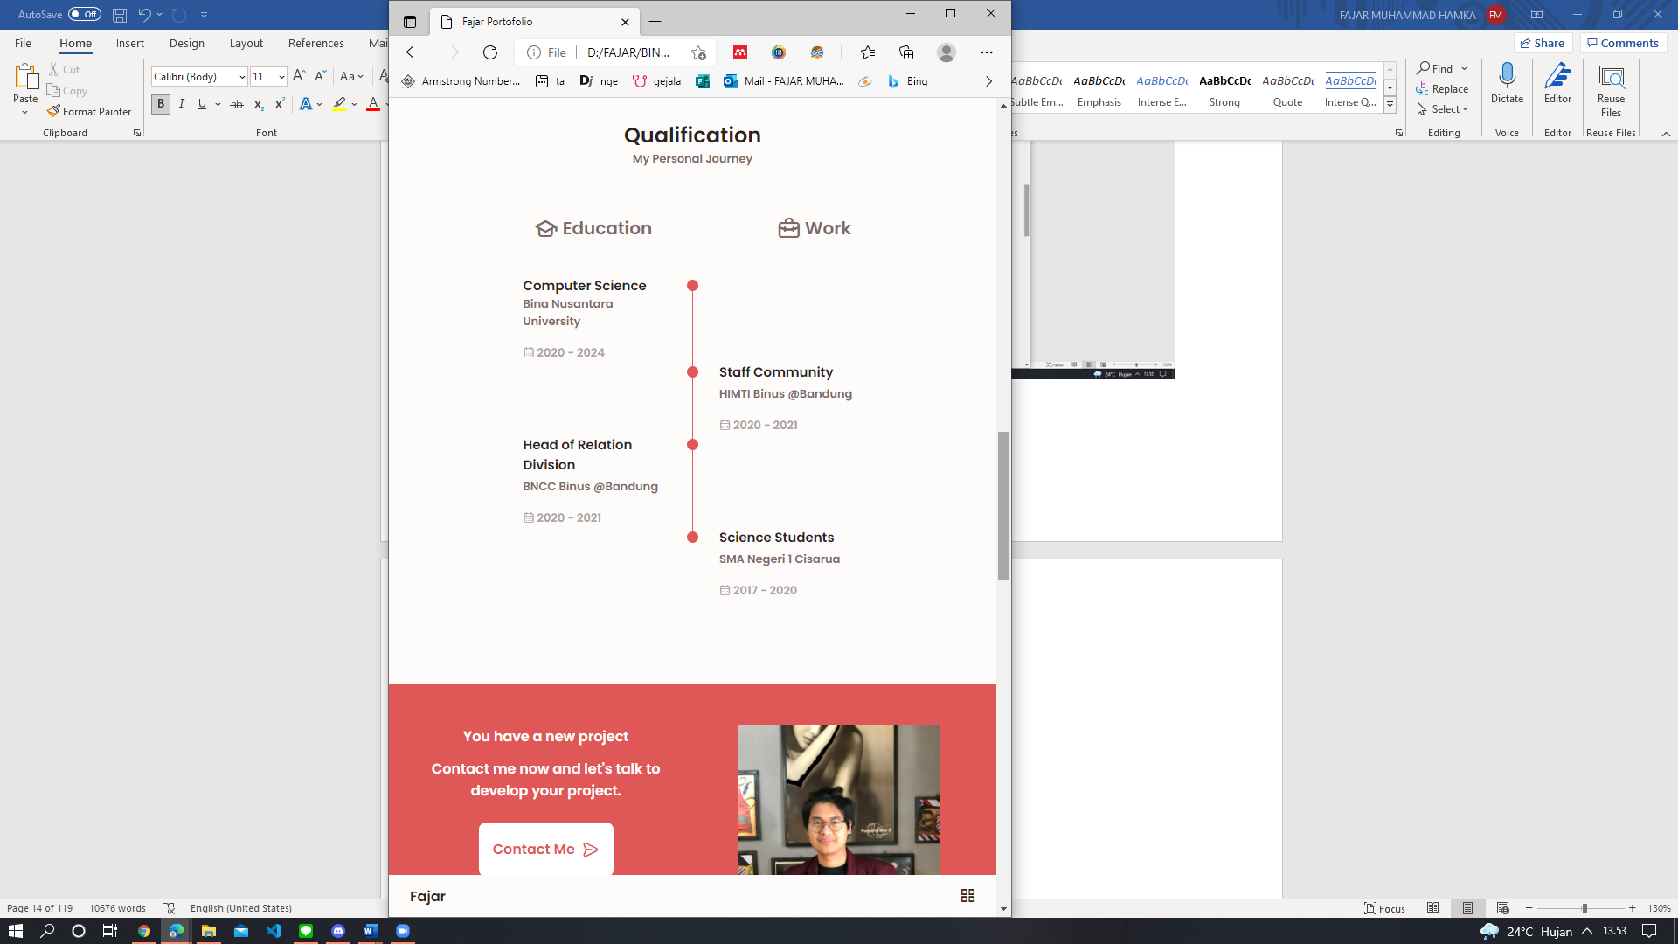

**Nama Halaman:** Halaman Direction Contact Me Portofolio Fajar.

**Deskripsi (fungsi halaman):**  Halaman ini berfungsi untuk promosi.

**Cara menggunakan dan masuk ke halaman tersebut:** Langsung scroll, lalu apabila contact me di pencet, akan masuk ke halaman contact me

**Screenshot Direction Contact Me Page Large Devices :**

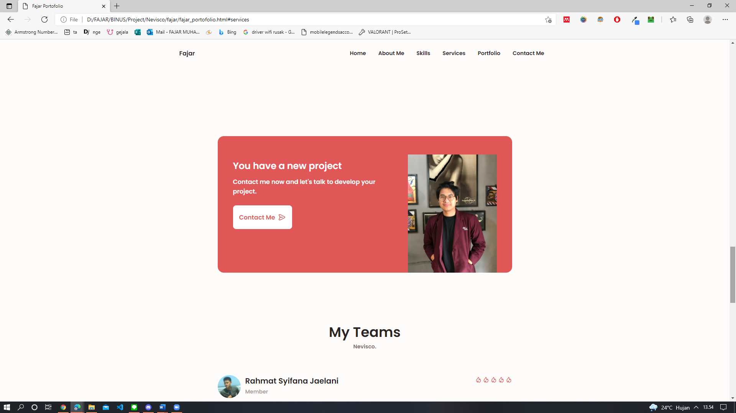

**Screenshot Direction Contact Me Page Medium Devices :**

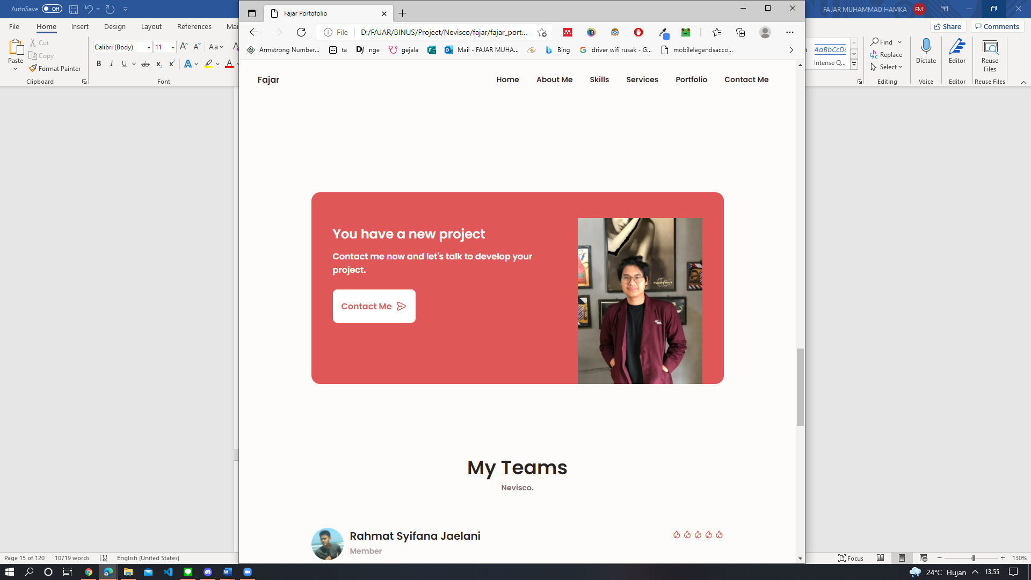

**Screenshot Direction Contact Me Page Small Devices :**

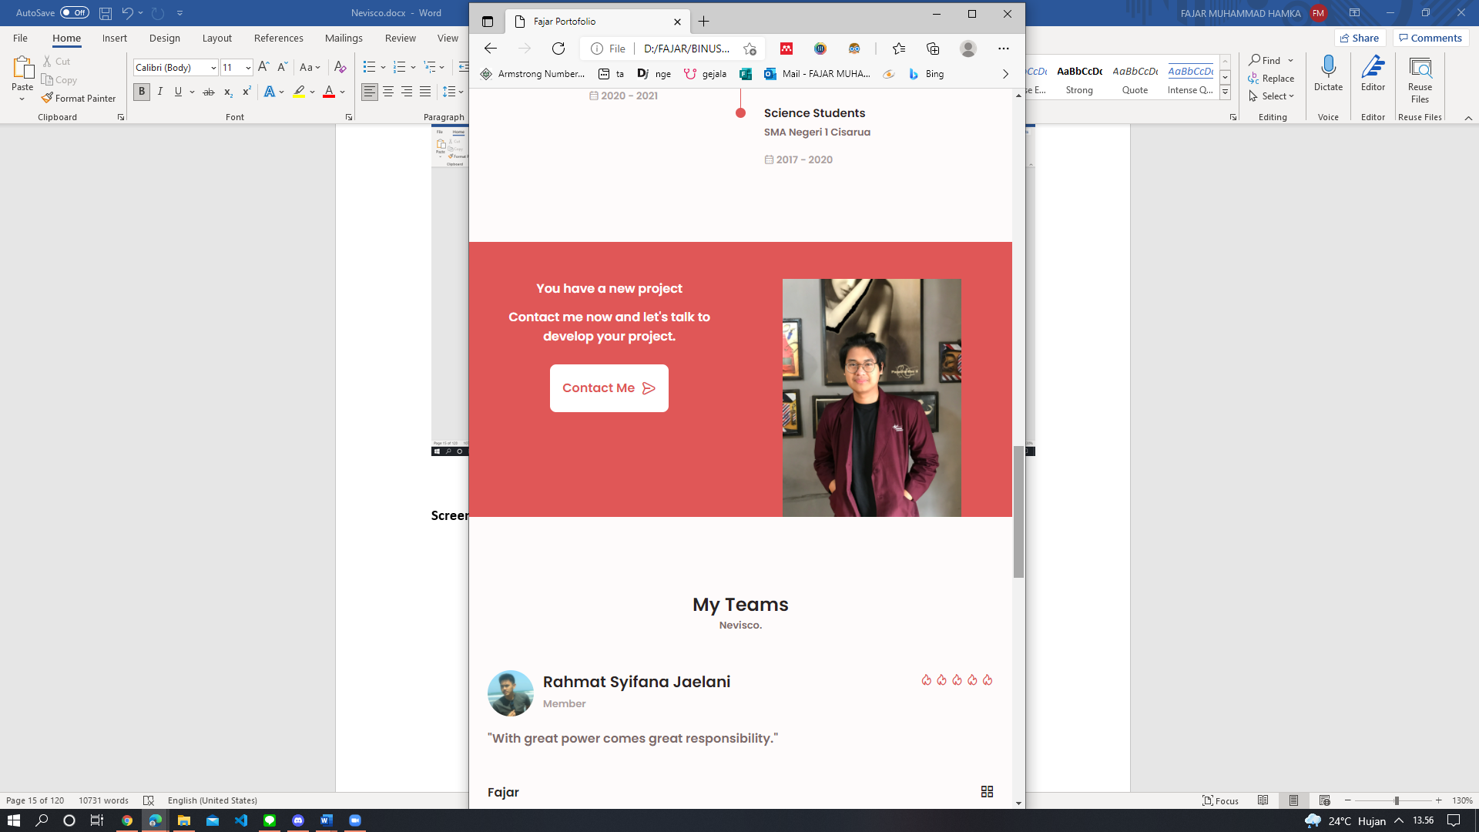

**Nama Halaman:** Halaman My Teams Portofolio Fajar.

**Deskripsi (fungsi halaman):**  Halaman ini berfungsi untuk promosi dan perkenalan Team.

**Cara menggunakan dan masuk ke halaman tersebut:** Langsung scroll.

**Screenshot My Teams Page Large Devices :**

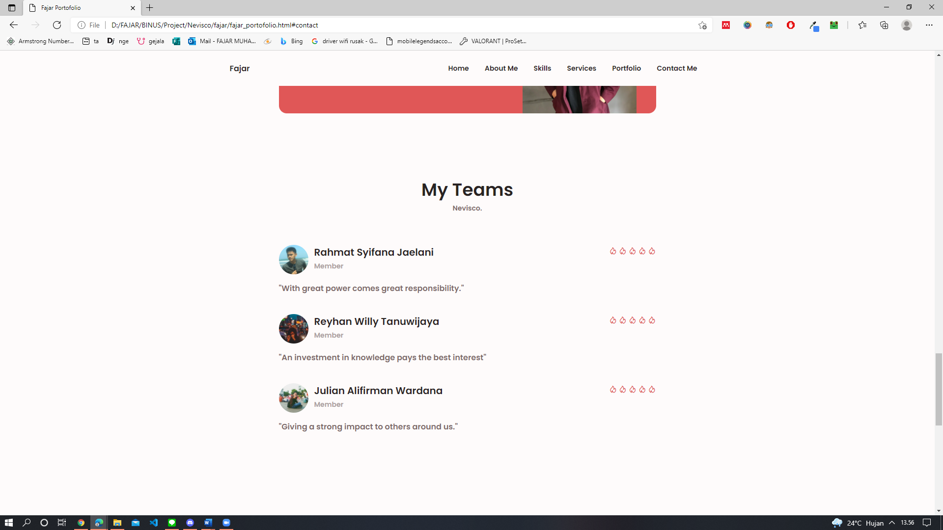

**Screenshot My Teams Page Medium Devices :**

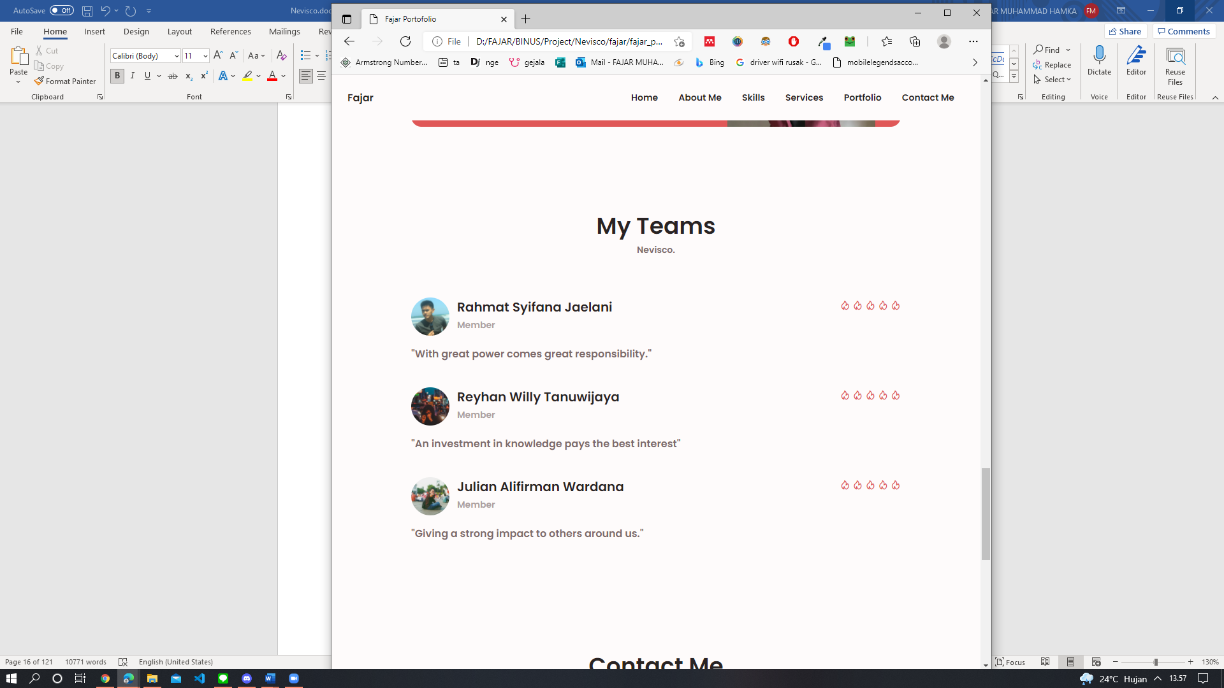

**Screenshot My Teams Page Small Devices :**

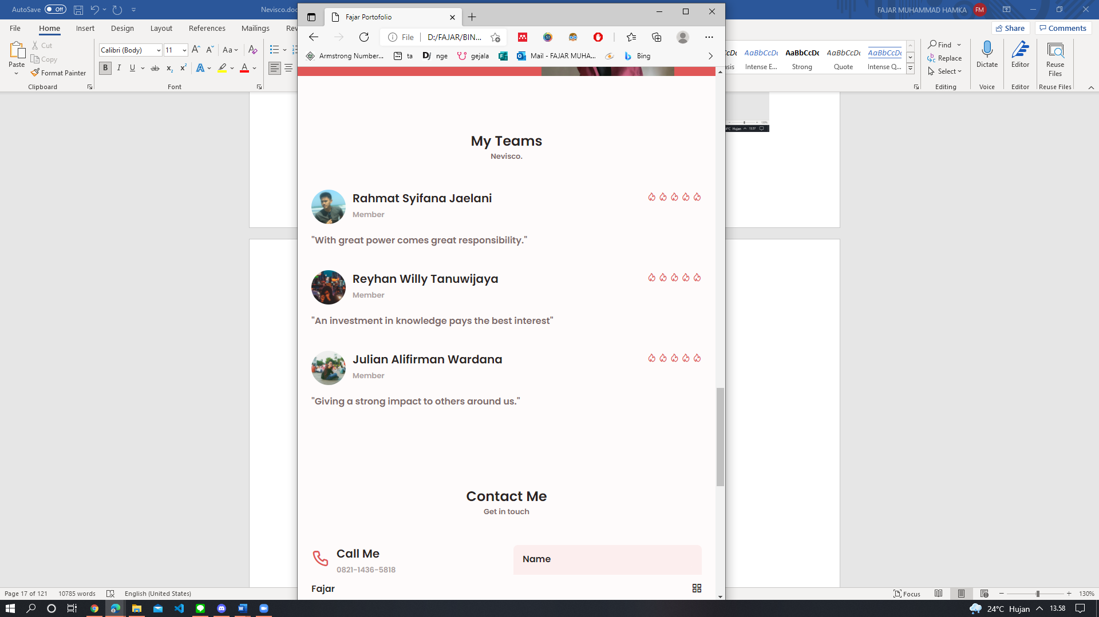

**Nama Halaman:** Halaman Contact Me Portofolio Fajar.

**Deskripsi (fungsi halaman):**  Halaman ini akan berfungsi saat orang tertarik berbisnis dengan saya dan akan email saya di halaman ini

**Cara menggunakan dan masuk ke halaman tersebut:** Langsung scroll / click contact me.

**Screenshot Contact Me Page Large Devices :**

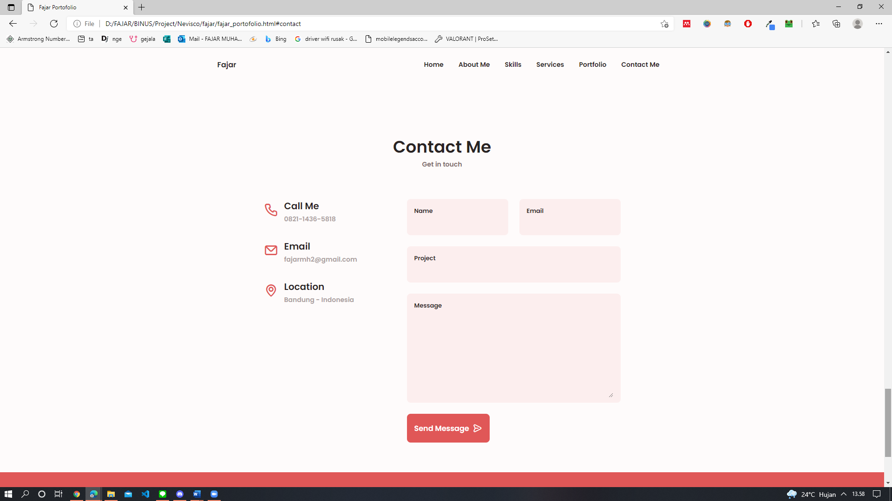

**Screenshot Contact Me Page Medium Devices :**

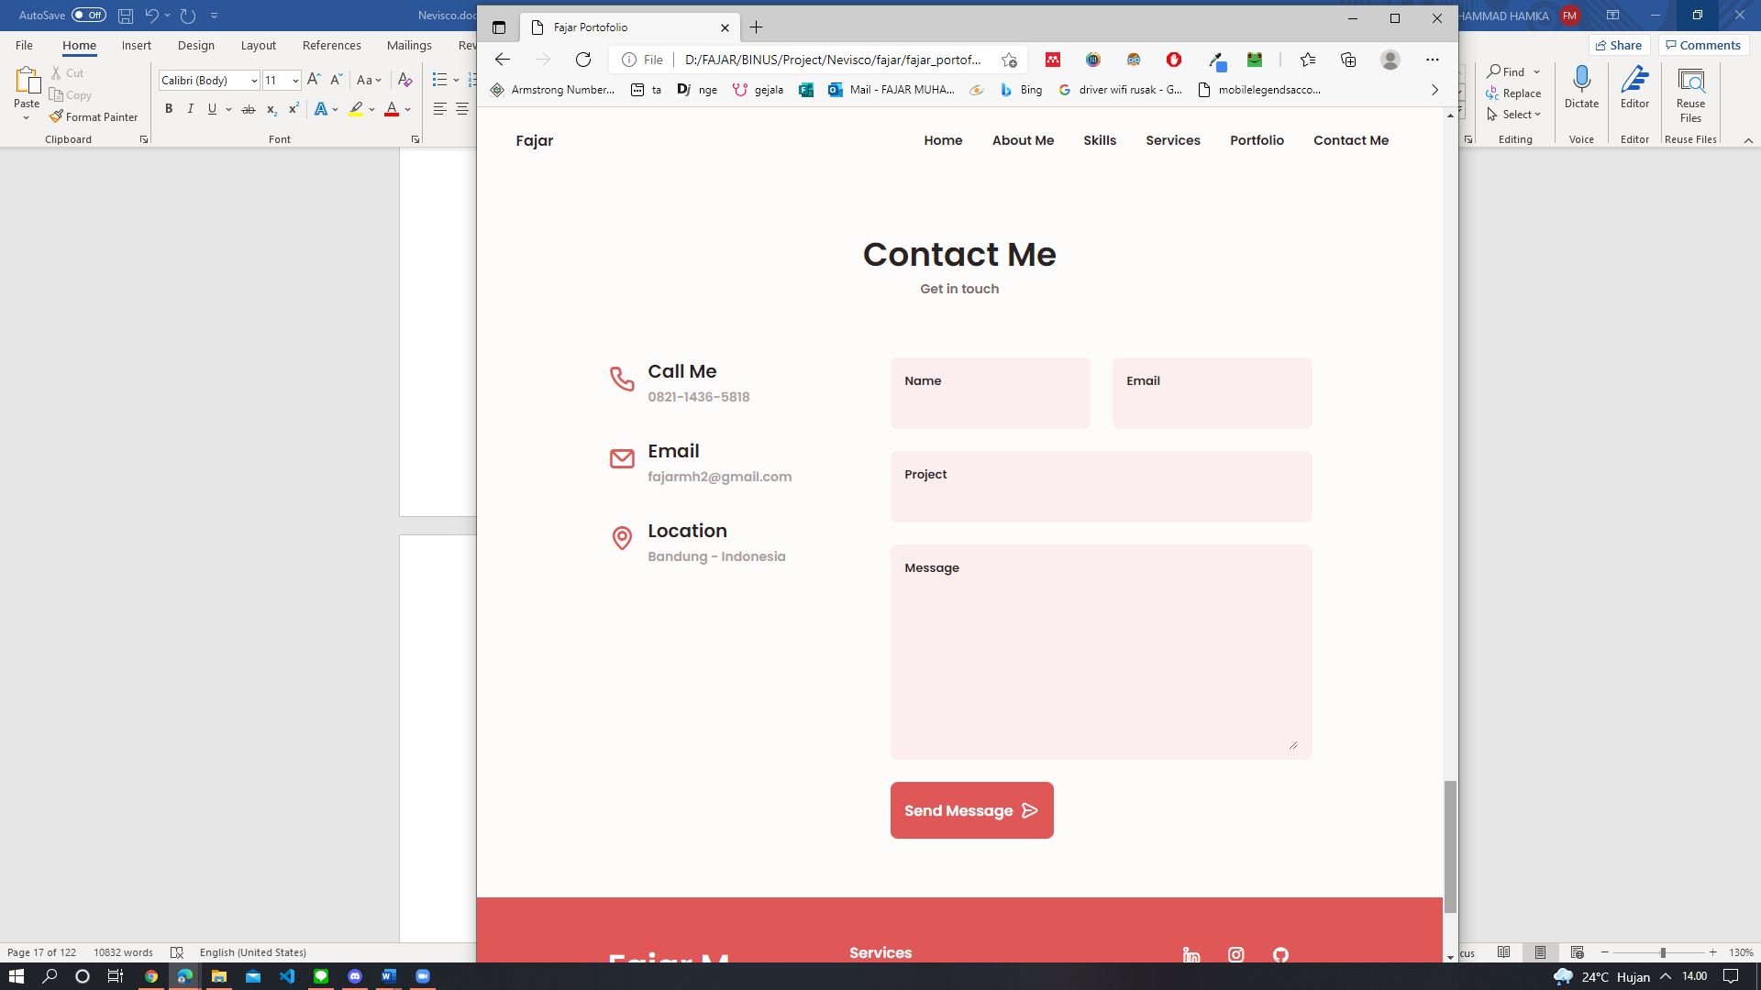

**Screenshot Contact Me Page Small Devices :**

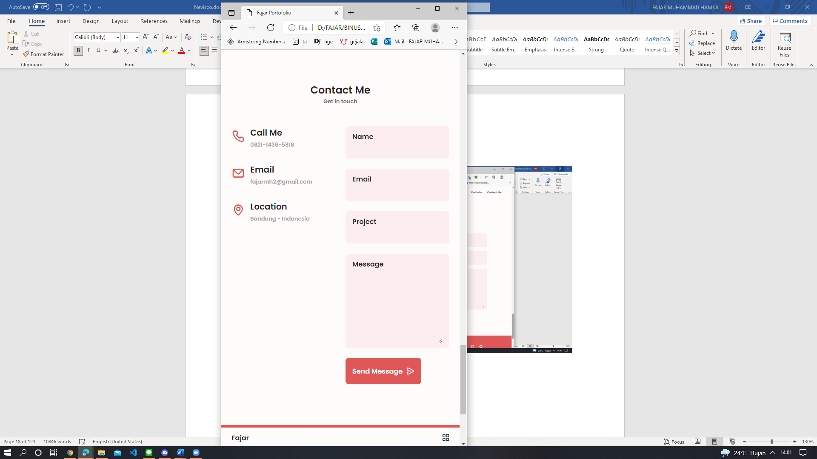

**Nama Halaman:** Halaman Footer Portofolio Fajar.

**Deskripsi (fungsi halaman):**  Halaman ini akan berfungsi untuk promosi kembali dan info tentang portofolio saya.

**Cara menggunakan dan masuk ke halaman tersebut:** Langsung scroll

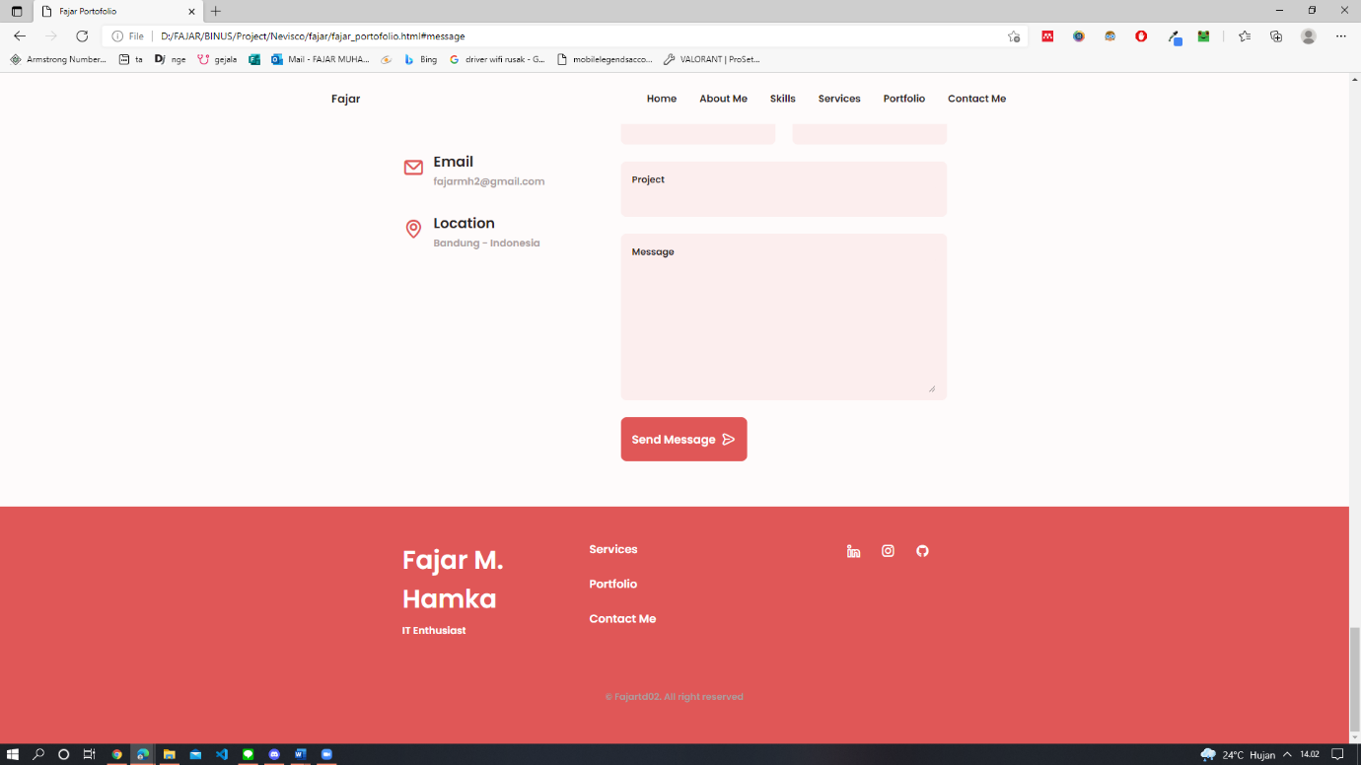**Screenshot Footer Page Large Devices :**

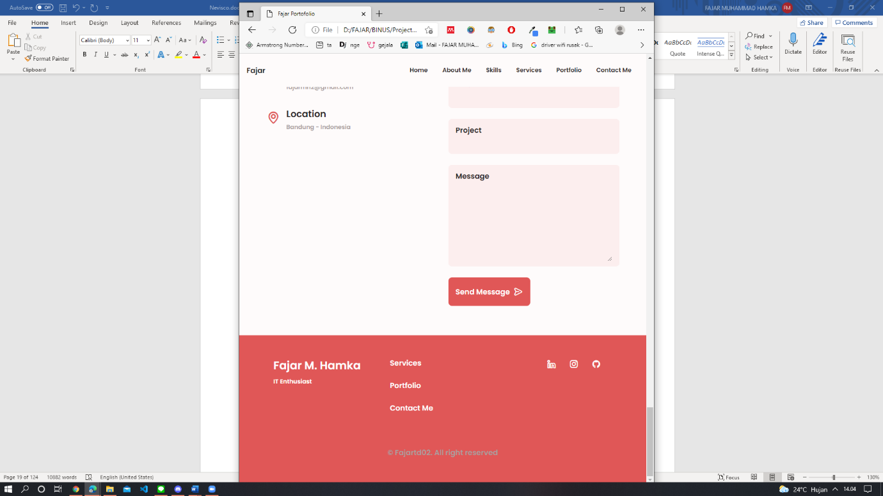**Screenshot Footer Page Medium Devices :**

**Screenshot Footer Page Small Devices :**

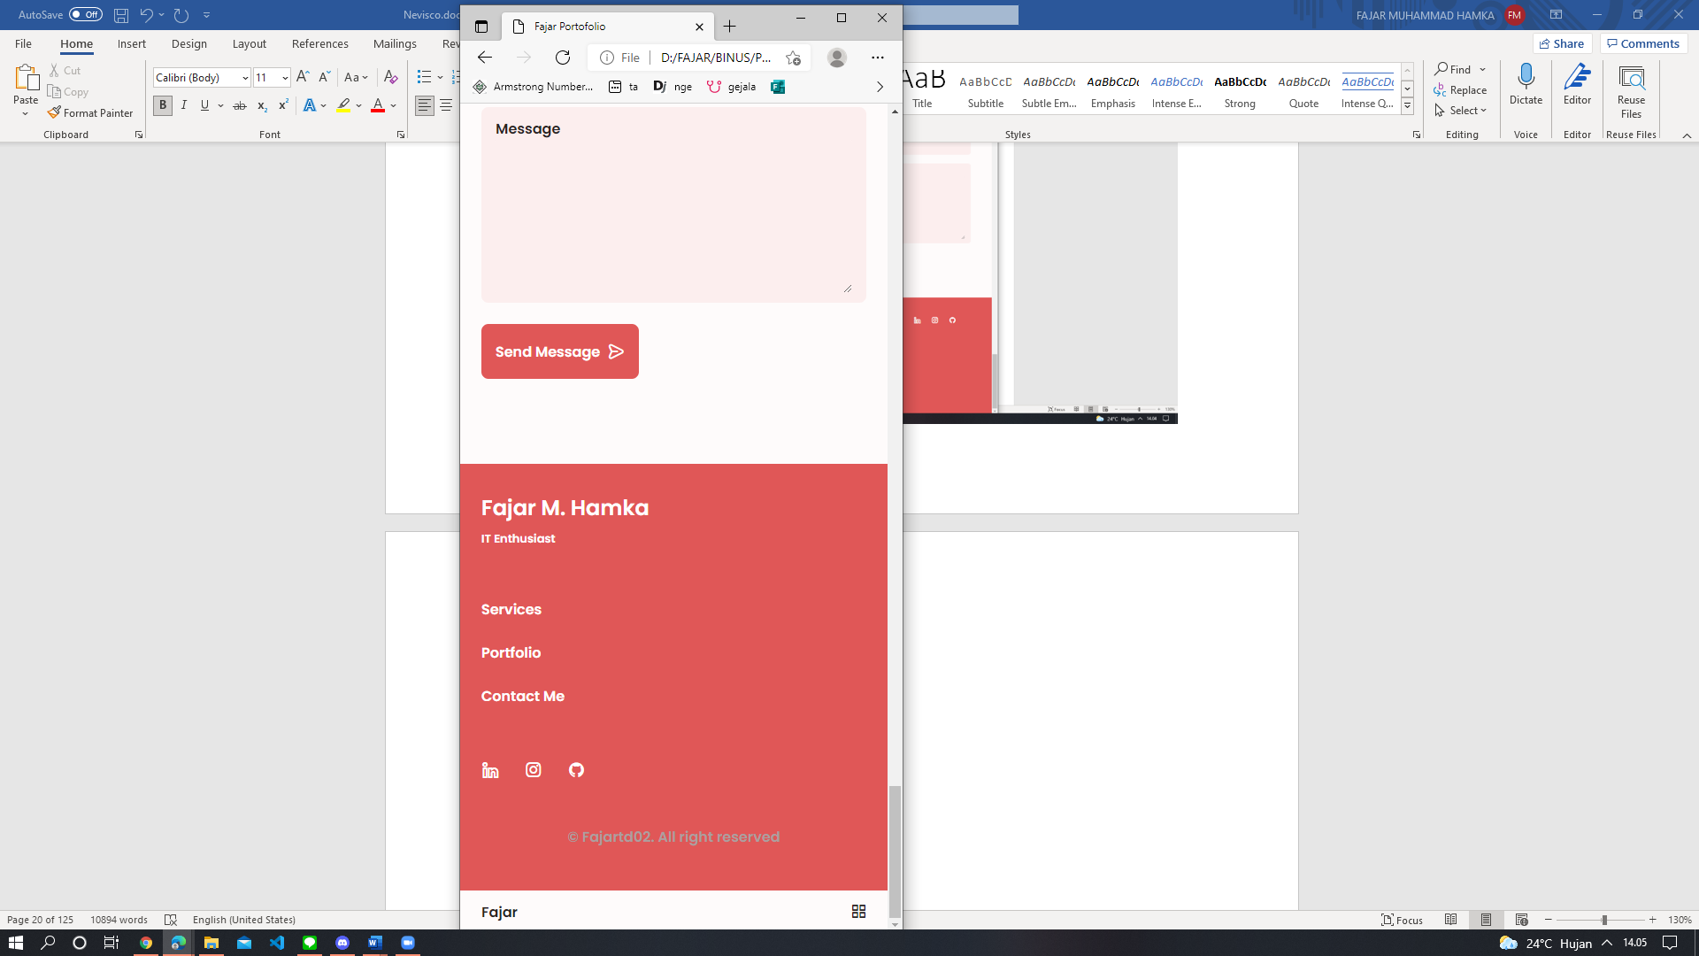

**Nama Halaman:** Halaman Game Rahmat (Flappy Bird)

**Deskripsi (fungsi halaman):** Halaman transisi dari halaman utama ke halaman portfolio

**Cara menggunakan dan masuk ke halaman tersebut:** Cara menggunakannya, klik pada halaman dengan menggunakan tombol kiri dari mouse Anda ketika sudah berada di halaman gamenya, lalu game pun dimulai. Cara masuk ke halamannya, klik member dengan nama “Rahmat Syifana Jaelani” pada bagian “Our Team” di halaman utama.

**Screenshoot halaman:**

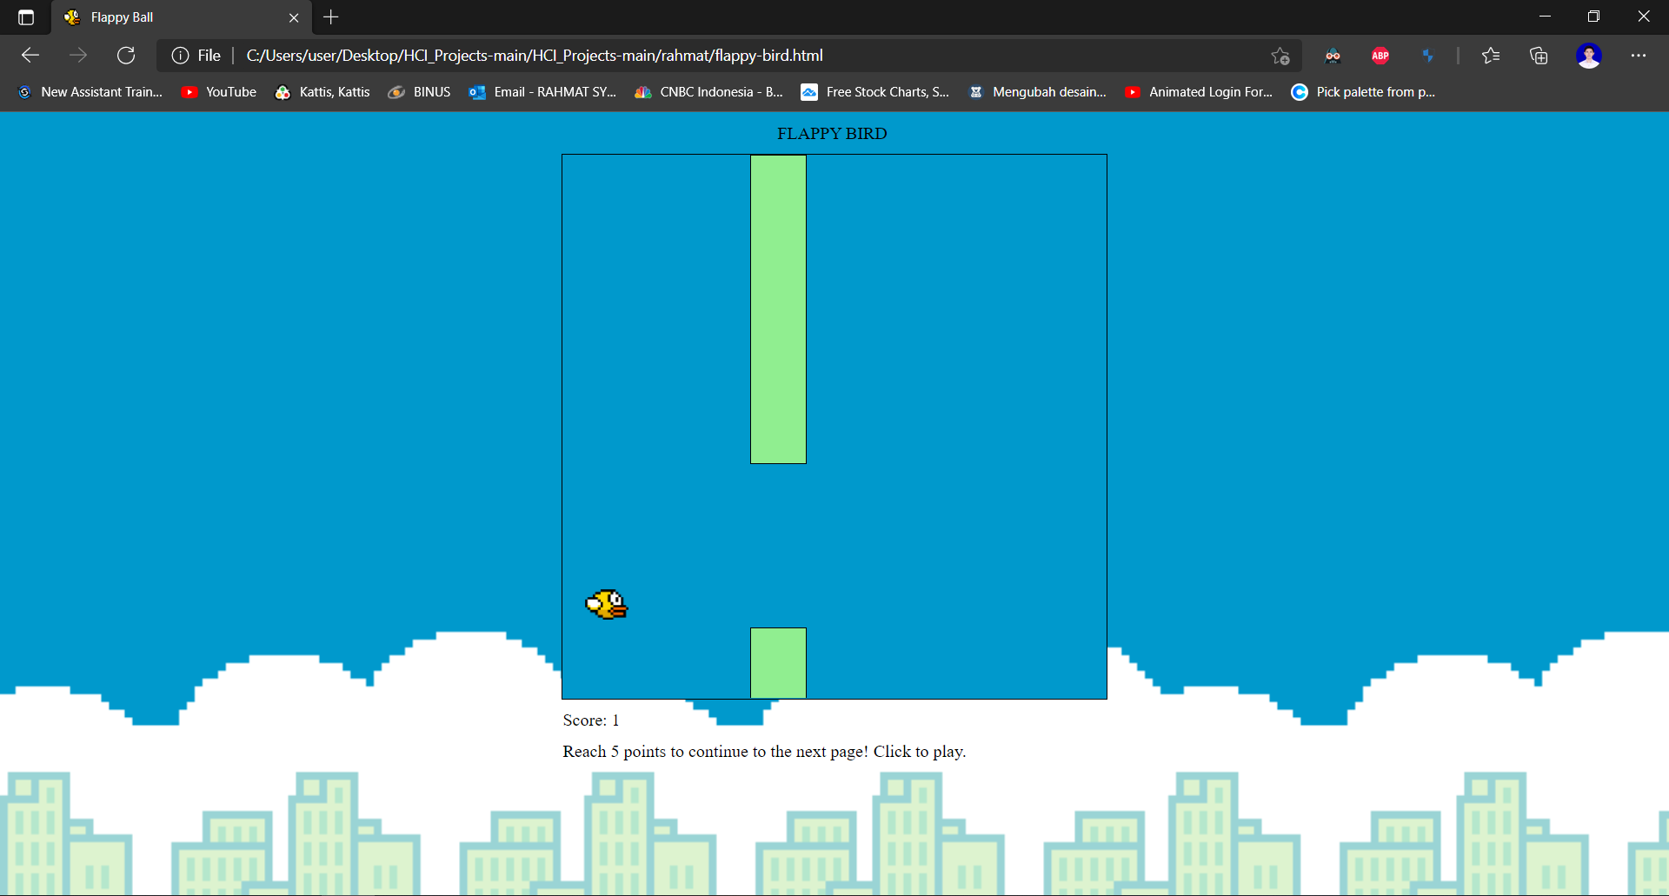

**Nama Halaman:** Halaman Portfolio Rahmat

**Deskripsi (fungsi halaman):** Memperkenalkan portfolio dari member nevisco (company)

**Cara menggunakan dan masuk ke halaman tersebut:** Klik link pada navbar untuk langsung menuju bagian halaman yang ingin dilihat. Klik tombol “Download CV” pada bagian about me untuk melihat CV dari member. Ketika width dari halamannya kurang dari 1001px, klik bar pada ujung kanan atas dari halaman untuk membuka navbar. Klik icon silang untuk menutup navbar kembali. Cara masuk ke halamannya, raih score sebesar 5 pada game flappy bird (halaman sebelum portfolio) untuk membuka halaman portfolio.

**Screenshoot halaman:**

**- navbar & home (max-width > 1000)**

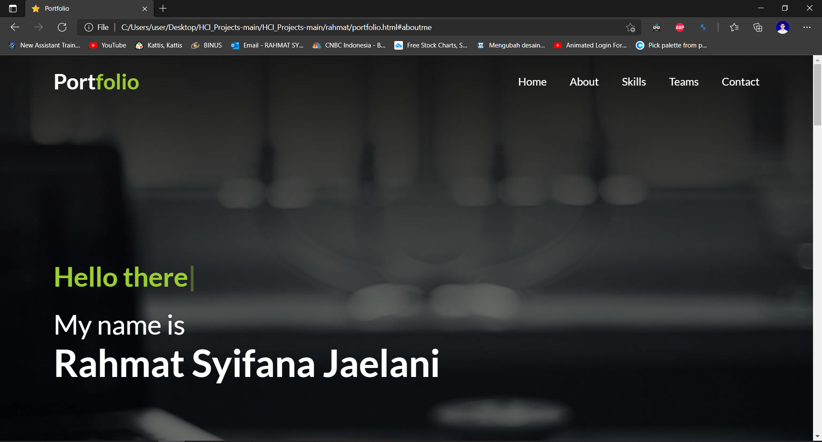

**- navbar & home (max-width <= 1000)**

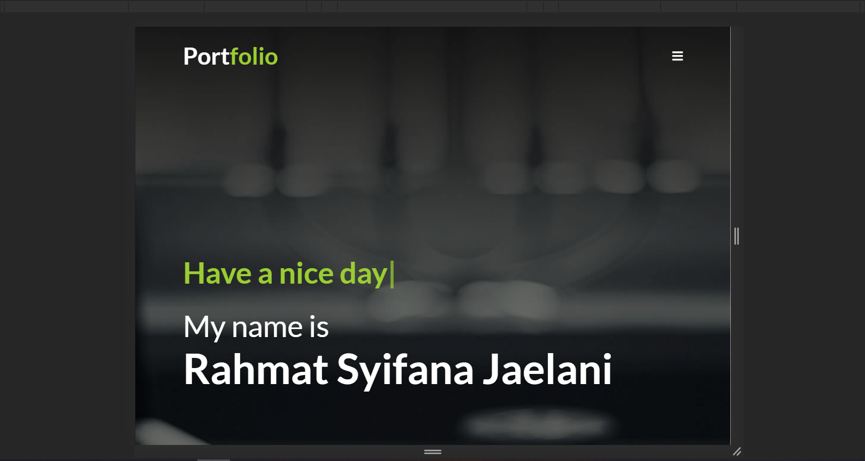

**- navbar open**

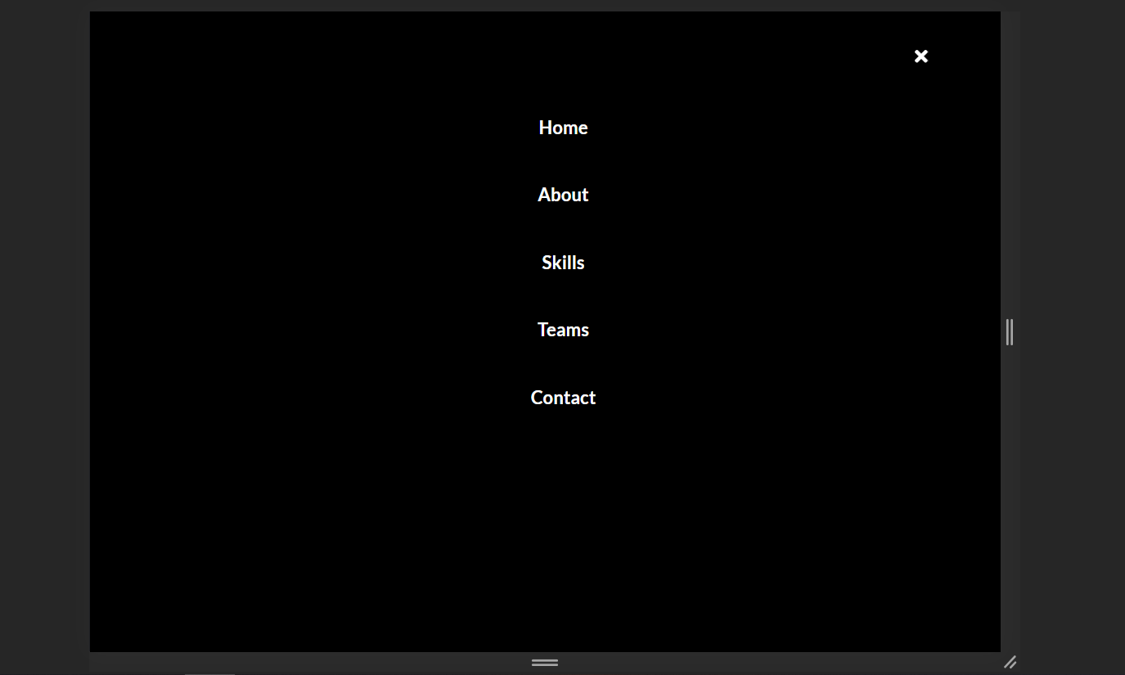

**- about me**

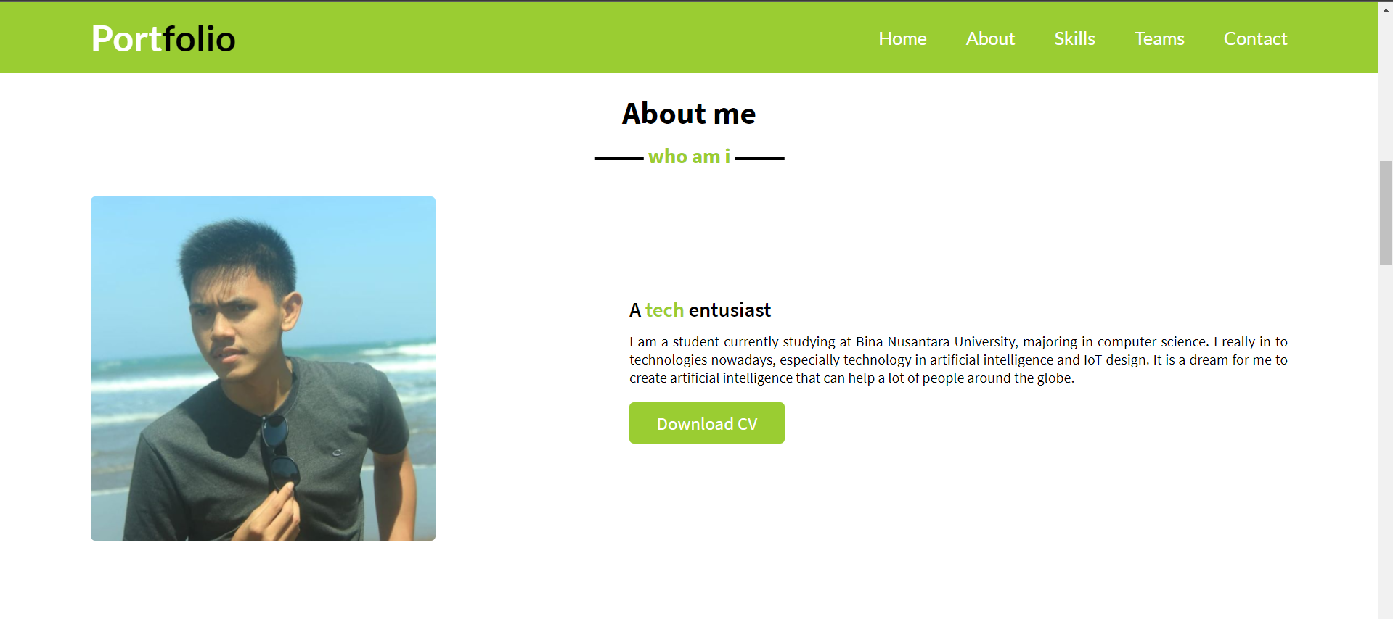

**- skills**

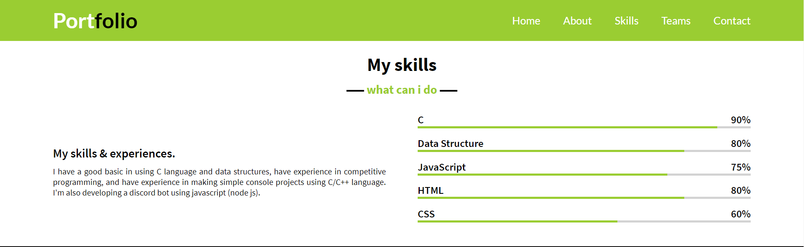

**- teams**

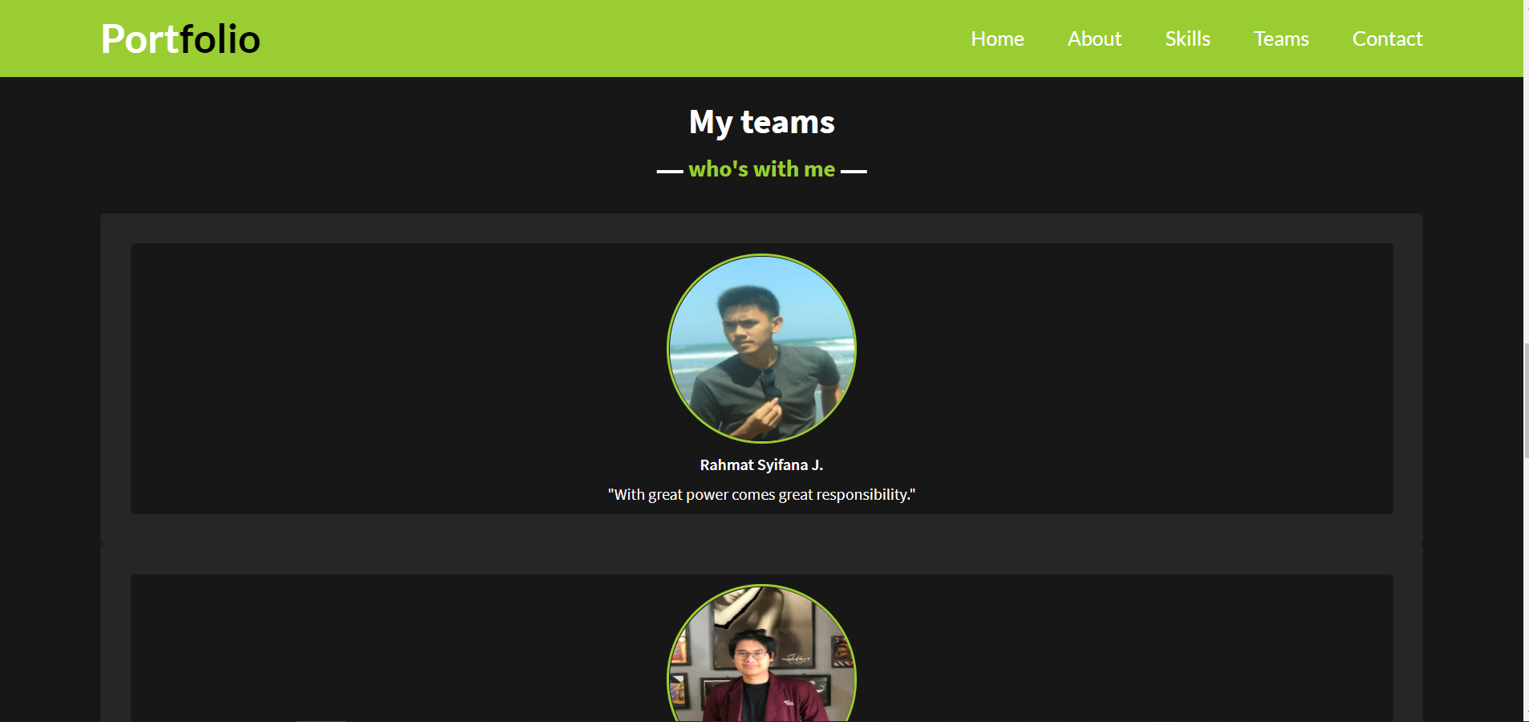

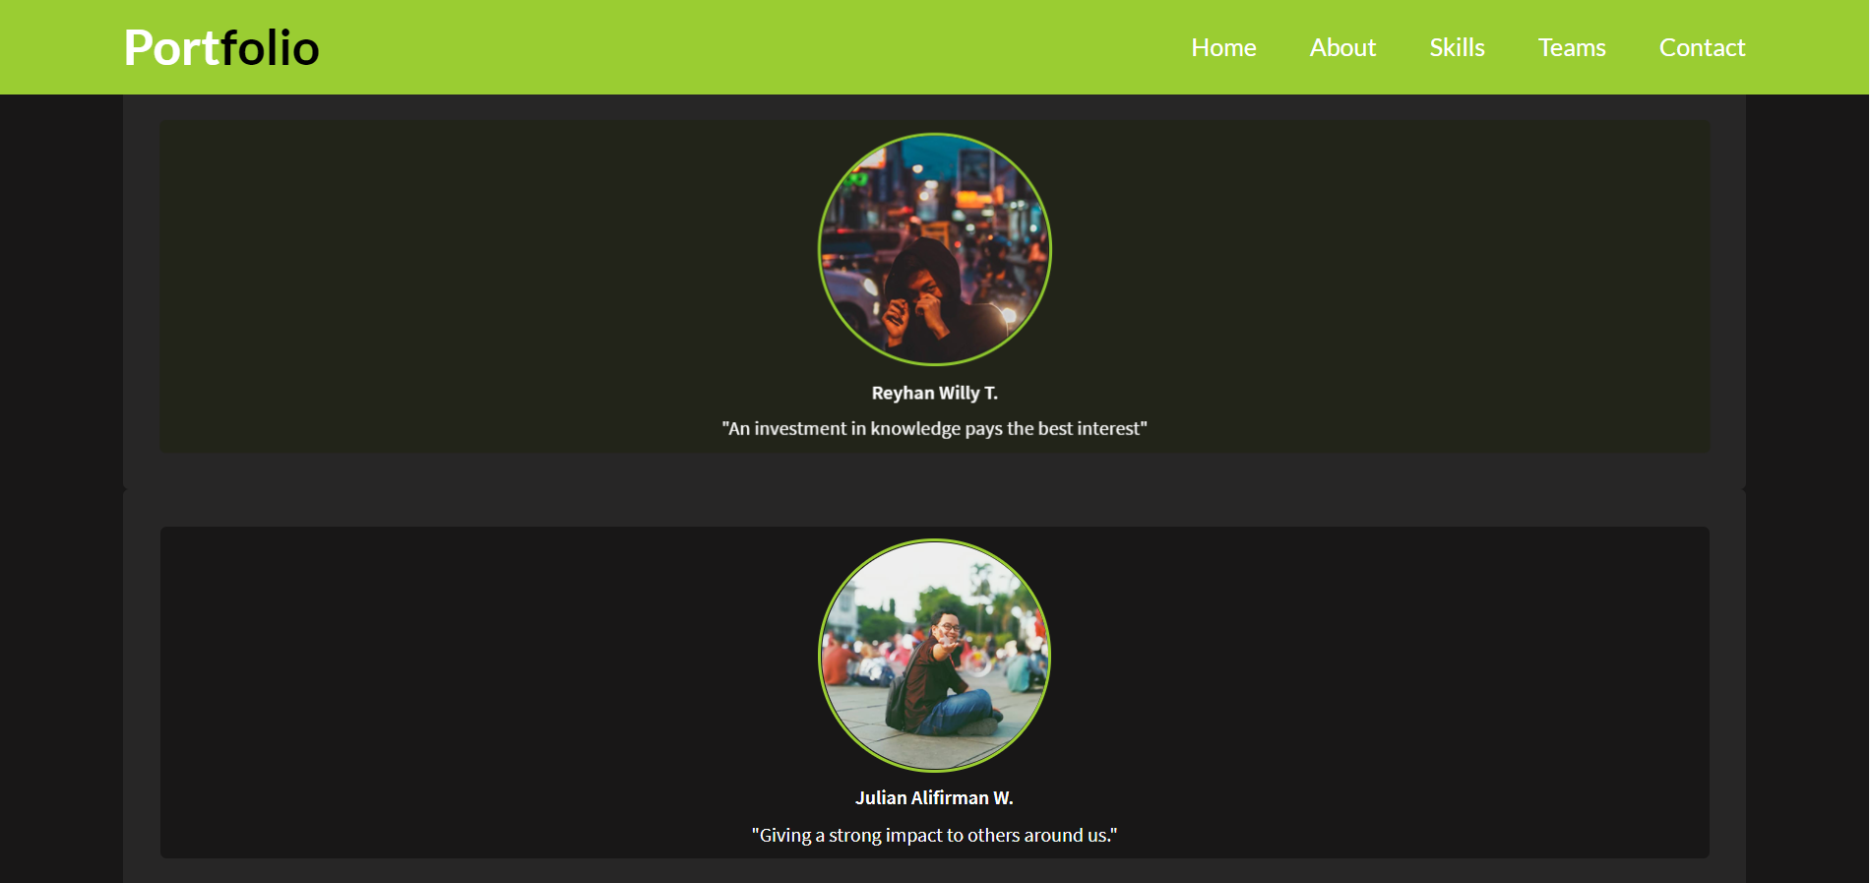

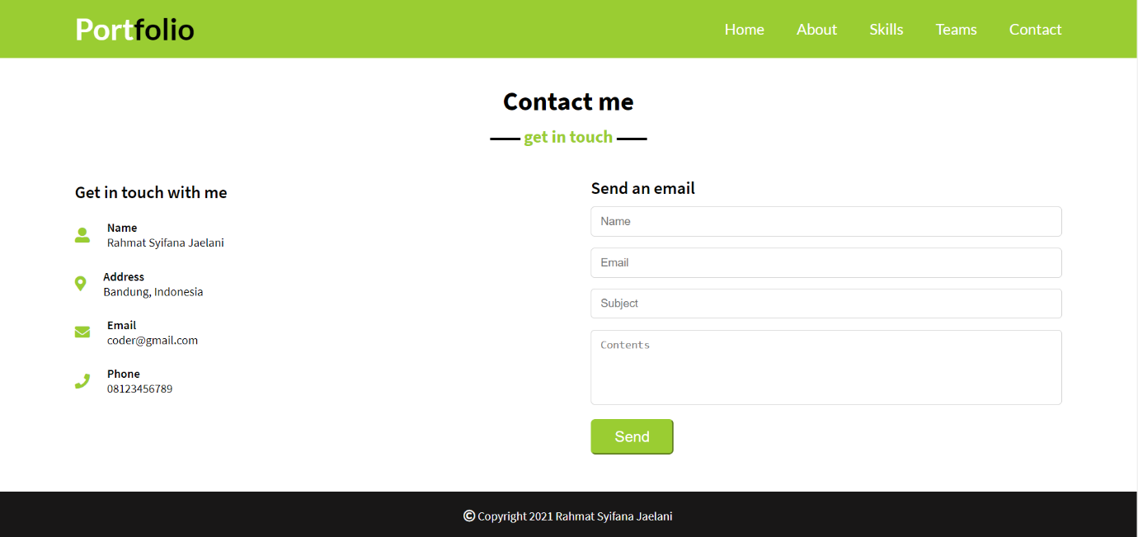**- contact & footer**

**Nama Halaman:Portofolio reyhan**

**Deskripsi (fungsi halaman): untuk menampilkan portofolio reyhan**

**Cara menggunakan dan masuk ke halaman tersebut: dengan mengklik nama reyhan apada main menu di menu pertama dan Ketika kita mengklik project atatu contact akan otomatis ke scroll sendiri dan Ketika kita mengklik ato cursor mengenai gambar maka gambar tersebut akan terscale dengan menggunakan hover dan kemudian Ketika kita kilk Instagram, twitter dan gmail maka itu akan membuka halaman baru menuju yang ingin dituju**

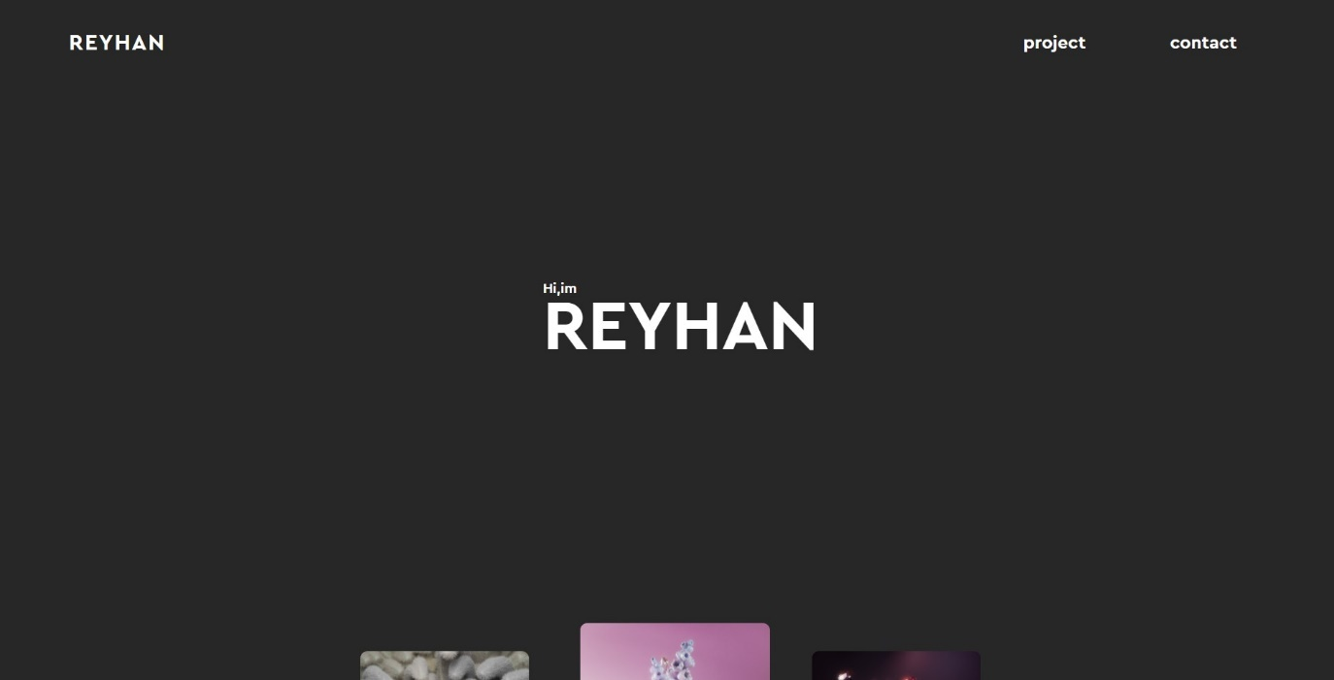**Screenshoot halaman:**

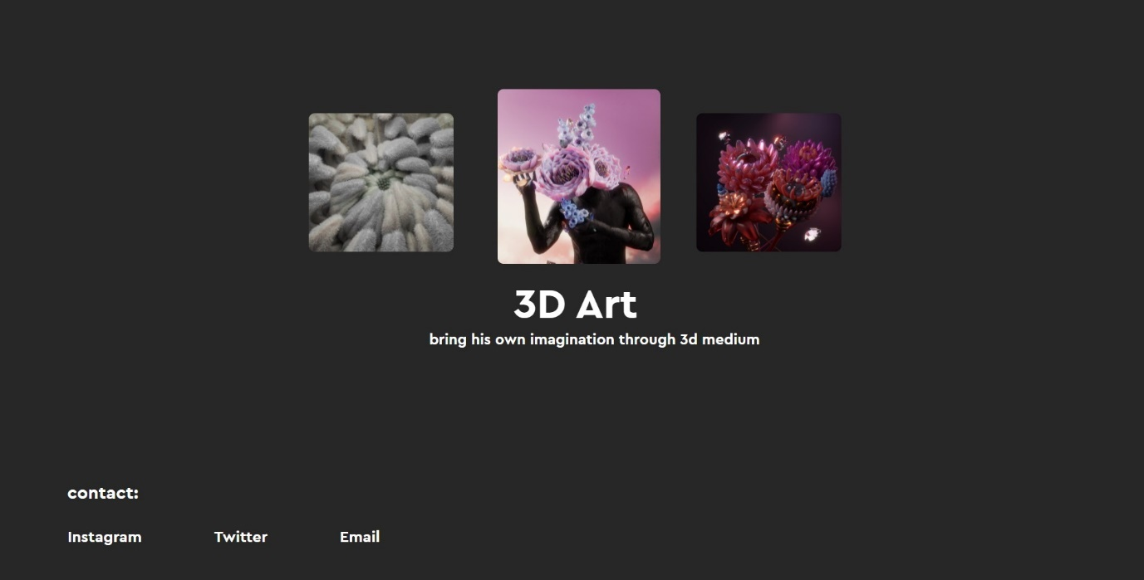

**Nama Halaman:** Bagian Game Julian

**Deskripsi (fungsi halaman):** Transisi Game Menuju Portofolio Julian (Buat Fun).

**Cara menggunakan dan masuk ke halaman tersebut:** Pada bagian ini, akan menampilkan game tic tac toe yang dapat dimainkan oleh 2 orang. Didalamnya terdapat score untuk pemain x dan o, pemberitahuan giliran main, dan papan bermain untuk tic tac toe. Setiap kotak pada papan bermain dapat diisi dengan x atau o sesuai dengan gilirannya. Jika hasil permainannya seri maka akan diminta restart permainannya. Sedangkan jika ada 1 pemain yang menang maka aka nada tompol untuk masuk ke halaman portofolio.

**Screenshot :**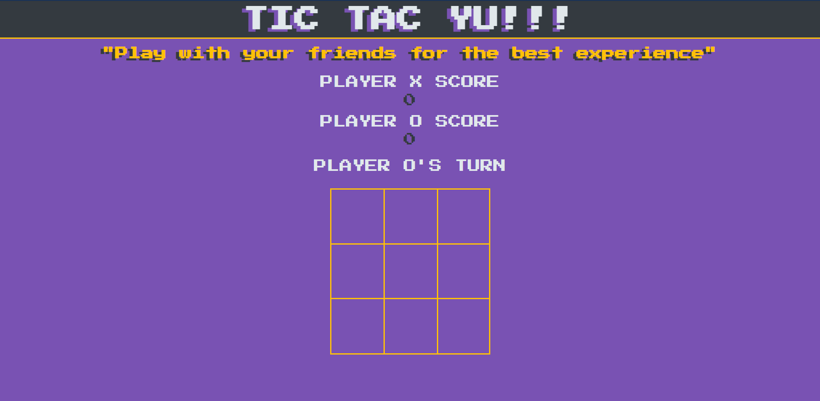

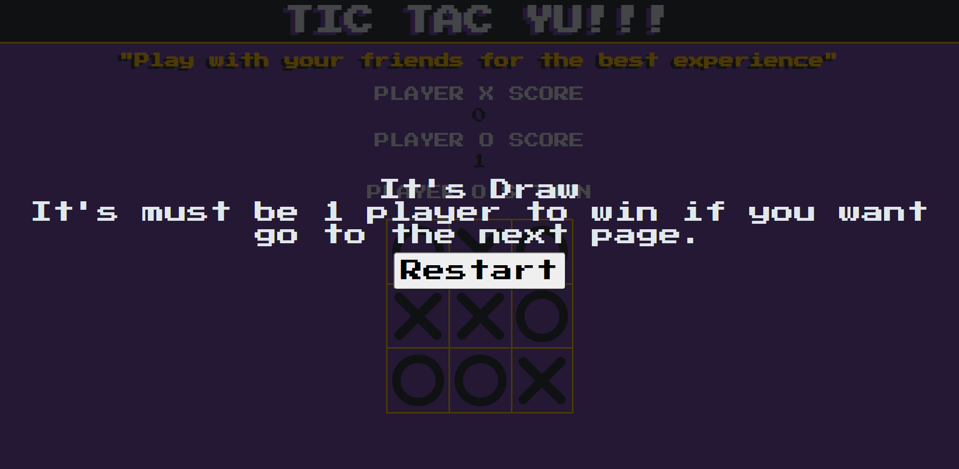

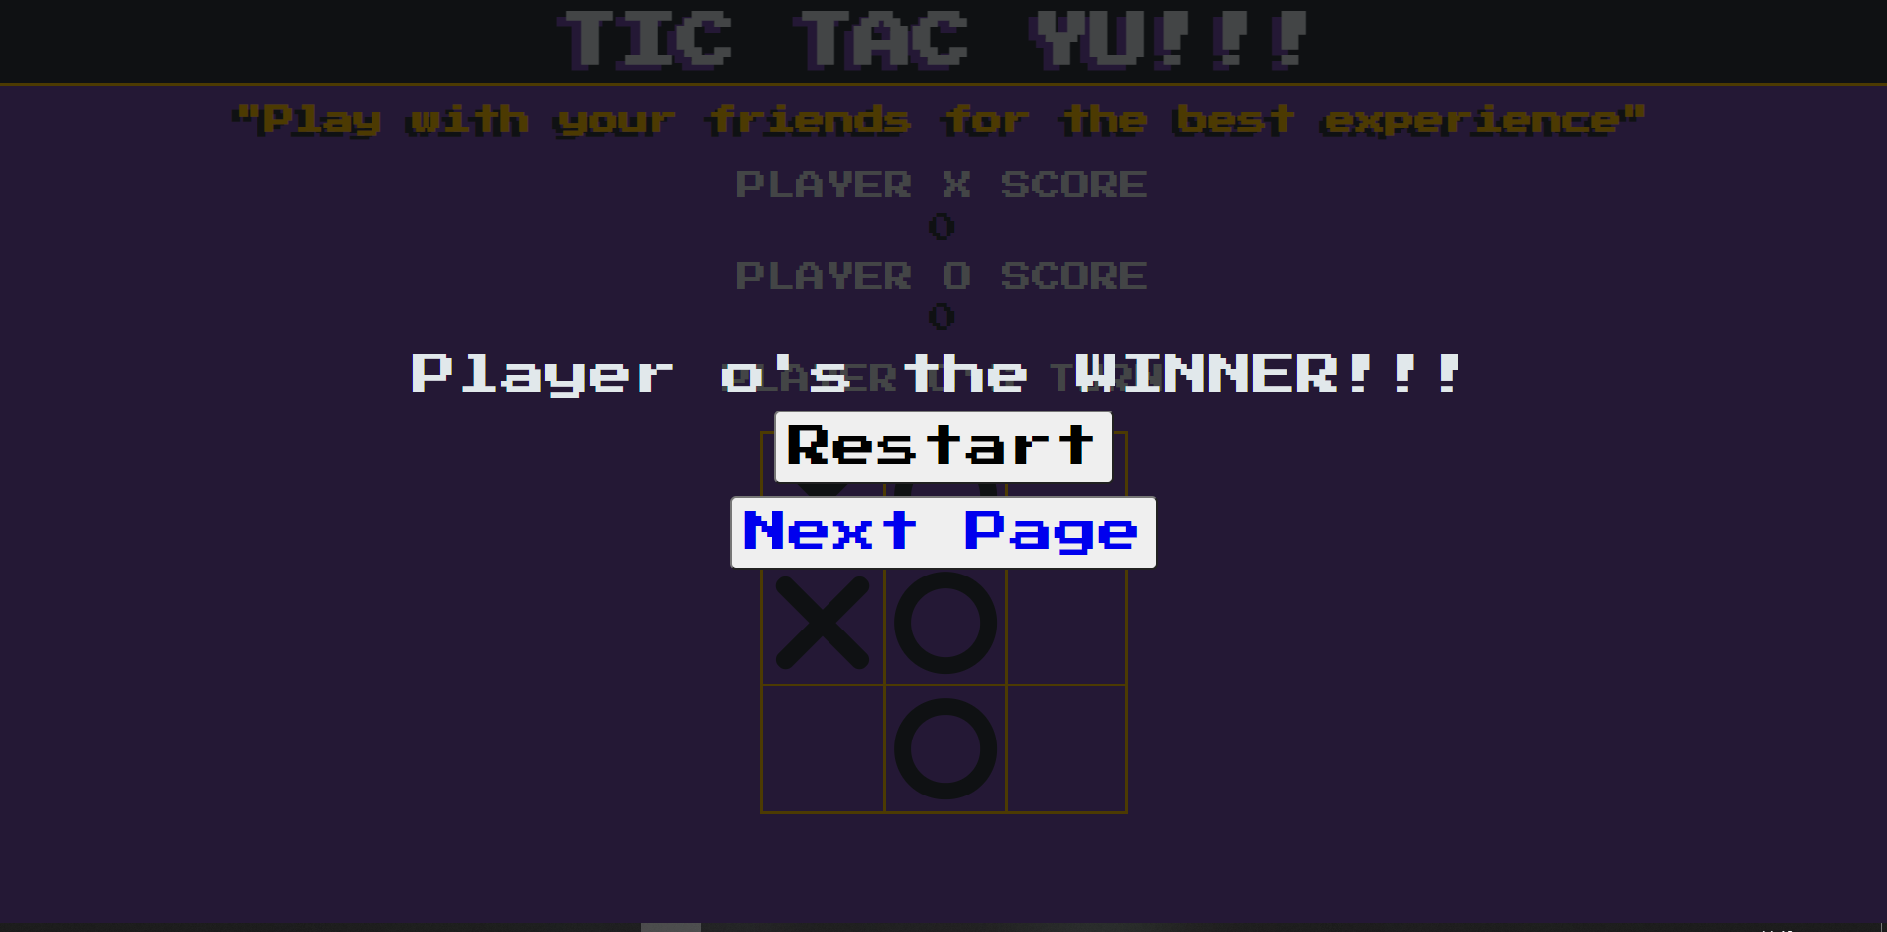

**Nama Halaman:** Bagian Home Portfolio Julian

**Deskripsi (fungsi halaman):** Halaman Saat Pertama kali muncul.

**Cara menggunakan dan masuk ke halaman tersebut:** Pada bagian ini, akan memunculkan gambar beserta pengenalan mengenai developernya. Selain itu ada tombol contact me yang jika diklik akan hover ke bagian contact dibawah dan juga ada tanda bulat di samping kanan sebanyak 3, tanda ini adalah navbar yang dibuat di sebelah kanan, pada masing masing tombol secara berurutan akan menandakan home, about me, dan contact.

**Screenshot :**

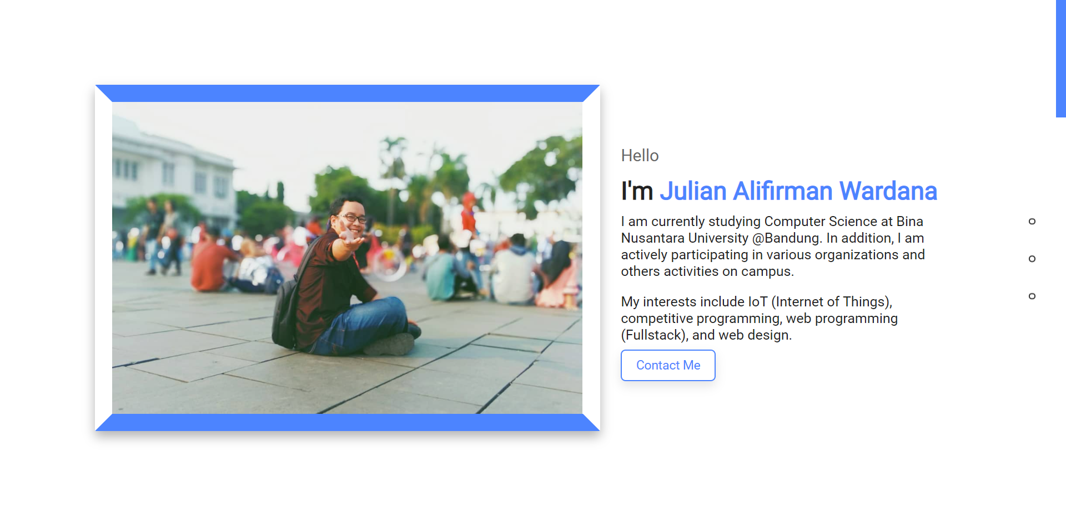

**Nama Halaman:** About Me Portfolio Julian

**Deskripsi (fungsi halaman):** Pada bagian ini akan menampilkan sekilas mengenai developernya dilihat dari coding skills, language skills, education, dan experiencenya.

**Cara menggunakan dan masuk ke halaman tersebut:** Langsung scroll/click pada navbar

**Screenshot :**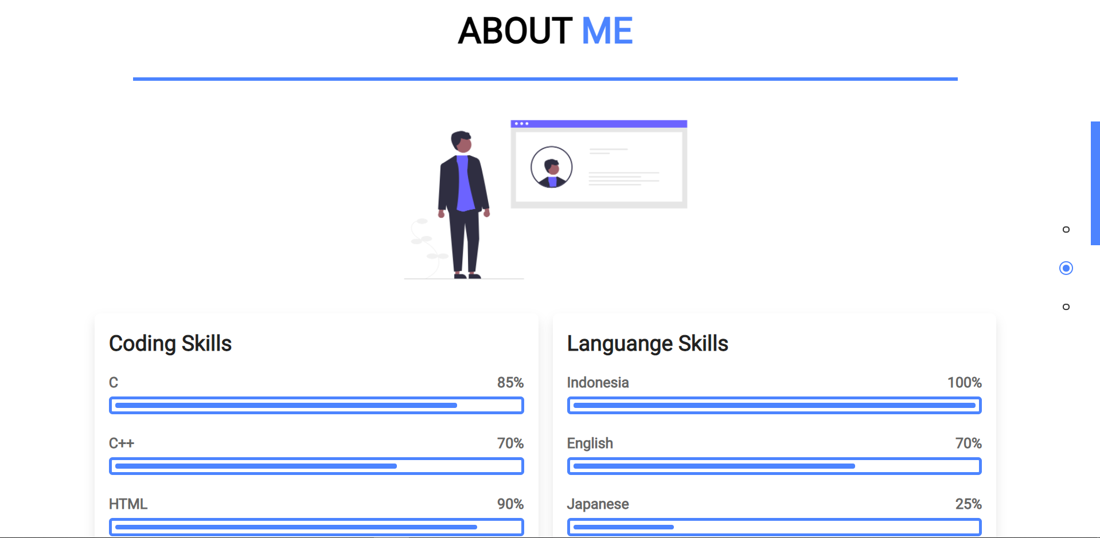

**Nama Halaman:** My Contact Portfolio Julian

**Deskripsi (fungsi halaman):** Pada bagian ini, akan menampilkan no.Telp, email, Alamat, dan juga lokasi developernya menggunakan iframe google maps embedded. Pada bagian lokasi dapat di zoom in, zoom out, dan digeser.

**Cara menggunakan dan masuk ke halaman tersebut**: Langsung scroll

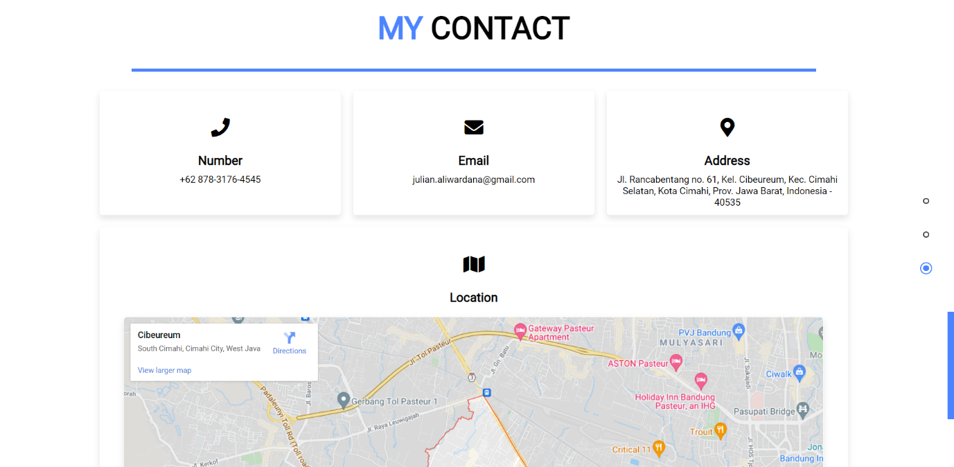**Screenshot :**

## Kode Desain Web

*Masukkan kode desain web (HTML, CSS, Javascript, dst) ke dalam box di bawah ini.*

path file : ./

|  |
| --- |
| **Halaman Utama HTML**  path file : ./index.html  <!DOCTYPE html>  <html lang="en">  <head>      <meta charset="UTF-8">      <meta http-equiv="X-UA-Compatible" content="IE=edge">      <meta name="viewport" content="width=device-width, initial-scale=1.0">      <!-- Icon Title -->      <link rel="icon" href="image/icon.PNG">      <!-- Local CSS -->      <link rel="stylesheet" href="style.css">      <!-- Fontawesome -->      <link href='https://cdnjs.cloudflare.com/ajax/libs/font-awesome/5.15.3/css/all.min.css' rel='stylesheet'>      <!-- JQuery -->      <script src="https://code.jquery.com/jquery-3.6.0.min.js"          integrity="sha256-/xUj+3OJU5yExlq6GSYGSHk7tPXikynS7ogEvDej/m4=" crossorigin="anonymous">          </script>      <!-- Typed JS -->      <script src="https://cdnjs.cloudflare.com/ajax/libs/typed.js/2.0.12/typed.min.js"      integrity="sha512-3J8teBiHrSyaaRBajZyIEtpDsXdPq1gsznKWIVb5CnorQuFhjWGhWe54z8YNnHHr7MZuExb9m5kvf964HiT1Sw=="      crossorigin="anonymous" referrerpolicy="no-referrer"></script>      <title>Nevisco</title>  </head>  <body>      <!-- Navbar -->      <div class="nav">          <div class="max-width">              <div class="logo"><a href="#">Nevis<span>co.</span></a></div>              <ul class="menu">                  <li><a href="#home" class="point">Home</a></li>                  <li><a href="#teams" class="point">Teams</a></li>                  <li><a href="#contact" class="point">Contact</a></li>              </ul>          </div>      </div>      <!-- Home -->      <div class="home" id="home">          <div class="max-width">              <div class="home-content">                  <div class="col text">                      <div class="text-1"> <span class="greet"></span></div>                      <div class="text-2"> We create website, apps, with experiences people and we crafted in house by                          tightly integrated team of designer and web deverlopers.</div>                  </div>                  <div class="col image">                      <img src="image/image_transparant.png" alt="">                  </div>              </div>          </div>      </div>      <!-- Teams -->      <div class="content" id="teams">          <div class="max-width">              <div class="heading">Our <span>Team</span></div>              <hr>              <div class="member">                  <a href="fajar/games.html">                      <div class="member_card" id="fajar">                          <div class="image">                              <img src="image/fajar.png" alt="">                          </div>                          <div class="info">                              <h3 class="name">Fajar Muhammad Hamka</h3>                              <p class="quotes">- 2440113616 -</p>                              <p class="quotes">"Problems won't be a problem as long as no one makes a fuss about it."</p>                          </div>                      </div>                  </a>                  <a href="rahmat/flappy-bird.html">                      <div class="member_card" id="rahmat">                          <div class="info">                              <h3 class="name">Rahmat Syifana Jaelani</h3>                              <p class="quotes">- 2440113585 -</p>                              <p class="quotes">"With great power comes great responsibility."</p>                          </div>                          <div class="image">                              <img src="image/rahmat.png" alt="">                          </div>                      </div>                  </a>                  <a href="reyhan/websiteprac.html">                      <div class="member_card" id="reyhan">                          <div class="image">                              <img src="image/reyhan.png" alt="">                          </div>                          <div class="info">                              <h3 class="name">Reyhan Willy Tanuwijaya</h3>                              <p class="quotes">- 2440082522 -</p>                              <p class="quotes">"An investment in knowledge pays the best interest"</p>                          </div>                      </div>                  </a>                  <a href="julian/game.html">                      <div class="member_card" id="julian">                          <div class="info">                              <h3 class="name">Julian Alifirman Wardana</h3>                              <p class="quotes">- 2440065264 -</p>                              <p class="quotes">"Giving a strong impact to others around us."</p>                          </div>                          <div class="image">                              <img src="image/julian.png" alt="">                          </div>                      </div>                  </a>              </div>          </div>      </div>      </div>      <hr>      <!-- Contact -->      <div class="contact" id="contact">          <div class="max-width">              <div class="title">Interest with us ?</div>              <div class="contact-content">                  <div class="col left">                      <div class="top">Contact Us</div>                      <div class="icons">                          <div class="row-contact">                              <i class="fas fa-user-alt"></i>                              <div class="info-contact">                                  <div class="header">Company Name</div>                                  <div class="details">Nevisco Company IT.</div>                              </div>                          </div>                          <div class="row-contact">                              <i class="fas fa-map-marker-alt" id="address"></i>                              <div class="info-contact">                                  <div class="header">Address</div>                                  <div class="details">Wangsakerta Street</div>                              </div>                          </div>                          <div class="row-contact">                              <i class="fas fa-envelope"></i>                              <div class="info-contact">                                  <div class="header">Email</div>                                  <div class="details">Nevisco@gmail.com</div>                              </div>                          </div>                          <div class="row-contact">                              <i class="fas fa-phone"></i>                              <div class="info-contact">                                  <div class="header">Phone</div>                                  <div class="details">+62214015367</div>                              </div>                          </div>                      </div>                  </div>                  <div class="col right">                      <div class="top">Send an email</div>                      <form action="#">                          <div class="fields">                              <div class="field name">                                  <input type="text" placeholder="Name">                              </div>                              <div class="field email">                                  <input type="email" placeholder="Email">                              </div>                              <div class="field subject">                                  <input type="text" placeholder="Subject">                              </div>                              <div class="field contents">                                  <textarea name="contents" id="massage" cols="30" rows="10"                                      placeholder="Contents"></textarea>                              </div>                              <div class="send">                                  <button type="submit">Send</button>                              </div>                          </div>                      </form>                  </div>              </div>          </div>      </div>      <!-- Footer -->      <footer>          <div class="max-width">              <a>                  <div class="logo-footer">Nevisco</div>              </a>              <div class="about-us">                  <h1>ABOUT US</h1>                  <p id="about-us-footer">We create website, apps, with experiences people and we crafted in house by                      tightly integrated team of designer and Web Deverlopers</p>              </div>              <div class="sosmed">                  <i class="fab fa-facebook-f"></i>                  <i class="fab fa-twitter"></i>                  <i class="fab fa-instagram"></i>              </div>          </div>      </footer>      <!-- Local Javascripts -->      <script src="script.js"></script>  </body>  </html> |

|  |
| --- |
| **Halaman Utama CSS**  **path file : ./style.css**  * {      padding: 0;      margin: 0;  }  body {      background: url(img/city.png);      background-size: 105%;  }  #game {      width: 500px;      height: 500px;      border: 1px solid black;      margin: auto;      margin-top: 10px;      overflow: hidden;      background-color: #0099CC;  }  #point-display, #info {      padding-top: 10px;      width: 500px;      margin: auto;      font-size: 19px;  }  #block {      width: 50px;      height: 500px;      background-color: lightgreen;      position: relative;      left: 500px;      animation: block 2.5s infinite linear;      border: 1px solid black;  }  #game-name {      width: 105px;      padding-top: 10px;      margin: auto;  }  @keyframes block {      0%{left:500px}      100%{left:-50px}  }  #hole {      width: 52px;      height: 150px;      background-color: #0099CC;      position: relative;      top: -200px;      left: 500px;      animation: block 2.5s infinite linear;      border-top: 1px solid black;      border-bottom: 1px solid black;      /* opacity: 0.7; */  }  #bird {      width: 40px;      height: 28px;      /* background-color: orange; */      position: relative;      top: -400px;      left: 20px;      /* border-radius: 50%; */      background-image: url(img/flappy.png);      background-size: cover;  } |

|  |
| --- |
| **Halaman Utama JavaScript**  **path file : ./script.css**  $(document).ready( () => {      $(window).scroll( () => {          if (this.scrollY > 12) {              $('.nav').addClass('stick');          } else {              $('.nav').removeClass('stick');          }      });      var scroll_link = $('.point');      scroll_link.click(function(e){          e.preventDefault();          $('body,html').animate({              scrollTop: $(this.hash).offset().top          }, 1000);      });      let typing = new Typed('.greet', {          strings: ['Hello', 'Bonjour', 'Hallo', 'Ni Hao', 'Konnichiwa', 'Privet'],          typeSpeed: 90,          backSpeed: 50,          loop: true      });  }); |

|  |
| --- |
| **Halaman Games Fajar : fajar/games.html**  <!DOCTYPE html>  <html lang="en">  <head>      <meta charset="UTF-8">      <meta http-equiv="X-UA-Compatible" content="IE=edge">      <meta name="viewport" content="width=device-width, initial-scale=1.0">      <title>Dinosaur Games</title>      <link rel="stylesheet" href="assets/css/style_games.css">  </head>  <body>      <h1 id="title">DINOSAUR JAR GAMES.</h1>      <div id="game">          <div id="dinosaur"></div>          <div id="batu"></div>      </div>      <h3>Play it until get score 80, and you can see the portofolio.</h3>      <h1 id="score">0</h1>      <script src="assets/js/script_games.js"></script>    </body>  </html> |

|  |
| --- |
| **JavaScript Games Fajar : ./fajar/assets/js/script_games.js**  const dino = document.getElementById('dinosaur');  const batu = document.getElementById('batu');  const score = document.getElementById('score');  function jump() {      dino.classList.add('jump_animate');      setTimeout(function() {          dino.classList.remove('jump_animate');      }, 523);  }  document.addEventListener('keypress', function() {      if (!dino.classList.contains('jump_animate')) {          jump();      }      jump();  });  setInterval(function () {      if(score.innerText >= 80) {          window.location.href = 'fajar_portofolio.html';      }      score.innerText++;      const top_dino = parseInt(window.getComputedStyle(dino).getPropertyValue('top'));      // console.log(top_dino);      const rock_position = parseInt(window.getComputedStyle(batu).getPropertyValue('left'));      // console.log(rock_position);      if (rock_position < 0) {          batu.style.display = 'none';      } else {          batu.style.display = '';      }      if(rock_position < 50 && rock_position > 0 && top_dino > 150) {          alert(              "Game Over\n" +              "Score : " +              score.innerText +              "\nPlease Try Again.");          score.innerText = 0;      }    }, 50); |

|  |
| --- |
| **CSS Games Fajar : ./fajar/assets/css/style_games.css**  body {      background-color: rgb(78, 239, 245);  }  #score {      text-align: center;  }  #game {      margin-top: 100px;      height: 300px;      width: 600px;      margin: auto;      border: 2px solid rgb(0, 0, 0);      background-image: url('../img/background.jpg');      background-size: cover;  }  #dinosaur {      background-image: url('../img/dino.png');      background-size: cover;      height: 75px;      width: 75px;      position: relative;      top: 225px;  }  #batu {      background-image: url('../img/rock.png');      background-size: cover;      height: 50px;      width: 50px;      position: relative;      top: 175px;      left: 550px;      animation: batu 1.4s infinite;  }  @keyframes batu {      0% {          left: 550px;      }      100% {          left: -50px;      }  }  .jump_animate {      animation: jump 0.5s;  }  @keyframes jump {      0% {          top: 225px;      }      50% {          top: 75px;      }      75% {          top: 75px;      }      100% {          top: 225px;      }  }  #title {      text-align: center;  }    h3 {      text-align: center;  } |

|  |
| --- |
| **HTML Portofolio Fajar : ./fajar/fajar_portofolio.html**  <!DOCTYPE html>  <html lang="en">  <head>      <meta charset="UTF-8">      <meta http-equiv="X-UA-Compatible" content="IE=edge">      <meta name="viewport" content="width=device-width, initial-scale=1.0">      <title>Fajar Portofolio</title>      <link rel="stylesheet" href="assets/css/style.css">      <link rel="stylesheet" href="https://unicons.iconscout.com/release/v4.0.0/css/line.css">  </head>  <body>      <header class="header" id="header">          <nav class="nav container">              <a href="#" class="nav_logo">Fajar</a>              <div class="nav_menu" id="nav-menu">                  <ul class="nav_list grid">                      <li class="nav_item">                          <a href="#home" class="nav_link">                              <i class="uil uil-home nav_icon"></i>Home                          </a>                      </li>                      <li class="nav_item">                          <a href="#about" class="nav_link">                              <i class="uil uil-user nav_icon"></i> About Me                          </a>                      </li>                      <li class="nav_item">                          <a href="#skills" class="nav_link">                              <i class="uil uil-file-info-alt nav_icon"></i> Skills                          </a>                      </li>                      <li class="nav_item">                          <a href="#services" class="nav_link">                              <i class="uil uil-briefcase-alt nav_icon"></i> Services                          </a>                      </li>                        <li class="nav_item">                          <a href="#portfolio" class="nav_link">                              <i class="uil uil-scenery nav_icon"></i> Portfolio                          </a>                      </li>                      <li class="nav_item">                          <a href="#message" class="nav_link">                              <i class="uil uil-message nav_icon"></i> Contact Me                          </a>                      </li>                  </ul>                  <i class="uil uil-times nav_close" id="nav-close"></i>              </div>              <div class="nav_btn">                  <div class="nav_toogle" id="nav-toogle">                      <i class="uil uil-apps"></i>                  </div>              </div>          </nav>      </header>      <main class="main">          <section class="home section" id="home">              <div class="home_container container grid">                  <div class="home_content grid">                      <div class="home_social">                          <a href="https://www.linkedin.com/in/fajar-muhammad-hamka-5882b7201/" target="_blank" class="home_social-icon">                              <i class="uil uil-linkedin-alt"></i>                          </a>                          <a href="https://www.instagram.com/fajarmh_/" target="_blank" class="home_social-icon">                              <i class="uil uil-instagram"></i>                          </a>                          <a href="https://github.com/fajartd02" target="_blank" class="home_social-icon">                              <i class="uil uil-github-alt"></i>                          </a>                      </div>                      <div class="home_img">                          <svg class="home_blob" viewBox="0 0 200 200" xmlns="http://www.w3.org/2000/svg">                              <mask id = "mask0" mask-type="alpha">                                  <path fill="#FF0066" d="M61.4,-61.4C77.7,-45,87.8,-22.5,88.2,0.4C88.6,23.4,79.4,46.7,63.1,61.6C46.7,76.5,23.4,82.9,0.4,82.6C-22.6,82.2,-45.3,75.1,-61.8,60.2C-78.4,45.3,-88.8,22.6,-88.1,0.7C-87.4,-21.2,-75.5,-42.4,-58.9,-58.7C-42.4,-75.1,-21.2,-86.7,0.7,-87.4C22.5,-88.1,45,-77.8,61.4,-61.4Z" transform="translate(100 100)" />                              </mask>                              <g mask="url(#mask0)">                                  <path fill="#FF0066" d="M61.4,-61.4C77.7,-45,87.8,-22.5,88.2,0.4C88.6,23.4,79.4,46.7,63.1,61.6C46.7,76.5,23.4,82.9,0.4,82.6C-22.6,82.2,-45.3,75.1,-61.8,60.2C-78.4,45.3,-88.8,22.6,-88.1,0.7C-87.4,-21.2,-75.5,-42.4,-58.9,-58.7C-42.4,-75.1,-21.2,-86.7,0.7,-87.4C22.5,-88.1,45,-77.8,61.4,-61.4Z" transform="translate(100 100)" />                                    <image class = "home_blob-img" x='14' y='-30' xlink:href="assets/img/fajar.jpg"/>                              </g>                            </svg>                      </div>                  </div>                  <div class="home_data">                      <h1 class="home_title">Hi, I'm Fajar Muhammad Hamka</h1>                      <h3>IT Enthusiast</h3>                      <p class="home_description">                          I'm Currently Study at Bina Nusantara University and My Dream is Go To Silicon Valley                      </p>                      <a href="#contact" class="button button--flex">                          Contact Me <i class="uil uil-message button_icon"></i>                      </a>                  </div>                  <div class="home_scroll">                      <a href="#about" class="home_scroll-button button--flex">                          <i class="uil uil-mouse-alt home_scroll-mouse">                          </i>                          <span class="home_scroll-name">Scroll down</span>                          <i class="uil uil-arrow-down home_scroll-arrow"></i>                      </a>                  </div>              </div>          </section>          <!-- About -->          <section class="about" id="about">              <h2 class="section_title">About Me</h2>              <span class="section_subtitle">My Introduction</span>              <div class="abuot_container container grid">                  <img src="assets/img/fajar.jpg" alt="Fajar Photos" class="about_img">                  <div class="about_data">                      <p class="about_description">                          IT Enthusiast That Want to be a good programmer and can be work in silicon valley and make start up that can be compete with Elon Musk.                      </p>                      <div class="about_info">                          <div>                              <span class="about_info-title">10+</span>                              <span class="about_info-name">Volunteer <br> Projects</span>                          </div>                          <div>                              <span class="about_info-title">3.93</span>                              <span class="about_info-name">Currently <br> IPK</span>                          </div>                          <div>                              <span class="about_info-title">8+</span>                              <span class="about_info-name">Programming <br> Language</span>                          </div>                      </div>                      <div class="about_buttons">                          <a download ="#" href="#" class="button button--flex">                              Download CV <i class="uil uil-download-alt button_icon"></i>                          </a>                      </div>                  </div>              </div>          </section>          <!-- Skills -->          <section class="skills section" id="skills">              <h2 class="section_title">Skills</h2>              <span class="section_subtitle">My technical level</span>              <div class="skills_container container grid">                  <div>                      <!-- Skills 1 -->                      <div class="skills_content skills_open">                          <div class="skills_header">                              <i class="uil uil-brackets-curly skills_icon"></i>                              <div>                                  <h1 class="skills_titles">Competitive Programming</h1>                                  <span class="skills_subtitle">More than 5 competitions</span>                              </div>                              <i class="uil uil-angle-down skills_arrow"></i>                          </div>                          <div class="skills_list grid">                              <div class="skills_data">                                  <div class="skills_titles">                                      <h3 class="skills_name">C</h3>                                      <span class="skils_number">90%</span>                                  </div>                                  <div class="skills_bar">                                      <span class="skills_percentage skills_c"></span>                                  </div>                              </div>                              <div class="skills_data">                                  <div class="skills_titles">                                      <h3 class="skills_name">C++</h3>                                      <span class="skils_number">88%</span>                                  </div>                                  <div class="skills_bar">                                      <span class="skills_percentage skills_cpp"></span>                                  </div>                              </div>                              <div class="skills_data">                                  <div class="skills_titles">                                      <h3 class="skills_name">JavaScript</h3>                                      <span class="skils_number">85%</span>                                  </div>                                  <div class="skills_bar">                                      <span class="skills_percentage skills_js"></span>                                  </div>                              </div>                                  <div class="skills_data">                                  <div class="skills_titles">                                      <h3 class="skills_name">Python</h3>                                      <span class="skils_number">84%</span>                                  </div>                                  <div class="skills_bar">                                      <span class="skills_percentage skills_python"></span>                                  </div>                              </div>                          </div>                      </div>                      <!-- Skills 2 -->                      <div class="skills_content skills_close">                          <div class="skills_header">                              <i class="uil uil-server-network skills_icon"></i>                              <div>                                  <h1 class="skills_titles">Frontend Developer</h1>                                  <span class="skills_subtitle">More than 6 Months</span>                              </div>                              <i class="uil uil-angle-down skills_arrow"></i>                          </div>                          <div class="skills_list grid">                              <div class="skills_data">                                  <div class="skills_titles">                                      <h3 class="skills_name">HTML</h3>                                      <span class="skils_number">95%</span>                                  </div>                                  <div class="skills_bar">                                      <span class="skills_percentage skills_html"></span>                                  </div>                              </div>                              <div class="skills_data">                                  <div class="skills_titles">                                      <h3 class="skills_name">CSS</h3>                                      <span class="skils_number">90%</span>                                  </div>                                  <div class="skills_bar">                                      <span class="skills_percentage skills_css"></span>                                  </div>                              </div>                              <div class="skills_data">                                  <div class="skills_titles">                                      <h3 class="skills_name">JavaScript</h3>                                      <span class="skils_number">85%</span>                                  </div>                                  <div class="skills_bar">                                      <span class="skills_percentage skills_js2"></span>                                  </div>                              </div>                                  <div class="skills_data">                                  <div class="skills_titles">                                      <h3 class="skills_name">React</h3>                                      <span class="skils_number">70%</span>                                  </div>                                  <div class="skills_bar">                                      <span class="skills_percentage skills_react"></span>                                  </div>                              </div>                          </div>                      </div>                  </div>                  <div>                       <!-- Skills 3 -->                       <div class="skills_content skills_close">                          <div class="skills_header">                              <i class="uil uil-swatchbook skills_icon"></i>                              <div>                                  <h1 class="skills_titles">Backend Developer</h1>                                  <span class="skills_subtitle">More than 3 Months</span>                              </div>                              <i class="uil uil-angle-down skills_arrow"></i>                          </div>                          <div class="skills_list grid">                              <div class="skills_data">                                  <div class="skills_titles">                                      <h3 class="skills_name">Laravel</h3>                                      <span class="skils_number">80%</span>                                  </div>                                  <div class="skills_bar">                                      <span class="skills_percentage skills_laravel"></span>                                  </div>                              </div>                              <div class="skills_data">                                  <div class="skills_titles">                                      <h3 class="skills_name">PHP</h3>                                      <span class="skils_number">80%</span>                                  </div>                                  <div class="skills_bar">                                      <span class="skills_percentage skills_php"></span>                                  </div>                              </div>                              <div class="skills_data">                                  <div class="skills_titles">                                      <h3 class="skills_name">Node JS</h3>                                      <span class="skils_number">70%</span>                                  </div>                                  <div class="skills_bar">                                      <span class="skills_percentage skills_nodejs"></span>                                  </div>                              </div>                                  <div class="skills_data">                                  <div class="skills_titles">                                      <h3 class="skills_name">Firebase</h3>                                      <span class="skils_number">40%</span>                                  </div>                                  <div class="skills_bar">                                      <span class="skills_percentage skills_firebase"></span>                                  </div>                              </div>                          </div>                      </div>                  </div>              </div>          </section>          <!-- qualification -->          <section class="qualification section">              <h2 class="section_title">Qualification</h2>              <span class="section_subtitle">My Personal Journey</span>              <div class="qualification__container container">                  <div class="qualification_tabs">                      <div class="qualification_button button--flex qualification_active" data-target='#education'>                          <i class="uil uil-graduation-cap qualification_icon"></i> Education                      </div>                      <div class="qualification_button button--flex" data-target="#work">                          <i class="uil uil-briefcase-alt qualification_icon"></i>                          Work                      </div>                  </div>                  <div class="qualification_sections">                      <!-- Qualification Content 1 -->                      <div class="qualification_content qualification_active" data-content id ="education">                          <!-- Qualification 1 -->                          <div class="qualification_data">                              <div>                                  <h3 class="qualification_title">Computer Science</h3>                                  <span class="qualification_subtitle">Bina Nusantara University</span>                                  <div class="qualification_calendar">                                      <i class="uil uil-calendar-alt"></i> 2020 - 2024                                  </div>                              </div>                              <div>                                  <span class="qualification_rounder"></span>                                  <span class="qualification_line"></span>                              </div>                          </div>                            <!-- Qualification 2 -->                            <div class="qualification_data">                              <div></div>                                <div>                                  <span class="qualification_rounder"></span>                                  <span class="qualification_line"></span>                              </div>                              <div>                                  <h3 class="qualification_title">Staff Community</h3>                                  <span class="qualification_subtitle">HIMTI Binus @Bandung</span>                                  <div class="qualification_calendar">                                      <i class="uil uil-calendar-alt"></i> 2020 - 2021                                  </div>                              </div>                          </div>                            <!-- Qualification 3 -->                            <div class="qualification_data">                              <div>                                  <h3 class="qualification_title">Head of Relation Division</h3>                                  <span class="qualification_subtitle">BNCC Binus @Bandung</span>                                  <div class="qualification_calendar">                                      <i class="uil uil-calendar-alt"></i> 2020 - 2021                                  </div>                              </div>                              <div>                                  <span class="qualification_rounder"></span>                                  <span class="qualification_line"></span>                              </div>                          </div>                            <!-- Qualification 4 -->                            <div class="qualification_data">                                <div></div>                              <div>                                  <span class="qualification_rounder"></span>                                  <!-- <span class="qualification_line"></span> -->                              </div>                              <div>                                  <h3 class="qualification_title">Science Students</h3>                                  <span class="qualification_subtitle">SMA Negeri 1 Cisarua</span>                                  <div class="qualification_calendar">                                      <i class="uil uil-calendar-alt"></i> 2017 - 2020                                  </div>                              </div>                          </div>                      </div>                       <!-- Qualification Content 2 -->                       <div class="qualification_content" data-content id="work">                          <!-- Qualification 1 -->                          <div class="qualification_data">                              <div>                                  <h3 class="qualification_title">Mobile App Development</h3>                                  <span class="qualification_subtitle">Bina Nusantara University</span>                                  <div class="qualification_calendar">                                      <i class="uil uil-calendar-alt"></i> 2022 - 2023                                  </div>                              </div>                              <div>                                  <span class="qualification_rounder"></span>                                  <span class="qualification_line"></span>                              </div>                          </div>                            <!-- Qualification 2 -->                            <div class="qualification_data">                              <div></div>                                <div>                                  <span class="qualification_rounder"></span>                                  <span class="qualification_line"></span>                              </div>                              <div>                                  <h3 class="qualification_title">Staff Research and Development</h3>                                  <span class="qualification_subtitle">HIMTI Binus @Bandung</span>                                  <div class="qualification_calendar">                                      <i class="uil uil-calendar-alt"></i> 2021 - 2022                                  </div>                              </div>                          </div>                            <!-- Qualification 3 -->                            <div class="qualification_data">                              <div>                                  <h3 class="qualification_title">Chairman</h3>                                  <span class="qualification_subtitle">BNCC Binus @Bandung</span>                                  <div class="qualification_calendar">                                      <i class="uil uil-calendar-alt"></i> 2021 - 2022                                  </div>                              </div>                              <div>                                  <span class="qualification_rounder"></span>                                  <!-- <span class="qualification_line"></span> -->                              </div>                          </div>                      </div>                  </div>              </div>          </section>          <!-- Services -->          <!-- BELUM Punya (Belom Freelance) -->          <!-- Portfolio -->          <!-- Belom ada -->          <!-- Project in Mind -->          <section class="project section">              <div class="project_bg">                  <div class="project_container container grid">                      <div class="project_data">                          <h2 class="project_title">You have a new project</h2>                          <p class="project_description">                              Contact me now and let's talk to develop your project.                          </p>                          <a href="#contact" class="button button--flex button--white">                              Contact Me                              <i class="uil uil-message project_icon button_icon"></i>                          </a>                      </div>                      <img src="assets/img/fajar.jpg" alt="fajar photos" class="project_img">                  </div>              </div>          </section>          <!-- Team / Testimonials -->          <section class="team section">              <h2 class="section_title">My Teams</h2>              <span class="section_subtitle">Nevisco.</span>              <div class="team_container container">                  <div>                       <!-- Team 1 -->                       <div class="team_content">                           <div class="team_data">                               <div class="team_header">                                   <img src="assets/img/rahmat.png" alt="Rahmat photos" class="team_img">                                   <div>                                      <h3 class="team_name">Rahmat Syifana Jaelani</h3>                                      <span class="team_client">Member</span>                                  </div>                               </div>                               <div>                                  <i class="uil uil-fire team_icon-star"></i>                                  <i class="uil uil-fire team_icon-star"></i>                                  <i class="uil uil-fire team_icon-star"></i>                                  <i class="uil uil-fire team_icon-star"></i>                                  <i class="uil uil-fire team_icon-star"></i>                               </div>                           </div>                           <p class="team_description">"With great power comes great responsibility."</p>                       </div>                       <!-- Team 2 -->                       <div class="team_content">                          <div class="team_data">                              <div class="team_header">                                  <img src="assets/img/reyhan.png" alt="Rayhan photos" class="team_img">                                  <div>                                     <h3 class="team_name">Reyhan Willy Tanuwijaya</h3>                                     <span class="team_client">Member</span>                                 </div>                              </div>                              <div>                                 <i class="uil uil-fire team_icon-star"></i>                                 <i class="uil uil-fire team_icon-star"></i>                                 <i class="uil uil-fire team_icon-star"></i>                                 <i class="uil uil-fire team_icon-star"></i>                                 <i class="uil uil-fire team_icon-star"></i>                              </div>                          </div>                          <p class="team_description">"An investment in knowledge pays the best interest"</p>                      </div>                      <!-- Team 3 -->                      <div class="team_content">                          <div class="team_data">                              <div class="team_header">                                  <img src="assets/img/julian.png" alt="Julian photos" class="team_img">                                  <div>                                     <h3 class="team_name">Julian Alifirman Wardana</h3>                                     <span class="team_client">Member</span>                                 </div>                              </div>                              <div>                                 <i class="uil uil-fire team_icon-star"></i>                                 <i class="uil uil-fire team_icon-star"></i>                                 <i class="uil uil-fire team_icon-star"></i>                                 <i class="uil uil-fire team_icon-star"></i>                                 <i class="uil uil-fire team_icon-star"></i>                              </div>                          </div>                          <p class="team_description">"Giving a strong impact to others around us."</p>                      </div>                  </div>              </div>          </section>          <!-- Contact Me -->          <section class="contact section" id="contact" >              <h2 class="section_title">Contact Me</h2>              <span class="section_subtitle">Get in touch</span>              <div class="contact_container container grid">                  <div>                      <div class="contact_information">                          <i class="uil uil-phone contact_icon"></i>                          <div>                              <h3 class="contact_title">                                  Call Me                              </h3>                              <span class="contact_subtitle">                                  0821-1436-5818                              </span>                          </div>                      </div>                      <div class="contact_information">                          <i class="uil uil-envelope contact_icon"></i>                          <div>                              <h3 class="contact_title">                                  Email                              </h3>                              <span class="contact_subtitle">                                  fajarmh2@gmail.com                              </span>                          </div>                      </div>                      <div class="contact_information">                          <i class="uil uil-map-marker contact_icon"></i>                          <div>                              <h3 class="contact_title">                                  Location                              </h3>                              <span class="contact_subtitle">                                  Bandung - Indonesia                              </span>                          </div>                      </div>                  </div>                  <form action="" class="contact_form grid">                     <div class="contact_inputs grid">                         <div class="contact_content">                             <label for="" class="contact_label">Name</label>                             <input type="text" class="contact_input">                         </div>                         <div class="contact_content">                             <label for="" class="contact_label">Email</label>                             <input type="email" class="contact_input">                         </div>                     </div>                     <div class="contact_content">                      <label for="" class="contact_label">Project</label>                      <input type="text" class="contact_input">                  </div>                  <div class="contact_content">                      <label for="" class="contact_label">Message</label>                      <textarea name="" id="" cols="0" rows="7" class="contact_input"></textarea>                  </div>                  <div>                      <a href="" class="button button--flex">                          Send Message                          <i class="uil uil-message button_icon"></i>                      </a>                  </div>                  </form>              </div>          </section>      </main>      <!-- Footer -->      <footer class="footer">          <div class="footer_bg">              <div class="footer_container container grid">                  <div>                      <h1 class="footer_title">Fajar M. Hamka</h1>                      <span class="footer_subtitle">IT Enthusiast                      </span>                  </div>                  <ul class="footer_links">                      <li>                          <a href="#services" class="footer_link">Services</a>                      </li>                      <li>                          <a href="#portfolio" class="footer_link">Portfolio</a>                      </li>                      <li>                          <a href="#contact" class="footer_link">Contact Me</a>                      </li>                  </ul>                  <div class="footer_socials">                      <a href="https://www.linkedin.com/in/fajar-muhammad-hamka-5882b7201/" target="_blank" class="footer_social">                          <i class="uil uil-linkedin-alt"></i>                      </a>                      <a href="https://www.instagram.com/fajarmh_/" target="_blank"  class="footer_social">                          <i class="uil uil-instagram"></i>                      </a>                      <a href="https://github.com/fajartd02" target="_blank"  class="footer_social">                          <i class="uil uil-github"></i>                      </a>                  </div>              </div>              <p class="footer_copy">&#169; Fajartd02. All right reserved</p>          </div>      </footer>     <script src="assets/js/script.js"></script>  </body>  </html> |

|  |
| --- |
| **CSS Halaman Portofolio Fajar : ./fajar/assets/css/style.css**  @import url('https://fonts.googleapis.com/css2?family=Poppins:wght@600&display=swap');  :root {      --header_height : 3rem;      /* most color */      --hue_color : 360;      /* colors */      --first_color: hsl(var(--hue_color), 69%, 61%);      --first_color_second : hsl(var(--hue_color), 69%, 61%);      --first_color_alt : hsl(var(--hue_color), 57%, 53%);      --first_color-lighter : hsl(var(--hue_color), 92%, 85%);      --title_color : hsl(var(--hue_color), 8%, 15%);      --text_color : hsl(var(--hue_color), 8%, 45%);      --text_color_light : hsl(var(--hue_color), 8%, 65%);      --input_color: hsl(var(--hue_color), 70%, 96%);      --body_color : hsl(var(--hue_color), 60%, 99%);      --container_color : #fff;      /* font */      --body_font : 'Poppins', sans-serif;      /* sizing */      --big_font_size :2rem ;      --h1_font_size : 1.5rem;      --h3_font_size : 1.25rem;      --normal_font_size: 1.125rem;      --normal_font_size : .938rem;      --small_font_size : .813rem;      --samller_font_size : .75rem;      /* font weight */      --font_medium: 500;      --font_semi_bold : 600;      /* Margin */      /* .25rem = 4px, .5 rem = 8px, .75rem = 12px */      --mb_0_25: .25rem;      --mb_0_5 : .5rem;      --mb_0_75: .75rem;      --mb_1: 1rem;      --mb_1_5: 1.5rem;      --mb_2: 2rem;      --mb_2_5: 2.5rem;      --mb_3: 3rem;      /* z Index */      --z_tooltip : 10;      --z_fixed : 100;      --z_modal: 1000;  }  /* Font size for device LARGE */  @media screen and (min-width: 968px) {      :root {          --big_font_size: 3rem;          --h1_font_size: 2.25rem;          --h2_font_size: 1.5rem;          --h3_font_size: 1.25rem;          --normal_font_size: 1rem;          --small_font_size: .875rem;          --smaller_font_size: .813rem;      }  }  /* base */  * {      box-sizing: border-box;      padding: 0;      margin: 0;  }  html {      scroll-behavior: smooth;  }  body {      margin: 0 0 var(--header_height) 0;      font-family: var(--body_font);      background-color: var(--body_color);      color: var(--text_color);  }  h1,h2,h3,h4 {      color: var(--title_color);      font-weight: var(--font_semi_bold);  }  ul {      list-style: none;  }  a {      text-decoration: none;  }  img {      max-width: 100%;      height: auto;  }  /* reusable */  .section {      padding: 2rem 0 4rem;  }  .section_title {      font-size: var(--h1_font_size);  }  .section_subtitle {      display: block;      font-size: var(--small_font_size);      margin-bottom: var(--mb_3);  }  .section_title,  .section_subtitle {      text-align: center;  }  /* Layout */  .container {      max-width: 768px;      margin-left: var(--mb_1_5);      margin-right: var(--mb_1_5);  }  .grid {      display: grid;      gap: 1.5rem;  }  .header {      width: 100%;      position: fixed;      bottom: 0;      left: 0;      z-index: var(--z_fixed);      background-color: var(--body_color);  }  /* NAV */  .nav {      max-width: 968px;      height: var(--header_height);      display: flex;      justify-content: space-between;      align-items: center;  }  .nav_logo,  .nav_toogle {      color: var(--title_color);      font-weight: var(--font_medium);  }  .nav_logo:hover {      color: var(--first_color);  }  .nav_toogle {      font-size: 1.1rem;      cursor: pointer;  }  .nav_toogle:hover {      color:var(--first_color);  }  @media screen and (max-width: 767px) {      .nav_menu {          position: fixed;          bottom: -100%;          left: 0;          width: 100%;          background-color: var(--body_color);          padding: 2rem 1.5rem 4rem;          box-shadow: 0 -1px 4px rgba(0,0,0,.15);          border-radius: 1.5rem 1.5rem 0 0;          transition: .3s;      }  }  .nav_list {      grid-template-columns: repeat(3, 1fr);      gap: 2rem;  }  .nav_link {      display: flex;      flex-direction: column;      align-items: center;      font-size: var(--small_font_size);      color: var(--title_color);      font-weight: var(--font_medium);  }  .nav_link:hover {      color: var(--first_color);  }  .nav_icon {      font-size: 1.2rem;  }  .nav_close {      position: absolute;      right: 1.3em;      bottom: .5rem;      font-size: 1.5rem;      cursor: pointer;      color: var(--first_color);  }  .nav_close:hover {      color: var(--first_color_alt);  }  /* show */  .show-menu {      bottom: 0;  }  /* HOME */  .home_container {      gap:1rem;  }  .home_content {      grid-template-columns: .5fr 3fr;      padding-top: 3.5rem;      align-items: center;  }  .home_social {      display: grid;      grid-template-columns: max-content;      row-gap: 1rem;  }  .home_social-icon {      font-size: 1.25rem;      color: var(--first_color);  }  .home_social-icon:hover {      color: var(--first_color_alt);  }  .home_blob {      width: 200px;      fill: var(--first_color);  }  .home_blob-img {      width: 190px;  }  .home_data {      grid-column: 1/3;  }  .home_title {      font-size: var(--big_font_size);  }  .home_subtitle {      font-size: var(--h3_font_size);      color: var(--text_color);      font-weight: var(--mb_0_75);  }  .home_description {      margin-bottom: var(--mb_2);  }  .home_scroll {      display: none;  }  .home_scroll-button {      color: var(--first_color);      transition: .3s;  }  .home_scroll-button:hover {      transform: translateY(.25rem);  }  .home_scroll-mouse {      font-size: 2rem;  }  .home_scroll-name {      font-size: var(--small_font_size);      color: var(--title_color);      font-weight: var(--font_medium);      margin-right: var(--mb_0_25);  }  .home_scroll-arrow {      font-size: 1.25rem;  }  /* Buttons */  .button {      display: inline-block;      background-color: var(--first_color);      color: #fff;      padding: 1rem;      border-radius: .5rem;      font-weight: var(--font_medium);  }  .button:hover {      background-color: var(--first_color_alt);  }  .button_icon {      font-size: 1.25rem;      margin-left: var(--mb_0_5);      transition: .3s;  }  .button--white {      background-color: #fff;      color: var(--first_color);  }  .button--white:hover {      background-color: #fff;      color: black;  }  .button--flex {      display: inline-flex;      align-items: center;  }  /* About */  .about_img {      width: 200px;      border-radius: .5rem;      justify-self: center;      align-self: center;  }  .about_description {      text-align: center;      margin-bottom: var(--mb_2_5);  }  .about_info {      display: flex;      justify-content: space-evenly;      margin-bottom: var(--mb_2_5);  }  .about_info-title {      font-size: var(--h2_font_size);      font-weight: var(--font_semi_bold);      color: var(--title_color);  }  .about_info-name {      font-size: var(--smaller_font_size);  }  .about_info-title,  .about_info-name{      display: block;      text-align: center;  }  .about_buttons {      display: flex;      justify-content: center;  }  /* Skills */  .skills_container {      row-gap: 0;  }  .skills_header{      display: flex;      align-items: center;      margin-bottom: var(--mb_2_5) ;      cursor: pointer;  }  .skills_icon,  .skills_arrow {      font-size: 2rem;      color: var(--first_color);  }  .skills_icon {      margin-right: var(--mb_0_75);  }  .skills_title {      font-size: var(--h3_font_size);  }  .skills_subtitle {      font-size: var(--small_font_size);      color: var(--text_color_light);  }  .skills_arrow {      margin-left: auto;      transition: .4s;  }  .skills_list {      row-gap: 1.5rem;      padding-left: 2.7rem;  }  .skills_titles {      display: flex;      justify-content: space-between;      margin-bottom: var(--mb_0_5);  }  .skills_name {      font-size: var(--normal_font_size);      font-weight: var(--font_medium);  }  .skills_bar,  .skills_percentage {      height: 5px;      border-radius: .25rem;  }  .skills_bar {      background-color: var(--first_color-lighter);  }  .skills_percentage {      display: block;      background-color: var(--first_color);  }  .skills_c {      width: 90%;  }  .skills_cpp {      width: 88%;  }  .skills_js {      width: 85%;  }  .skills_python {      width: 84%;  }  .skills_html {      width: 95%;  }  .skills_css {      width: 90%;  }  .skills_js2{      width: 85%;  }  .skills_react {      width: 70%;  }  .skills_laravel{      width: 80%;  }  .skills_php {      width: 80%;  }  .skills_nodejs {      width: 70%;  }  .skills_firebase{      width: 40%;  }  .skills_close .skills_list {      height: 0;      overflow: hidden;  }  .skills_open .skills_list {      height: max-content;      margin-bottom: var(--mb_2_5);  }  .skills_open .skills_arrow {      transform: rotate(-180deg);  }  /* Qualification */  .qualification_tabs {      display: flex;      justify-content: space-evenly;      margin-bottom: var(--mb_2);  }  .qualification_button {      font-size: var(--h3_font_size);      font-weight: var(--font_medium);      cursor: pointer;  }  .qualification_button:hover {      color: var(--first_color);  }  .qualification_icon {      font-size: 1.8rem;      margin-right: var(--mb_0_25);  }  .qualification_data {      display: grid;      grid-template-columns: 1fr max-content 1fr;      column-gap: 1.5rem;  }  .qualification_title {      font-size: var(--normal_font_size);      font-weight: var(--font_medium);  }  .qualification_subtitle {      display: inline-block;      font-size: var(--small_font_size);      margin-bottom: var(--mb_1);  }  .qualification_calendar {      font-size: var(--small_font_size);      color: var(--text_color_light);  }  .qualification_rounder {      display: inline-block;      width: 13px;      height: 13px;      background-color: var(--first_color);      border-radius: 50%;  }  .qualification_line {      display: block;      width: 1px;      height: 100%;      background-color: var(--first_color);      transform: translate(6px, -7px);  }  .qualification [data-content] {      display: none;  }  .qualification_active[data-content] {      display: block;  }  .qualification_button.qualification_active {      column-rule: var(--first_color);  }  /*  <!-- Services -->  <!-- BELUM Punya (Belom Freelance) -->  <!-- Portfolio -->  <!-- Belom ada --> */  /* project in mind */  .project {      text-align: center;  }  .project_bg {      background-color: var(--first_color_second);      padding-top: 3rem;  }  .project_title {      font-size: var(--h2_font_size);      margin-bottom: var(--mb_0_75);  }  .project_description {      margin-bottom: var(--mb_1_5);  }  .project_title,  .project_description {      color: #fff;  }  .project_img {      width: 232px;      justify-self: center;  }  /* Team/Testimonial */  .team_data,  .team_header {      display: flex;  }  .team_data {      justify-content: space-between;      margin-bottom: var(--mb_1);  }  .team_img {      width: 60px;      height: 60px;      border-radius: 50%;      margin-right: var(--mb_0_75);  }  .team_name {      font-size: var(--h3_font_size);      font-weight: var(--font_medium);  }  .team_client {      font-size: var(--small_font_size);      color: var(--text_color_light);  }  .team_description {      margin-bottom: var(--mb_2_5);  }    .team_icon-star {      color: var(--first_color);  }  /* Contact Me */  .contact_container {      row-gap: 3rem;  }  .contact_information {      display: flex;      margin-bottom: var(--mb_2);  }  .contact_icon {      font-size: 2rem;      color: var(--first_color);      margin-right: var(--mb_0_75);  }  .contact_title {      font-size: var(--h3_font_size);      font-weight: var(--font_medium);  }  .contact_subtitle {      font-size: var(--small_font_size);      color: var(--text_color_light);  }  .contact_content {      background-color: var(--input_color);      border-radius: .5rem;      padding: .75rem 1rem .25rem;  }  .contact_label {      font-size: var(--smaller_font_size);      color: var(--title_color);  }  .contact_input {      width: 100%;      background-color: var(--input_color);      color: var(--text_color);      font-family: var(--body_font);      font-size: var(--normal_font_size);      border: none;      outline: none;      padding: .25rem .5rem .5rem 0;  }  .footer {      padding-top:      2rem;  }  .footer_container {      row-gap: 3.5rem;  }  .footer_bg {      background-color: var(--first_color_second);      padding: 2rem 0 3rem;  }  .footer_title {      font-size: var(--h1_font_size);      margin-bottom: var(--mb_0_25);  }  .footer_subtitle {      font-size: var(--small_font_size);  }  .footer_links {      display: flex;      flex-direction: column;      row-gap: 1.5rem;  }  .footer_link:hover {      color: var(--first_color-lighter);  }  .footer_social {      font-size: 1.25rem;      margin-right: var(--mb_1_5);  }  .footer_social:hover {      color: var(--first_color-lighter);  }  .footer_copy {      font-size: var(--smaller_font_size);      text-align: center;      color: var(--text_color_light);      margin-top: var(--mb_3);  }  .footer_title,  .footer_subtitle,  .footer_link,  .footer_social {      color: #fff;  }    /* Media Queries */  /* Small Devices */  @media screen and (max-width: 350px) {      .container {          margin-left: var(--mb_1);          margin-right: var(--mb_1);      }      .nav_menu {          padding: 2rem .25rem 4rem;      }      .nav_list {          column-gap: 0;      }      .home_content {          grid-template-columns: .25fr 3fr;      }      .home_blob {          width: 180px;      }      .skills_title {          font-size: var(--normal_font_size);      }      .qualification_data {          gap: .5rem;      }      .project_img {          width: 200px;      }      .team_data,      .team_header {          flex-direction: column;          align-items: center;      }      .team_img {          margin-right: 0;          margin-bottom: var(--mb_0_25);      }      .team_data,      .team_description {          text-align: center;      }  }  /* Medium Devices */  @media screen and (min-width: 568px) {      .home_content {          grid-template-columns: max-content 1fr 1fr;      }      .home_data {          grid-column: initial;      }      .home_img {          order: 1;          justify-self: center;      }      .about_container,      .skills_container,      .project_container,      .contact_container,      .footer_container {          grid-template-columns: repeat(2, 1fr);      }      .qualification_sections {          display: grid;          grid-template-columns: .6fr;          justify-content: center;      }  }  @media screen and (min-width : 768px) {      .container {          margin-left: auto;          margin-right: auto;      }      body {          margin: 0;      }      .section {          padding: 6rem 0 2rem;      }      .section_subtitle {          margin-bottom: 4rem;      }      .header {          top: 0;          bottom: initial;      }      .header,      .main,      .footer_container {          padding: 0 1rem;      }      .nav {          height: calc(var(--header_height) + 1.5rem);          column-gap: 1rem;      }      .nav_icon,      .nav_close,      .nav_toogle {          display: none;      }      .nav_list {          display: flex;          column-gap: 2rem;      }      .nav_menu {          margin-left: auto;      }      .change-theme {          margin: 0;      }      .home_container {          row-gap: 5rem;      }      .home_content {          padding-top:5.5rem ;          column-gap: 2rem;      }      .home_blob {          width: 270px;      }      .home_scroll {          display: block;      }      .home_scroll-button{          margin-left: 3rem;      }      .about_container {          column-gap: 5rem;      }      .about_img {          width: 350px;      }      .about_description {          text-align: initial;      }      .about_info {          justify-content: space-between;      }      .about_buttons {          justify-content: initial;      }      .qualification_tabs {          justify-content: center;      }      .qualification_button {          margin: 0; margin-bottom: 1px;      }      .qualification_sections {          grid-template-columns: .5fr;      }        .project {          text-align: initial;      }      .project_bg {          background: none;      }      .project_container {          background-color: var(--first_color_second);          border-radius: 1rem;          padding: 3rem 2.5rem 0;          grid-template-columns: 1fr max-content;          column-gap: 3rem;      }      .project_data {          padding-top: .8rem;      }      .footer_container {          grid-template-columns: repeat(3, 1fr);      }      .footer_bg {          padding:3rem 0 3.5rem;      }      .footer_link {          flex-direction: row;          column-gap: 2rem;      }      .footer_socials {          justify-self: flex-end;      }      .footer_copy {          margin-top: 4.5rem;      }  }  /* Large Devices */  @media screen and (min-width:1024px) {      .header,      .main,      .footer_container {          padding: 0;      }      .home_blob {          width: 320px;      }      .home_social {          transform: translate(-6rem);      }      .contact_form {          width: 460px;      }        .contact_inputs {          grid-template-columns: repeat(2, 1fr);      }  } |

|  |
| --- |
| **Javascript Halaman Portofolio Fajar : ./fajar/assets/js/script.js**  // menu Show Y Hidden  const nav_menu = document.getElementById('nav-menu');  const nav_toogle = document.getElementById('nav-toogle');  const nav_close = document.getElementById('nav-close');  // Menu, validate if exist  if(nav_toogle) {      nav_toogle.addEventListener('click', ()=> {          nav_menu.classList.add('show-menu')      })  }  //Menu hidden  if(nav_close) {      nav_close.addEventListener('click', function() {          nav_menu.classList.remove('show-menu')      })  }  // Remove Menu mobile  const navLink = document.querySelectorAll('.nav_link')  function linkAction(){      const navMenu = document.getElementById('nav-menu')      // When we click on each nav__link, we remove the show-menu class      navMenu.classList.remove('show-menu')  }  navLink.forEach(n => n.addEventListener('click', linkAction));  // SKILLS  const skills_content = document.getElementsByClassName('skills_content');  const skills_header = document.querySelectorAll('.skills_header');  function toogle_skills() {      let item_class = this.parentNode.className;      for(i = 0; i < skills_content.length; i++) {          skills_content[i].className = 'skills_content skills_close'      }      if(item_class === 'skills_content skills_close') {          this.parentNode.className = 'skills_content skills_open'      }  }  skills_header.forEach((el) => {      el.addEventListener('click', toogle_skills)  })  // Qualification Tabs  const tabs = document.querySelectorAll('[data-target]');const tab_contents = document.querySelectorAll('[data-content]');  tabs.forEach(tab => {      tab.addEventListener('click', () => {          const target = document.querySelector(tab.dataset.target)          tab_contents.forEach(tab_content => {              tab_content.classList.remove('qualification_active')          })          target.classList.add('qualification_active');          tabs.forEach(tab => {              tab.classList.remove('qualification_active')          })          tab.classList.add('qualification_active')      })  }) |

|  |
| --- |
| **HTML Halaman Game Rahmat ./rahmat/flappy-bird.html**  <!DOCTYPE html>  <html onclick="flap()">      <head>          <title>Flappy Ball</title>          <link rel="stylesheet" href="flappy-style.css">          <link rel="icon" href="img/flappy.png">      </head>      <body>          <div id="game-name">FLAPPY BIRD</div>          <div id="game">              <div id="block"></div>              <div id="hole"></div>              <div id="bird"></div>          </div>          <div id="point-display">Score: 0</div>          <div id="info">Reach 5 points to continue to the next page! Click to play.</div>          <script src="flappy-script.js"></script>      </body>  </html> |

|  |
| --- |
| **CSS Halaman Game Rahmat ./rahmat/flappy-style.html**  * {      padding: 0;      margin: 0;  }  body {      background: url(img/city.png);      background-size: 105%;  }  #game {      width: 500px;      height: 500px;      border: 1px solid black;      margin: auto;      margin-top: 10px;      overflow: hidden;      background-color: #0099CC;  }  #point-display, #info {      padding-top: 10px;      width: 500px;      margin: auto;  }  #block {      width: 50px;      height: 500px;      background-color: lightgreen;      position: relative;      left: 500px;      animation: block 2.5s infinite linear;      border: 1px solid black;  }  #game-name {      width: 105px;      padding-top: 10px;      margin: auto;  }  @keyframes block {      0%{left:500px}      100%{left:-50px}  }  #hole {      width: 52px;      height: 150px;      background-color: #0099CC;      position: relative;      top: -200px;      left: 500px;      animation: block 2.5s infinite linear;      border-top: 1px solid black;      border-bottom: 1px solid black;      /* opacity: 0.7; */  }  #bird {      width: 40px;      height: 28px;      /* background-color: orange; */      position: relative;      top: -400px;      left: 20px;      /* border-radius: 50%; */      background-image: url(img/flappy.png);      background-size: cover;  } |

|  |
| --- |
| **JavaScript Halaman Game Rahmat ./rahmat/flappy-script.js**  let hole = document.getElementById('hole');  let block = document.getElementById('block');  let bird = document.getElementById('bird');  let point = document.getElementById('point-display');  let jumping = 0;  let score = 0;  let hasStarted = false;  let gravity;  block.style.animation = 'none';  hole.style.animation = 'none';  hole.addEventListener('animationiteration', () => {      let randHole = -1 * ((Math.random() * 250) + 200);      hole.style.top = randHole + 'px';      if (hasStarted) {          score++;          point.innerHTML = 'Score: ' + score;          if (score === 5) {              clearInterval(gravity);              window.location.href = 'portfolio.html';              return;          }      }  });  function flap() {      jumping = 1;      let jumpCount = 0;      let jumpInterval = setInterval(() => {          let ballPos = parseInt(window.getComputedStyle(bird).getPropertyValue('top'));          bird.style.top = (ballPos - 5) + 'px';            if (ballPos > 6 && jumpCount < 20) {              bird.style.top = (ballPos - 3) + 'px';          }            if (jumpCount > 18) {              clearInterval(jumpInterval);              jumping = jumpCount = 0;          }          jumpCount++;      }, 10);  }  document.addEventListener('click', () => {      if (hasStarted) {          return;      }      hasStarted = true;      block.style.animation = '';      hole.style.animation = '';        gravity = setInterval( () => {          let ballPos = parseInt(window.getComputedStyle(bird).getPropertyValue('top'));            if (jumping == 0) {              bird.style.top = (ballPos + 3) + 'px';          }            let blockLeft = parseInt(window.getComputedStyle(block).getPropertyValue('left'));          let holeTop = parseInt(window.getComputedStyle(hole).getPropertyValue('top'));          let ballTop = -1 * (500 - ballPos);            if (ballPos > -170 || ((blockLeft < 40) && (blockLeft > -30) && ((ballTop + 650 < holeTop) || (ballTop + 650 > holeTop + 130)))) {              alert('Game Over! Click OK to try again.');                hole.style.top = -200 + 'px';              bird.style.top = -400 + 'px';              score = 0;              point.innerHTML = 'Score: ' + score;                block.style.animation = 'none';              hole.style.animation = 'none';                setTimeout( () => {                  block.style.animation = '';                  hole.style.animation = '';              }, 10);          }      }, 10);  }); |

|  |
| --- |
| **HTML Halaman Portfolio Rahmat ./rahmat/portfolio.html**  <!DOCTYPE html>  <html>      <head>          <meta charset="utf-8">          <meta http-equiv="X-UA-Compatible" content="IE=edge">          <meta name="viewport" content="width=device-width, initial-scale=1.0">          <title>Portfolio</title>          <link href="img/icon.png" rel="icon"></link>          <link rel="stylesheet" href="portfolio-style.css">          <script src="https://cdnjs.cloudflare.com/ajax/libs/typed.js/2.0.12/typed.min.js" integrity="sha512-3J8teBiHrSyaaRBajZyIEtpDsXdPq1gsznKWIVb5CnorQuFhjWGhWe54z8YNnHHr7MZuExb9m5kvf964HiT1Sw==" crossorigin="anonymous" referrerpolicy="no-referrer"></script>          <link rel="stylesheet" href="https://cdnjs.cloudflare.com/ajax/libs/font-awesome/5.15.3/css/all.min.css" integrity="sha512-iBBXm8fW90+nuLcSKlbmrPcLa0OT92xO1BIsZ+ywDWZCvqsWgccV3gFoRBv0z+8dLJgyAHIhR35VZc2oM/gI1w==" crossorigin="anonymous" referrerpolicy="no-referrer" />          <script src="https://code.jquery.com/jquery-3.6.0.min.js" integrity="sha256-/xUj+3OJU5yExlq6GSYGSHk7tPXikynS7ogEvDej/m4=" crossorigin="anonymous">          </script>      </head>      <body>          <div class="navbar">              <div class="max-width">                  <div class="logo"><a href="#">Port<span>folio</span></a></div>                  <ul class="menu">                      <li><a href="#home">Home</a></li>                      <li><a href="#aboutme">About</a></li>                      <li><a href="#skills">Skills</a></li>                      <li><a href="#my-teams">Teams</a></li>                      <li><a href="#contact">Contact</a></li>                  </ul>                  <div class="menu-bar">                      <i class="fas fa-bars"></i>                  </div>              </div>          </div>          <div class="home" id="home">              <div class="max-width">                  <div id="home-content">                      <div class="part-1"> <span class="type"></span></div><br>                      <div class="part-2">My name is</div>                      <div class="part-3">Rahmat Syifana Jaelani</div>                  </div>              </div>          </div>          <div class="aboutme" id="aboutme">              <div class="max-width">                  <div class="title">About me</div>                  <div class="aboutme-content">                      <div class="col-left">                          <img src="./img/about-me.PNG" alt="me-image">                      </div>                      <div class="col-right">                          <div class="top">A <span>tech</span> entusiast</div>                          <p>I am a student currently studying at Bina Nusantara University, majoring in computer science. I really in to technologies nowadays, especially technology in artificial intelligence and IoT design. It is a dream for me to create artificial intelligence that can help a lot of people around the globe.</p>                          <a class="cv" href="https://drive.google.com/file/d/1l1RLgCxTWe6wih9NdNtsyLBpAlWtgDdG/view?usp=sharing">Download CV</a>                      </div>                  </div>              </div>          </div>          <div class="skills" id="skills">              <div class="max-width">                  <div class="title">My skills</div>                  <div class="skills-content">                      <div class="col left">                          <div class="top">My skills & experiences.</div>                          <p>I have a good basic in using C language and data structures, have experience in competitive programming, and have experience in making simple console projects using C/C++ language. I'm also developing a discord bot using javascript (node js).</p>                      </div>                      <div class="col right">                          <div class="bars">                              <div class="info">                                  <span>C</span>                                  <span>90%</span>                              </div>                              <div class="ability-range c"></div>                          </div>                          <div class="bars">                              <div class="info">                                  <span>Data Structure</span>                                  <span>80%</span>                              </div>                              <div class="ability-range ds"></div>                          </div>                          <div class="bars">                              <div class="info">                                  <span>JavaScript</span>                                  <span>75%</span>                              </div>                              <div class="ability-range js"></div>                          </div>                          <div class="bars">                              <div class="info">                                  <span>HTML</span>                                  <span>80%</span>                              </div>                              <div class="ability-range html"></div>                          </div>                          <div class="bars">                              <div class="info">                                  <span>CSS</span>                                  <span>60%</span>                              </div>                              <div class="ability-range css"></div>                          </div>                      </div>                  </div>              </div>          </div>          <div class="my-teams" id="my-teams">              <div class="max-width">                  <div class="title">My teams</div>                  <div class="container">                      <div class="card">                          <div class="box">                              <img src="img/about-me.PNG" alt="">                              <div class="name">Rahmat Syifana J.</div>                              <p>"With great power comes great responsibility."</p>                          </div>                      </div>                      <div class="card">                          <div class="box">                              <img src="img/team-1.jpg" alt="">                              <div class="name">Fajar Muhammad H.</div>                              <p>"Problems won't be a problem as long as no one makes a fuss about it."</p>                          </div>                      </div>                      <div class="card">                          <div class="box">                              <img src="img/team-2.png" alt="">                              <div class="name">Reyhan Willy T.</div>                              <p>"An investment in knowledge pays the best interest"</p>                          </div>                      </div>                      <div class="card">                          <div class="box">                              <img src="img/team-3.png" alt="">                              <div class="name">Julian Alifirman W.</div>                              <p>"Giving a strong impact to others around us."</p>                          </div>                      </div>                  </div>              </div>          </div>          <div class="contact" id="contact">              <div class="max-width">                  <div class="title">Contact me</div>                  <div class="contact-content">                      <div class="col left">                          <div class="top">Get in touch with me</div>                          <div class="icons">                              <div class="row-contact">                                  <i class="fas fa-user-alt"></i>                                  <div class="info-contact">                                      <div class="header">Name</div>                                      <div class="details">Rahmat Syifana Jaelani</div>                                  </div>                              </div>                              <div class="row-contact">                                  <i class="fas fa-map-marker-alt" id="address"></i>                                  <div class="info-contact">                                      <div class="header">Address</div>                                      <div class="details">Bandung, Indonesia</div>                                  </div>                              </div>                              <div class="row-contact">                                  <i class="fas fa-envelope"></i>                                  <div class="info-contact">                                      <div class="header">Email</div>                                      <div class="details">coder@gmail.com</div>                                  </div>                              </div>                              <div class="row-contact">                                  <i class="fas fa-phone"></i>                                  <div class="info-contact">                                      <div class="header">Phone</div>                                      <div class="details">08123456789</div>                                  </div>                              </div>                          </div>                      </div>                      <div class="col right">                          <div class="top">Send an email</div>                          <form action="#">                              <div class="fields">                                  <div class="field name">                                      <input type="text" placeholder="Name">                                  </div>                                  <div class="field email">                                      <input type="email" placeholder="Email">                                  </div>                                  <div class="field subject">                                      <input type="text" placeholder="Subject">                                  </div>                                  <div class="field contents">                                      <textarea name="contents" id="massage" cols="30" rows="10" placeholder="Contents"></textarea>                                  </div>                                  <div class="send">                                      <button type="submit">Send</button>                                  </div>                              </div>                          </form>                      </div>                  </div>              </div>          </div>          <footer>              <div class="container">                  <i class="far fa-copyright"></i><span> Copyright 2021 Rahmat Syifana Jaelani</span>              </div>          </footer>            <script src="portfolio-script.js"></script>      </body>  </html> |

|  |
| --- |
| **CSS Halaman Portfolio Rahmat ./rahmat/portfolio-style.css**  @import url('https://fonts.googleapis.com/css2?family=Bona+Nova&family=Lato:wght@300;400;700&display=swap');  @import url('https://fonts.googleapis.com/css2?family=Source+Sans+Pro:wght@300;400;600;700&display=swap');  * {      margin: 0;      padding: 0;      box-sizing: border-box;      text-decoration: none;      scroll-behavior: smooth;  }  .max-width {      max-width: 1600px;      padding: 0 100px;      margin: auto;  }  .aboutme, .skills, .my-teams, .contact, footer {      font-family: 'Source Sans Pro', sans-serif;  }  /* navbar styling */  .navbar {      width: 100%;      position: fixed;      padding: 25px 0;      font-family: 'Lato', sans-serif;      transition: all 0.4s ease;      z-index: 800;  }  .navbar .logo span {      color: yellowgreen;  }  .navbar .logo a {      color: #fff;      font-size: 40px;      font-weight: 700;  }  .navbar.stay {      padding: 15px 0;      background-color: yellowgreen;  }  .navbar.stay .logo span {      color: #000000;      transition: all 0.4s ease;  }  .navbar .menu li a {      color: #fff;      font-size: 20px;      transition: color 0.4s ease;  }  .navbar .menu li a:hover {      color: yellowgreen;      transition: color 0.4s ease;  }  .navbar.stay .menu li a:hover {      color: #000000;      transition: color 0.4s ease;  }  .navbar .menu li {      display: inline-block;      list-style: none;      margin-left: 40px;  }  .navbar .max-width {      display: flex;      align-items: center;      justify-content: space-between;  }  /* menu styling  */  .menu-bar {      font-size: 20px;      color: #fff;      cursor: pointer;      display: none;  }  /* home styling  */  .home {      display: flex;      background: url("img/home.jpg") no-repeat center;      height: 100vh;      color: #fff;      min-height: 1000px;      font-family: 'Lato', sans-serif;  }  .home .max-width {      margin: auto 0 auto 150px;  }  .home #home-content .part-1 {      font-size: 50px;      font-weight: 600;      padding-bottom: 10px;      color: yellowgreen;  }  .home #home-content .part-2 {      font-size: 50px;  }  .home #home-content .part-3 {      font-size: 70px;      font-weight: 600;  }  .home #home-content .part-4 {      font-size: 40px;      margin: 10px 0;  }  .home #home-content .part-4 span {      color: yellowgreen;      font-weight: 600;  }  /* about me styling */  .aboutme {      padding-top: 100px;  }  .title {      text-align: center;      font-family: 'Source Sans Pro', sans-serif;      font-size: 35px;      font-weight: 700;      margin-bottom: 40px;      padding-bottom: 30px;      position: relative;  }  .title::before {      content: "";      position: absolute;      width: 210px;      left: 50%;      height: 3px;      background-color: #000000;      transform: translateX(-50%);      bottom: 0;  }  .title::after {      content: "who am i";      position: absolute;      bottom: -15px;      left: 50%;      font-size: 23px;      color: yellowgreen;      padding: 5px;      background-color: white;      transform: translateX(-50%);  }  .aboutme-content, .skills-content, .contact-content {      display: flex;      align-items: center;      justify-content: space-between;      flex-wrap: wrap;  }  .aboutme-content .col-left {      width: 45%;  }  .aboutme-content .col-left img {      width: 380px;      height: 380px;      object-fit: cover;      border-radius: 5px;  }  .aboutme-content .col-right {      width: 55%;  }  .aboutme-content .col-right p {      text-align: justify;  }  .aboutme-content .col-right .top {      font-size: 23px;      font-weight: 600;      margin-bottom: 10px;  }  .aboutme-content .col-right .top span {      color: yellowgreen;  }  .aboutme-content .col-right .cv {      text-align: justify;      background-color: yellowgreen;      color: white;      font-size: 20px;      display: inline-block;      padding: 10px 30px;      margin-top: 18px;      border-radius: 5px;      transition: all 0.4s ease;  }  .aboutme-content .col-right .cv:hover {      background-color: green;  }  /* skills styling */  .skills {      padding-top: 100px;      padding-bottom: 30px;  }  .skills-content .left .top {      font-size: 23px;      font-weight: 600;      margin-bottom: 10px;  }  .skills-content .left p {      text-align: justify;  }  .skills-content .col {      width: calc(50% - 30px);  }  .skills-content .right .bars {      margin-bottom: 15px;  }  .skills-content .right .info {      align-items: center;      display: flex;      justify-content: space-between;  }  .skills-content .right span {      font-weight: 600;      font-size: 20px;  }  .skills-content .right .ability-range {      background-color: lightgray;      position: relative;      height: 4px;      width: 100%;  }  .skills-content .right .ability-range::before {      background-color: yellowgreen;      content: "";      position: absolute;      height: 4px;      width: 100%;  }  .skills-content .right .c::before {      width: 90%;  }  .skills-content .right .ds::before {      width: 80%;  }  .skills-content .right .js::before {      width: 75%;  }  .skills-content .right .html::before {      width: 80%;  }  .skills-content .right .css::before {      width: 60%;  }  .skills .title::after {      content: "what can i do";  }  /* my teams styling */  .my-teams {      padding-top: 100px;      padding-bottom: 30px;      background-color:rgb(24, 23, 23);      color: white;  }  .my-teams .title::before {      background-color: white;  }  .my-teams .title::after {      content: "who's with me";      background-color:rgb(24, 23, 23);  }  .card img {      width: 190px;      height: 190px;      border: 3px solid yellowgreen;      border-radius: 50%;      transition: all 0.4s ease;  }  .container .card {      background-color: rgb(39, 38, 38);      padding: 30px 30px;      border-radius: 5px;  }  .container .card .box {      display: flex;      align-items: center;      justify-content: center;      flex-direction: column;      background-color:rgb(24, 23, 23);      padding: 10px 0;      border-radius: 5px;      transition: all 0.4s ease;  }  .container .card .box .name {      padding: 10px 0;      font-weight: 600;  }  .container .card .box:hover {      transform: scale(1.02);      background-color: yellowgreen;      transition: all 0.4s ease;  }  .container .card .box:hover img {      border-color: green;      transition: all 0.4s ease;  }  /* contact styling */  .contact {      padding-top: 100px;      padding-bottom: 30px;  }  .contact-content .left .top {      font-size: 23px;      font-weight: 600;      margin-bottom: 10px;  }  .contact .title::after {      content: "get in touch";  }  .contact .contact-content .left {      margin-top: -40px;  }  .contact .contact-content .col {      width: calc(50% - 30px);  }  .contact .contact-content .right p {      text-align: justify;  }  .contact .contact-content .left .icons {      margin: 10px 0;  }  .contact .contact-content .row-contact {      display: flex;      height: 65px;      align-items: center;  }  .contact .contact-content .row-contact .info-contact {      margin-left: 23px;  }  .contact .contact-content .row-contact i {      font-size: 20px;      color: yellowgreen;  }  .contact .contact-content .row-contact .info-contact .header {      font-weight: 600;  }  .contact .skills-content .row-contact #address {      font-size: 26px;  }  .right form .field input, .right form .contents textarea {      height: 40px;      width: 100%;      border: 1px solid lightgray;      border-radius: 5px;      font-size: 15px;      outline: none;      margin-bottom: 15px;      padding: 0 12px;  }  .right form .field input:hover {      border-color: #000000;  }  .right form .contents textarea:hover {      border-color: #000000;  }  .right form .contents textarea {      padding-top: 10px;      height: 100px;      resize: none;  }  .right .top {      font-size: 23px;      font-weight: 600;      margin-bottom: 10px;      padding-top: 10px;  }  .right .send button {      text-align: justify;      background-color: yellowgreen;      color: white;      font-size: 20px;      display: inline-block;      padding: 10px 30px;      /* margin-top: 18px; */      border-radius: 6px;      transition: all 0.4s ease;      border-color: yellowgreen;  }  .right .send button:hover {      background-color: green;      border-color: green;      transition: all 0.4s ease;      cursor: pointer;  }  /* footer styling */  footer {      margin-top: 20px;      background-color: rgb(24, 23, 23);      padding: 22px 25px;      color: white;  }  footer .container {      width: 281px;      margin: auto;  }  /* interaktif styling  */  @media (max-width: 1000px) {      .max-width {          padding: 0 80px;      }      .navbar .menu {          background-color: #000000;          height: 100vh;          width: 100%;          top: 0;          left: -100%;          padding-top: 90px;          position: fixed;          transition: all 0.4s ease;      }      .navbar .menu li {          display: block;          text-align: center;      }      .navbar .menu li a {          display: inline-block;          margin: 25px 0;          font-size: 20px;          font-weight: 600;      }      .menu-bar {          display: block;          z-index: 800;      }      .navbar .menu.appear {          left: 0;      }      .menu-bar i.appear::before {          content: '\f00d';      }  }  @media (max-width: 1919px) {      .home .max-width {          margin: auto 0 auto 0;      }  }  @media (max-width: 900px) {      .home #home-content .part-1 {          font-size: 50px;      }        .home #home-content .part-2 {          font-size: 40px;      }        .home #home-content .part-3 {          font-size: 60px;          font-weight: 600;      }        .home #home-content .part-4 {          font-size: 40px;          margin: 10px 0;      }      .aboutme-content .col-left {          width: 300px;          margin: 0 auto;          padding-bottom: 12px;      }      .aboutme-content .col-right {          width: 100%;      }      .aboutme-content .col-left img {          width: 380px;          height: 380px;          object-fit: cover;          border-radius: 5px;      }      .skills-content .col {          width: 100%;      }      .skills-content .left {          padding-bottom: 12px;      }  }  @media (max-width: 800px) {      .home #home-content .part-1 {          font-size: 40px;          font-weight: 600;      }        .home #home-content .part-2 {          font-size: 30px;      }        .home #home-content .part-3 {          font-size: 50px;          font-weight: 600;      }        .home #home-content .part-4 {          font-size: 40px;          margin: 10px 0;      }  }  @media (max-width: 1283px) {      .aboutme-content .col-left img {          width: 330px;          height: 330px;      }  }  @media (max-width: 1138px) {      .aboutme-content .col-left img {          width: 300px;          height: 300px;      }  } |

|  |
| --- |
| **JavaScript Halaman Portfolio Rahmat ./rahmat/portfolio-script.js**  $(document).ready( () => {      $(window).scroll( () => {          if (this.scrollY > 10) {              $('.navbar').addClass('stay');          } else {              $('.navbar').removeClass('stay');          }      });      $('.menu-bar').click( () => {          $('.navbar .menu').toggleClass('appear');          $('.menu-bar i').toggleClass('appear');      });      let typing = new Typed('.type', {          strings: ['Hello there', 'Welcome', 'Nice to see you', 'Have a nice day'],          typeSpeed: 80,          backSpeed: 80,          loop: true      });  }); |

|  |
| --- |
| **HTML Halaman Portofolio Reyhan ./reyhan/websiteprec.html**  <!DOCTYPE html>  <html lang="en">  <head>      <meta charset="UTF-8">      <meta http-equiv="X-UA-Compatible" content="IE=edge">      <meta name="viewport" content="width=device-width, initial-scale=1.0">      <link rel="stylesheet" href="stylewebu.css">      <title>Document</title>      <script src="https://ajax.googleapis.com/ajax/libs/jquery/3.3.1/jquery.min.js"></script>      <script src="web.js"></script>  </head>  <body>      <header>          <a href="#" class="reyhan">REYHAN</a>          <ul>              <li><a href="#tigad">project</a></li>              <li><a href="#tigad">contact</a></li>          </ul>          <section>              <div id="nama">Hi,im</div>              <div id="text">REYHAN</div>              <div id="tigad">3D Art</div>              <div id="tigad1">bring his own imagination through 3d medium</div>          </section>          <div class="contact">contact:</div>          <div id="card">              <ul class="card">                <li><a href="https://www.instagram.com/reyhanwt" target="_blank">Instagram</a></li>                <li><a href="https://twitter.com/areaheyy" target="_blank">Twitter</a></li>                <li><a href="reyhan.willy51@gmail.com" target="_blank">Email</a></li>              </ul>            </div>          <div class="foto foto1"></div>          <div class="foto foto2"></div>          <div class="foto foto3"></div>            </header>  </body>  </html> |

|  |
| --- |
| **CSS Halaman Portofolio Reyhan ./reyhan/stylewebu.css**  @font-face{      margin: 0;      padding: 0;      box-sizing: border-box;      font-family: 'cerapro';      src: url(font/cera_pro_bold-webfont.woff);      font-style: normal;  }  body{      background-color: #272727;      width: 1850px;    height: 1700px;    overflow-y: auto;    overflow-x: hidden;  }  ul.card  {      font-family: cerapro;  }  header{      position: absolute;      top: 0;      left: 0;      width: 90%;      padding: 30px 100px;      display: flex;      justify-content: space-between;      align-items: center;  }  header .reyhan{      color: #fff;      font-weight: 700;      text-decoration: none;      font-size: 2em;      text-transform: uppercase;      letter-spacing: 2px;      font-family: cerapro;  }  header ul  {      display: flex;      justify-content: center;      align-items: center;  }  header ul li  {      list-style: none;      margin-left: 20px;  }  header ul li a  {      text-decoration: none;      padding: 6px 50px;      color: #fff;      border-radius: 40px;      font-family: cerapro;      font-size: 26px;      transition: ease-out 0.3s;  }  header ul li a:hover  {      background: #fff;      color: #272727;      transition: ease-out 0.5s;  }  section  {      position: absolute;      top: 400px;      right: 1050px;      justify-content: center;      align-items: center;      font-family: cerapro;      color: #fff;  }  #text  {      position: absolute;      left: 460px;      font-size: 100px;  }  #nama  {      position: absolute;      left: 460px;      font-size: 20px;  }  #tigad  {      position: relative;      left: 540px;      top: 800px;      font-size: 70px;  }  #tigad1  {      display: flex;      position: relative;      font-size: 25px;      left: 400px;      top: 800px;  }  #card  {      display: flex;      position: absolute;      top: 1600px;      left: 5px;  }  ul.card  {      font-family: cerapro;  }  .contact  {      display: flex;      position: absolute;      align-items: center;      top: 1540px;      right: 1680px;      font-family: cerapro;      font-size: 30px;      color: #fff;  }  .foto  {      display: flex;      position: absolute;      top: 920px;      right: 840px;      display: inline-block;      border-radius: 10px;      padding: 15px 25px;      box-sizing: border-box;      cursor: pointer;      margin: 10px 15px;      background-position: center;      background-size: cover;      transition: transform: 0.5s;  }  .foto:hover  {      transform: scale(1.2);      transition: ease-in 0.2s;  }  .foto1  {      right: 500px;      width: 240px;      height: 230px;      background-image: url(images/Floraexplorationfinalgraded.png);  }  .foto2  {      right: 800px;      top: 880px;      width: 270px;      height: 290px;      background-image: url(images/selfbloom\ finished.png);  }  .foto3  {      width: 240px;      height: 230px;      left: 500px;      background-image: url(images/flowerweirdfinal.png);  } |

|  |
| --- |
| **HTML Games Julian : ./julian/game.html**  <!DOCTYPE html>  <html lang="en">  <head>      <meta charset="UTF-8">      <meta http-equiv="X-UA-Compatible" content="IE=edge">      <meta name="viewport" content="width=device-width, initial-scale=1.0">  *<!-- Local CSS -->*      <link rel="stylesheet" href="assets/css/style.css">  *<!-- Google Fonts -->*      <link rel="preconnect" href="https://fonts.gstatic.com">      <link href="https://fonts.googleapis.com/css2?family=Press+Start+2P&display=swap" rel="stylesheet">  *<!-- Title Icon -->*      <link rel="icon" href="Portofolio/assets/img/LogoJulian.PNG">      <title>Tic-Tac-Toe Game</title>  </head>  <body>      <header>          <h1>TIC TAC YU!!!</h1>      </header>      <h4>"Play with your friends for the best experience"</h4>      <br>      <p>Player X Score</p>      <p class="p1Wins" id="p1Wins"></p>      <br>      <p>Player O Score</p>      <p class="p2Wins" id="p2Wins"></p>      <p class="player" id="player" style="margin-top: 25px;"></p>      <main>          <section class="board" id="board">              <div class="tile"></div>              <div class="tile"></div>              <div class="tile"></div>              <div class="tile"></div>              <div class="tile"></div>              <div class="tile"></div>              <div class="tile"></div>              <div class="tile"></div>              <div class="tile"></div>          </section>      </main>      <div class="message" id="message">          <div data-message-text>Player x's the WINNER!!!</div>          <div class="tips" id="tips">It's must be 1 player to win if you want go to the next page.</div>          <button class="restart" id="restart">Restart</button>          <button class="next" id="next"><a href="Portofolio/portofolio.html">Next Page</a></button>      </div>      <script src="assets/js/scripts.js"></script>  </body>  </html> |

|  |
| --- |
| **CSS Games Julian : ./julian/assets/css/style.css**  :root {      --white: #e1e8eb;      --grey: #ccc;      --dark: #343a40;      --purple: #7952b3;      --yellow: #ffc107;  }  * {      margin: 0;      padding: 0;      box-sizing: border-box;      font-family: "Press Start 2P", cursive;  }  body {      background: var(--purple);      display: flex;      flex-direction: column;      min-height: 100vh;  }  header {      color: #e1e8eb;      background-color: var(--dark);      padding: 10px;      display: flex;      justify-content: center;      align-items: center;      border-bottom: 3px solid var(--yellow);  }  header h1 {      font-size: 48px;      justify-content: center;      align-items: center;      text-transform: uppercase;      text-shadow: -8px 5px var(--purple);  }  h4 {      color: var(--yellow);      font-size: 24px;      margin-top: 15px;      margin-bottom: 15px;      text-shadow: -6px 4px var(--dark);  }  h3 {      color: var(--white);      font-size: 16px;      display: flex;      justify-content: center;      align-items: center;  }  p {      color: var(--white);      font-size: 24px;      text-transform: uppercase;  }  p.p1Wins,  p.p2Wins {      color: var(--dark);      margin-top: 10px;  }  h4,  p {      display: flex;      justify-content: center;      align-items: center;  }  a {      text-decoration: none;  }  main {      display: flex;      align-items: center;      justify-content: center;      flex: 0.5 0.5 0%;  }  .board {      display: grid;      grid-template-columns: repeat(3, auto);  }  .tile {      position: relative;      border: 3px solid var(--yellow);      width: 100px;      padding-top: 100%;      cursor: pointer;  }  .tile.x,  .tile.o {      cursor: not-allowed;  }  .tile:nth-child(1),  .tile:nth-child(2) {      border-right: none;  }  .tile:nth-child(1),  .tile:nth-child(2),  .tile:nth-child(3) {      border-bottom: none;  }  .tile:nth-child(4),  .tile:nth-child(5) {      border-right: none;  }  .tile:nth-child(4),  .tile:nth-child(5),  .tile:nth-child(6) {      border-bottom: none;  }  .tile:nth-child(7),  .tile:nth-child(8) {      border-right: none;  }  .tile.x::after,  .tile.x::before,  .board.turn-x .tile:not(.x):not(.o):hover::after,  .board.turn-x .tile:not(.x):not(.o):hover::before {      content: "";      display: block;      position: absolute;      top: 50%;      left: 50%;      width: 100px;      height: 15px;      background-color: var(--dark);      border-radius: 99px;  }  .tile.x::before,  .board.turn-x .tile:not(.x):not(.o):hover::before {      transform: translate(-50%, -50%) rotate(-45deg);  }  .tile.x::after,  .board.turn-x .tile:not(.x):not(.o):after {      transform: translate(-50%, -50%) rotate(45deg);  }  .tile.o::before,  .board.turn-o .tile:not(.x):not(.o):hover::before {      content: "";      display: block;      position: absolute;      top: 50%;      left: 50%;      width: 55px;      height: 55px;      border: 14px solid var(--dark);      border-radius: 50%;      transform: translate(-50%, -50%);  }  .board.turn-x .tile:not(.x):not(.o):hover::after,  .board.turn-x .tile:not(.x):not(.o):hover::before {      background-color: var(--grey);  }  .board.turn-o .tile:not(.x):not(.o):hover::before {      border-color: var(--grey);  }  .message {      display: none;      position: fixed;      top: 0;      left: 0;      right: 0;      bottom: 0;      background-color: rgba(0, 0, 0, 0.7);      justify-content: center;      align-items: center;      color: var(--white);      font-size: 36px;      text-align: center;      flex-direction: column;  }  .message button {      margin-top: 10px;      padding: 10px;      font-size: 36px;      border-radius: 5px;  }  .message button.restart:hover {      background-color: var(--yellow);      color: var(--dark);      border-color: var(--yellow);  }  .message button.next:hover {      background-color: var(--purple);      color: var(--dark);      border-color: var(--purple);  }  .message button {      cursor: pointer;  }  .message button a {      text-decoration: none;  }  .message.show {      display: flex;  } |

|  |
| --- |
| **JS Games Julian : ./julian/assets/js/scripts.js**  var board = document.querySelector('#board');  var tiles = document.querySelectorAll('#board .tile');  var player = document.querySelector('#player');  var winmsg = document.querySelector('[data-message-text]');  var winmsgelements = document.querySelector('#message');  var restart = document.querySelector('#restart');  var p1Wins = document.querySelector('#p1Wins');  var p2Wins = document.querySelector('#p2Wins');  const patterns = [    [0, 1, 2],    [3, 4, 5],    [6, 7, 8],    [0, 3, 6],    [1, 4, 7],    [2, 5, 8],    [0, 4, 8],    [2, 4, 6]  ];  var countP1 = 0;  var countP2 = 0;  var turn;  p1Wins.innerHTML = 0;  p2Wins.innerHTML = 0;  game();  restart.addEventListener('click', game);  function game () {    board.classList.remove('turn-x', 'turn-o');    winmsgelements.classList.remove('show');    p1Wins.innerHTML = countP1;    p2Wins.innerHTML = countP2;    for (var tile of tiles) {      tile.classList.remove('x', 'o');      tile.addEventListener('click', fillTile, { once: true });    }    turn = Math.round(Math.random(0,1)) === 1 ? 'x' : 'o';    board.classList.add('turn-' + turn);    player.innerHTML = "Player " + turn + "'s turn";  }  function fillTile () {    this.classList.add(turn);      if (checkWinner()) {      winmsg.innerHTML = "Player " + turn + "'s the WINNER!!!";      turn === 'x' ? countP1++ : countP2++;      winmsgelements.classList.add('show');      document.getElementById("next").style.display = "block";      document.getElementById("tips").style.display = "none";    }    else if (checkDraw()) {      winmsg.innerHTML = "It's Draw";      winmsgelements.classList.add('show');      document.getElementById("next").style.display = "none";      document.getElementById("tips").style.display = "block";    }    else {      turn = turn === 'x' ? 'o' : 'x';      board.classList.remove('turn-o', 'turn-x');      board.classList.add('turn-' + turn);      player.innerHTML = "Player " + turn + "'s turn";    }  }  function checkWinner () {    return patterns.some(*pattern* => {      return *pattern*.every(*path* => {        if (tiles[*path*].classList.contains(turn)) {          return true;        }        return false;      });    });  }  function checkDraw () {    return [...tiles].every(*path* => {      if (path.classList.contains('x') || path.classList.contains('o')) {        return true;      }      return false;    });  } |

|  |
| --- |
| **HTML Portofolio Julian : ./julian/Portfolio/portfolio.html**  <!DOCTYPE html>  <html lang="en">  <head>      <meta charset="UTF-8">      <meta http-equiv="X-UA-Compatible" content="IE=edge">      <meta name="viewport" content="width=device-width, initial-scale=1.0">  *<!-- Local CSS -->*      <link rel="stylesheet" href="assets/css/style.css">  *<!-- Google Fonts -->*      <link rel="preconnect" href="https://fonts.googleapis.com">      <link rel="preconnect" href="https://fonts.gstatic.com" crossorigin>      <link href="https://fonts.googleapis.com/css2?family=Poppins&family=Spartan:wght@400;600&display=swap"          rel="stylesheet">  *<!-- FontAwesome -->*      <link href='https://cdnjs.cloudflare.com/ajax/libs/font-awesome/5.15.3/css/all.min.css' rel='stylesheet'>  *<!-- Title Icon -->*      <link rel="icon" href="assets/img/LogoJulian.PNG">      <title>Portofolio</title>  </head>  <body>  *<!-- header -->*      <nav class="navbar">          <ul>              <li><a href="#home" class="point" data-scroll="home"><span><i class="fas fa-home"></i> Home</span></a></li>              <li><a href="#about" class="point" data-scroll="about"><span><i class="fas fa-user"></i> About</span></a>              </li>              <li><a href="#contact" class="point" data-scroll="contact"><span><i class="fas fa-address-book"></i> My                          Contact</span></a></li>          </ul>      </nav>  *<!-- Home -->*      <section class="home point_section" id="home">          <div class="image">              <img src="assets/img/my_photo.jpg" alt="">          </div>          <div class="content">              <span class="greet">Hello</span>              <h3> I'm <span>Julian Alifirman Wardana</span> </h3>              <p>I am currently studying Computer Science at Bina Nusantara University @Bandung. In addition, I am                  actively                  participating in various organizations and others activities on campus.              </p>              <p>My interests include                  IoT (Internet of Things), competitive programming, web programming (Fullstack), and web design.</p>              <a href="#contact" class="button point">Contact Me</a>          </div>      </section>  *<!-- About Me -->*      <section class="about point_section" id="about">          <h1 class="heading"> about <span>me</span> </h1>          <hr>          <div class="image">              <img src="assets/img/about_me.png" alt="">          </div>          <div class="row">              <div class="card">                  <h3 class="title">Coding Skills</h3>                  <div class="progress">                      <h3> C <span>85%</span> </h3>                      <div class="bar"><span></span></div>                  </div>                  <div class="progress">                      <h3> C++ <span>70%</span> </h3>                      <div class="bar"><span></span></div>                  </div>                  <div class="progress">                      <h3> HTML <span>90%</span> </h3>                      <div class="bar"><span></span></div>                  </div>                  <div class="progress">                      <h3> CSS <span>80%</span> </h3>                      <div class="bar"><span></span></div>                  </div>                  <div class="progress">                      <h3> JS <span>75%</span> </h3>                      <div class="bar"><span></span></div>                  </div>                  <div class="progress">                      <h3> PHP <span>65%</span> </h3>                      <div class="bar"><span></span></div>                  </div>                  <div class="progress">                      <h3> Python <span>30%</span> </h3>                      <div class="bar"><span></span></div>                  </div>              </div>              <div class="card">                  <h3 class="title">Languange Skills</h3>                  <div class="progress">                      <h3> Indonesia <span>100%</span> </h3>                      <div class="bar"><span></span></div>                  </div>                  <div class="progress">                      <h3> English <span>70%</span> </h3>                      <div class="bar"><span></span></div>                  </div>                  <div class="progress">                      <h3> Japanese <span>25%</span> </h3>                      <div class="bar"><span></span></div>                  </div>              </div>              <div class="card">                  <h3 class="title">Education</h3>                  <div class="exp-card">                      <h3>Bina Nusantara University</h3>                      <p>Berkuliah di kampus Bina Nusantara University, mengambil jurusan Computer Science selama 4 tahun                          lamanya dari tahun 2020 - 2024.</p>                  </div>                  <div class="exp-card">                      <h3>SMK Negeri 1 Cimahi</h3>                      <p>Besekolah di SMK Negeri 1 Cimahi, dari tahun 2016 - 2020 selama 4 tahun. Tahun ke-1 sampai ke-3                          mengikuti pembelajaran normatif adaptif dan praktik di workshop, sedangkan tahun ke-4 melakukan                          magang dan skripsi hasil magang.</p>                  </div>              </div>              <div class="card">                  <h3 class="title">Experience</h3>                  <div class="exp-card">                      <h3>Internship</h3>                      <p>Magang di PT Selindo Alpha, pada tahun 2019. Menjadi bagian Administrasi kelengkapan beserta                          bagian Workshop Modem dan Satelit.</p>                  </div>              </div>          </div>      </section>  *<!-- My Contact -->*      <section class="contact point_section" id="contact">          <h1 class="heading"><span>My </span> Contact</h1>          <hr>          <div class="box-container">              <div class="box">                  <i class="fas fa-phone"></i>                  <h3>Number</h3>                  <p>+62 878-3176-4545</p>              </div>              <div class="box">                  <i class="fas fa-envelope"></i>                  <h3>Email</h3>                  <p>julian.aliwardana@gmail.com</p>              </div>              <div class="box">                  <i class="fas fa-map-marker-alt"></i>                  <h3>Address</h3>                  <p>Jl. Rancabentang no. 61, Kel. Cibeureum, Kec. Cimahi Selatan, Kota Cimahi, Prov. Jawa Barat,                      Indonesia - 40535</p>              </div>          </div>          <div class="box">              <i class="fas fa-map"></i>              <h3>Location</h3>              <iframe class="map"                  src="https://maps.google.com/maps?width=600&amp;height=400&amp;hl=en&amp;q=Kelurahan Cibeureum&amp;t=&amp;z=14&amp;ie=UTF8&amp;iwloc=B&amp;output=embed"                  allowfullscreen="" loading="lazy"></iframe>          </div>      </section>  *<!-- JQuery CDN -->*      <script src="https://code.jquery.com/jquery-3.6.0.min.js"          integrity="sha256-/xUj+3OJU5yExlq6GSYGSHk7tPXikynS7ogEvDej/m4=" crossorigin="anonymous"></script>  *<!-- Local JavaScripts -->*      <script src="assets/js/scripts.js"></script>  </body>  </html> |

|  |
| --- |
| **CSS Portofolio Julian : ./julian/Portfolio/assets/css/style.css**  @import url("https://fonts.googleapis.com/css2?family=Roboto:wght@100;300;400&display=swap");  :root {      --main-blue: #4c84ff;      --bg-white: #fff;      --bg-crame: #eee;      --text-black: #222;      --text-grey: #666;  }  * {      font-family: "Roboto", sans-serif;      margin: 0;      padding: 0;      box-sizing: border-box;      outline: none;      border: none;      text-decoration: none;  */* transition: all 0.3s cubic-bezier(0.5, 1.2, 1, 1.3); */*  }  html {      font-size: 62.5%;      overflow-x: hidden;  }  html::-webkit-scrollbar {      width: 15px;  }  html::-webkit-scrollbar-thumb {      background-color: var(--main-blue);  }  hr {      background-color: var(--main-blue);      height: 5px;      width: 90%;      margin: 20px auto;      text-align: center;      justify-content: center;  }  */* Navbar */*  .navbar {      position: fixed;      top: 50%;      right: 30px;      transform: translateY(-50%);      z-index: 1000;  }  .navbar ul {      list-style: none;      padding: 0;      margin: 0;  }  .navbar ul li {      width: 200px;      position: relative;      text-align: right;  }  .navbar ul li .point {      font-size: 20px;      color: var(--bg-white);      display: block;      padding: 5px 0;  }  .navbar ul li .point span {      display: inline-block;      background: var(--main-blue);      letter-spacing: 1px;      padding: 10px 10px;      margin-right: 30px;      border-radius: 3px;      transform: translateX(30px);      opacity: 0;  }  .navbar ul li:hover .point span {      transform: translateX(0px);      opacity: 1;      transition: 0.2s ease-out;  }  .navbar ul li .point span::before {      content: "";      position: absolute;      top: 50%;      right: 0;      transform: translate(7px, -50%);      border-left: 7px solid var(--main-blue);      border-top: 7px solid transparent;      border-bottom: 7px solid transparent;      display: block;  }  .navbar ul li .point::before,  .navbar ul li .point::after {      content: "";      position: absolute;      top: 50%;      border-radius: 50%;      display: block;      transition: 0.2s ease-out;  }  .navbar ul li .point::before {      height: 5px;      width: 5px;      border: 2px solid #333;      right: 0;      transform: translateY(-50%);  }  .navbar ul li .point.active::before,  .navbar ul li:hover .point::before {      border-color: var(--main-blue);      background: var(--main-blue);  }  .navbar ul li .point::after {      height: 15px;      width: 15px;      border: 2px solid var(--main-blue);      right: -5px;      transform: translateY(-50%) scale(0);  }  .navbar ul li .point.active::after,  .navbar ul li:hover .point::after {      transform: translateY(-50%) scale(1);  }  */* Section */*  section.home,  section.about {      min-height: 100vh;      padding: 15px;      padding: 0 8%;  }  section.contact {      margin-left: 150px;      margin-right: 150px;      margin-bottom: 50px;  }  */* Button */*  .button {      position: relative;      display: inline-block;      padding: 10px 20px;      font-size: 18px;      background: none;      color: var(--main-blue);      border-radius: 7px;      border: 0.2rem solid var(--main-blue);      box-shadow: 0 7px 15px rgba(0, 0, 0, 0.1);      z-index: 0;      overflow: hidden;  }  .button::before {      content: "";      position: absolute;      top: -100%;      left: 2.5%;      border-radius: 7px;      background: var(--bg-white);      height: 85%;      width: 95%;      z-index: -1;      transition: 0.2s linear;  }  .button:hover:before {      top: 100%;      background: var(--main-blue);      transform: translate(0%, -108%);  }  .button:hover {      color: var(--bg-white);  }  */* Heading */*  .heading {      font-size: 50px;      color: var(--text-white);      text-align: center;      padding: 15px;      text-transform: uppercase;  }  .heading span {      color: var(--main-blue);      text-transform: uppercase;  }  */* Home */*  .home {      align-items: center;      justify-content: center;      padding-left: 50px;      padding-right: 50px;      display: flex;      height: 600px;  }  .home .image {      flex: 1 1 50px;      padding: 15px;      text-align: center;  }  .home .image img {      height: 500px;      box-shadow: 0 8px 16px rgba(0, 0, 0, 0.3);      border-top: 25px solid var(--main-blue);      border-right: 25px solid var(--bg-white);      border-bottom: 25px solid var(--main-blue);      border-left: 25px solid var(--bg-white);      border-radius: 2px;  }  .home .content {      flex: 1 1 50px;      padding: 15px;  }  .home .content .greet {      display: inline-block;      padding: 15px 0;      font-size: 24px;      color: var(--text-grey);  }  .home .content h3 {      color: var(--text-black);      font-size: 36px;  }  .home .content h3 span {      color: var(--main-blue);  }  .home .content p {      padding: 1rem 0;      color: var(--text-black);      font-size: 2rem;  }  .home .content .hobby {      display: flex;      text-align: center;      margin: auto;  }  .home .content .hobby li {      display: block;      list-style: none;      font-size: 32px;      margin: 0 30px;  }  */* About */*  .about {      margin-bottom: 30px;  }  .about .image {      text-align: center;  }  .about .image img {      height: auto;      width: 500px;  }  .about .row {      display: flex;      align-items: top;      justify-content: center;      flex-wrap: wrap;  }  .about .row .card {      flex: 1 1 600px;      background-color: var(--bg-white);      border-radius: 8px;      box-shadow: 0 8px 15px rgba(0, 0, 0, 0.1);      padding: 8px 20px;      margin: 10px;  }  .about .row .card .title {      color: var(--text-black);      font-size: 30px;      padding: 15px 0;  }  .about .row .card .progress {      padding: 10px 0;  }  .about .row .card .progress h3 {      font-size: 20px;      color: var(--text-grey);      display: flex;      justify-content: space-between;  }  .about .row .card .progress .bar {      height: 25px;      padding: 5px;      margin: 8px 0;      border-radius: 0.5rem;      border: 4px solid var(--main-blue);  }  .about .row .card .progress .bar span {      height: 100%;      border-radius: 0.3rem;      background-color: var(--main-blue);      display: block;  }  .about .row .card:nth-child(1) .progress:nth-child(2) .bar span {      width: 85%;  }  .about .row .card:nth-child(1) .progress:nth-child(3) .bar span {      width: 70%;  }  .about .row .card:nth-child(1) .progress:nth-child(4) .bar span {      width: 90%;  }  .about .row .card:nth-child(1) .progress:nth-child(5) .bar span {      width: 80%;  }  .about .row .card:nth-child(1) .progress:nth-child(6) .bar span {      width: 75%;  }  .about .row .card:nth-child(1) .progress:nth-child(7) .bar span {      width: 65%;  }  .about .row .card:nth-child(1) .progress:nth-child(8) .bar span {      width: 30%;  }  .about .row .card:nth-child(2) .progress:nth-child(2) .bar span {      width: 100%;  }  .about .row .card:nth-child(2) .progress:nth-child(3) .bar span {      width: 70%;  }  .about .row .card:nth-child(2) .progress:nth-child(4) .bar span {      width: 25%;  }  .about .row .card .exp-card {      padding: 0 20px;      margin-top: 0;      margin-bottom: 0;      border-left: 4px solid var(--main-blue);      position: relative;  }  .about .row .card .exp-card h3 {      color: var(--main-color);      font-size: 2rem;  }  .about .row .card .exp-card p {      color: var(--text-grey);      font-size: 1.5rem;      padding: 1rem 0;  }  .about .row .card .exp-card::before {      content: "";      position: absolute;      top: 0;      left: -12px;      border-radius: 50%;      height: 20px;      width: 20px;      background: var(--main-blue);  }  .contact {      margin: 0;      align-items: center;      justify-content: center;      text-align: center;  }  .contact .box-container {      display: flex;      justify-content: space-between;      flex-wrap: wrap;      align-items: center;  }  .contact .box {      flex: 1 1 30rem;      margin: 1rem;      padding: 3rem 1rem;      background: var(--primary-bg-color);      box-shadow: 0 0.5rem 1rem rgba(0, 0, 0, 0.1);      border-radius: 0.5rem;      text-align: center;  }  .contact .box-container .box {      flex: 1 1 30rem;      margin: 1rem;      padding: 3rem 1rem;      background: var(--primary-bg-color);      box-shadow: 0 0.5rem 1rem rgba(0, 0, 0, 0.1);      border-radius: 0.5rem;      text-align: center;      height: 200px;  }  .contact .box i {      height: 6rem;      width: 6rem;      line-height: 6rem;      border-radius: 50%;      font-size: 3rem;      background: var(--secondary-bg-color);      color: var(--main-color);  }  .contact .box-container .box h3,  .contact .box h3 {      color: var(--primary-text-color);      padding: 1rem 0;      font-size: 2rem;  }  .contact .box-container .box p {      font-size: 1.5rem;      color: var(--secondary-text-color);  }  .contact .map {      flex: 1 1 40rem;      margin: 1rem;      box-shadow: 0 0.5rem 1rem rgba(0, 0, 0, 0.1);      border-radius: 0.5rem;      border: 2rem solid var(--primary-bg-color);      width: 95%;      height: 500px;  }  */* Responsive */*  @media only screen and (max-width: 991px) {      html {          font-size: 55%;      }      section {          padding: 10px;          padding: 0 3%;      }      .home {          height: auto;          display: block;      }      .contact {          width: auto;      }  }  @media only screen and (max-width: 700px) {      .home {          height: auto;          display: block;      }      .home .image {          width: auto;          padding-top: 50px;      }      .home .image img {          height: auto;          padding-bottom: 0;          width: 100%;      }      .home .content {          flex: 1 1 300px;          padding: 15px;          padding-left: 10px;      }      .about {          display: block;      }      .about .image {          width: auto;  */* padding-top: 50px; */*      }      .about .image img {          height: auto;          padding-bottom: 0;          width: 100%;      }      section.contact {          margin: 0px;          display: block;      }      .contact .box-container {          display: block;      }      .contact .map {          height: auto;      }  } |

|  |
| --- |
| **JS Portofolio Julian : ./julian/Portfolio/assets/js/scripts.js**  $(document).ready(function(){      $(window).on('scroll',function(){          var navbar = $('.point');          console.log(navbar);          var top = $(window).scrollTop();          $('.point_section').each(function(){              var id = $(this).attr('id');              var height = $(this).height();              var offset = $(this).offset().top;              if(top >= offset && top < offset + height){                  navbar.removeClass('active');                  $('.navbar').find('[data-scroll="' + id + '"]').addClass('active');              }          });      });      var scroll_link = $('.point');      scroll_link.click(function(*e*){  *e*.preventDefault();          $('body,html').animate({              scrollTop: $(this.hash).offset().top          }, 1000);      });  }); |

## Link Presentasi

Link Youtube : <https://youtu.be/dYvVZ40b9kE>

# PENUTUP

*Silakan berikan kesimpulan atas apa yang sudah dikerjakan pada tugas ini.*  
Jadi website yang kami buat diharapkan dapat bermanfaat dan membantu masyarakat untuk membuat start-up atau companynya dari awal. Kita build hingga dapat berdiri sendiri dan menjadi perusahaan yang kokoh dengan fitur yang kami buat dimana fiturnya ini sangat bagus dan tidak kalah dengan website profesional. Dengan jasa kami, start up akan sangat terbantu dan company / start-up akan terus bekerja sama dengan kita.  
  
Lalu selanjutnya, Tujuan dari portofolio ini adalah untuk memperkuat kepercayaan client, agar projek yang mereka inginkan dapat terbukti ter-realisasi karena telah melihat portofolio kami yang sangat berpengalaman.